UNITED STATES

SECURITIES AND EXCHANGE COMMISSION

Washington, D.C. 20549

FORM 10-Q/A

Amendment No. 1

(Mark One)

- QUARTERLY REPORT PURSUANT TO SECTION 13 OR 15(d) OF THE SECURITIES EXCHANGE ACT OF 1934 For the quarterly period ended March 31, 2018

or

- TRANSITION REPORT PURSUANT TO SECTION 13 OR 15(d) OF THE SECURITIES EXCHANGE ACT OF 1934 For the transition period from _________ to _____________

Commission file number: 001-38273

ACM Research, Inc.

(Exact Name of Registrant as Specified in Its Charter)

Delaware

(State or Other Jurisdiction of Incorporation or Organization)

94-3290283

(I.R.S. EmployerIdentification No.)

42307 Osgood Road, Suite I, Fremont, California 94539

(Address of Principal Executive Offices) (Zip Code)

Indicate by check mark whether the registrant (1) has filed all reports required to be filed by Section 13 or 15(d) of the Securities Exchange Act of 1934 during the preceding 12 months (or for such shorter period that the registrant was required to file such reports), and (2) has been subject to such filing requirements for the past 90 days.

Yes ☑ No ☐

Indicate by check mark whether the registrant has submitted electronically and posted on its corporate Web site, if any, every Interactive Data file required to be submitted and posted pursuant to Rule 405 of Regulation S-T during the preceding 12 months (or for such shorter period that the registrant was required to submit and post such files). Yes ☑ No ☐

Indicate by check mark whether the registrant is a large accelerated filer, an accelerated filer, a non-accelerated filer, or a smaller reporting company. See definitions of “large accelerated filer,” “accelerated filer” and “smaller reporting company” in Rule 12b-2 of the Exchange Act.
Large accelerated filer | ☐ | Accelerated filer | ☐
Non-accelerated file | ☐ | Smaller reporting company | ☑
(Do not check if a smaller reporting company) |  | Emerging growth company | ☑

If an emerging growth company, indicate by check mark if the registrant has elected not to use the extended transition period for complying with any new or revised financial accounting standards provided pursuant to Section 13(a) of the Exchange Act. ☑

Indicate by check mark whether the registrant is a shell company (as defined in Rule 12b-2 of the Exchange Act).

Yes ☐ No ☑

Indicate the number of shares outstanding of each of the registrant’s classes of common stock, as of the latest practicable date.

Class | Number of Shares Outstanding
Class A Common Stock, $0.0001 par value | 13,626,637 shares outstanding as of May 9, 2018
Class B Common Stock, $0.0001 par value | 2,213,510 shares outstanding as of May 9, 2018

EXPLANATORY NOTE

We are filing this Amendment No. 1 on Form 10-Q/A, or this Amendment, to amend our Quarterly Report on Form 10-Q for the quarterly period ended March 31, 2018, as filed with the Securities and Exchange Commission on May 14, 2018, or the Original Form 10-Q. This Amendment is being filed solely for the purpose of filing Exhibits 10.05 and 10.06. In accordance with Rule 12b-15 under the Securities Exchange Act of 1934, new certifications by our principal executive officer and principal financial officer are filed as Exhibits 31.01 and 31.02 to this Amendment. We are not including new certifications pursuant to Section 1350 of Chapter 63 of Title 18 of the United States Code (18 U.S.C. 1350), as no financial statements are being filed with this Amendment.

Accordingly, this Amendment consists of only the facing page, this explanatory note, Item 6 of Part II, “Exhibits,” and Exhibits 10.05, 10.06, 31.01 and 31.02 hereto. This Amendment is presented as of the filing date of the Original Form 10-Q and does not reflect events occurring after that date, or modify or update disclosures or exhibits in any way, other than as required to reflect the filing of Exhibits 10.05 and 10.06.

Item 6. Exhibits

 | Exhibit
 | Number |  |  | Description
 | 10.01* |  |  | Advisory Board Agreement dated May 1, 2016 by and between ACM Research, Inc. and Chenming Hu
 | 10.02* |  |  | Warrant Exercise Agreement dated March 30, 2018 by and among ACM Research, Inc., ACM Research (Shanghai), Inc., and Shengxin (Shanghai)
 |  |  |  | Management Consulting Limited Partnership
 | 10.03* |  |  | Senior Secured Promissory Note dated March 30, 2018 issued by Shengxin (Shanghai) Management Consulting Limited Partnership to ACM
 |  |  |  | Research (Shanghai), Inc.
 | 10.04* |  |  | Intercompany Promissory Note dated March 30, 2018 issued by ACM Research (Shanghai), Inc. to ACM Research, Inc.
 | 10.05 |  |  | Lease Agreement dated January 18, 2018 between ACM Research (Shanghai), Inc. and Shanghai Shengyu Culture Development Co., Ltd.
 | 10.06 |  |  | Lease Amendment dated February 28, 2018 between ACM Research, Inc. and D&J Construction, Inc.
 | 31.01 |  |  | Certification of Principal Executive Officer Pursuant to Section 302 of the Sarbanes-Oxley Act of 2002
 | 31.02 |  |  | Certification of Principal Financial Officer Pursuant to Section 302 of the Sarbanes-Oxley Act of 2002
 | 32.01* |  |  | Certification of Principal Executive Officer and Principal Financial Officer Pursuant to Section 906 of the Sarbanes-Oxley Act of 2002
 | 101.INS |  |  | XBRL Instance Document
 | 101.SCH |  |  | XBRL Taxonomy Extension Schema Document
 | 101.CAL |  |  | XBRL Taxonomy Extension Calculation Linkbase Document
 | 101.DEF |  |  | XBRL Taxonomy Extension Definition Linkbase Document
 | 101.LAB |  |  | XBRL Taxonomy Extension Label Linkbase Document
 | 101.PRE |  |  | XBRL Taxonomy Extension Presentation Linkbase Document

* Filed previously.

SIGNATURE

Pursuant to the requirements of the Securities Exchange Act of 1934, the registrant has duly caused this report to be signed on its behalf by the undersigned, thereunto duly authorized.

 | ACM RESEARCH, INC.
Dated: October15, 2018 | By: | /s/ DAVID H. WANG
 |  | David H. Wang
 |  | Chief Executive Officer and President

Exhibit 10.5
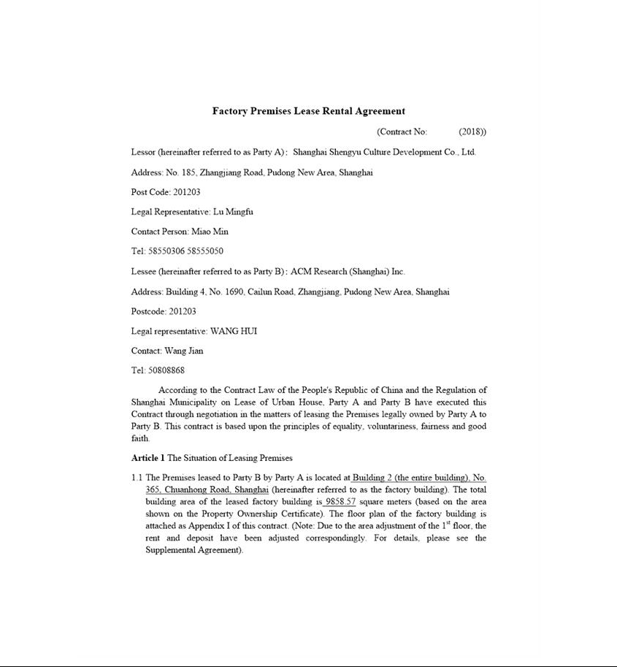

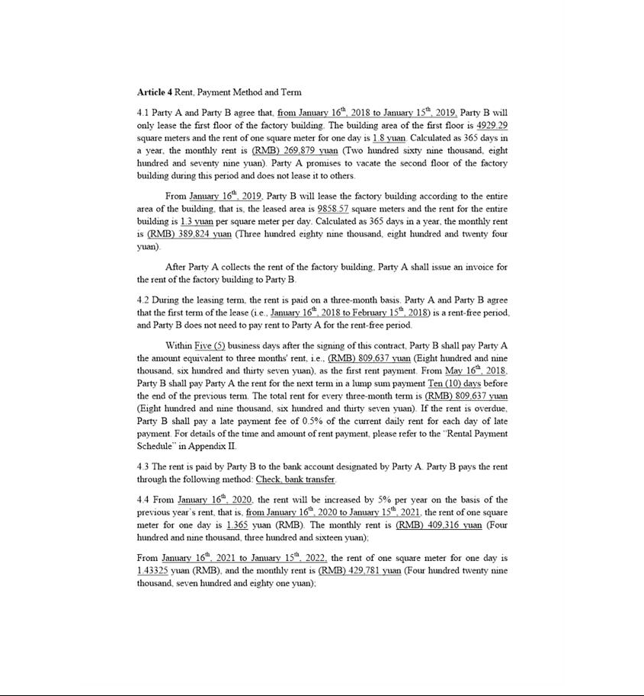

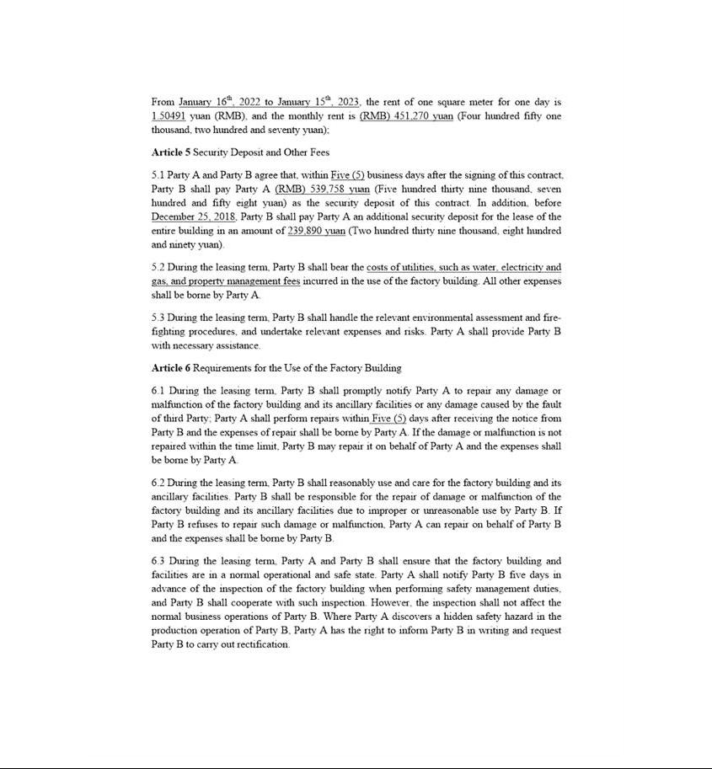

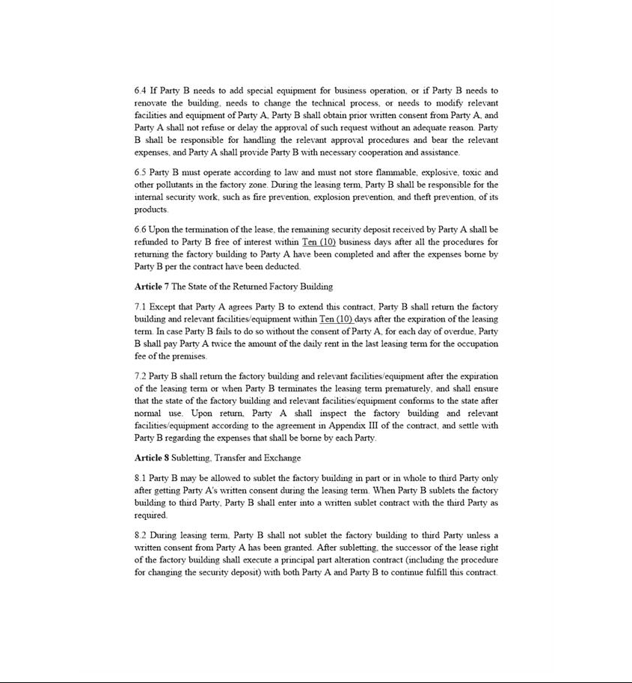

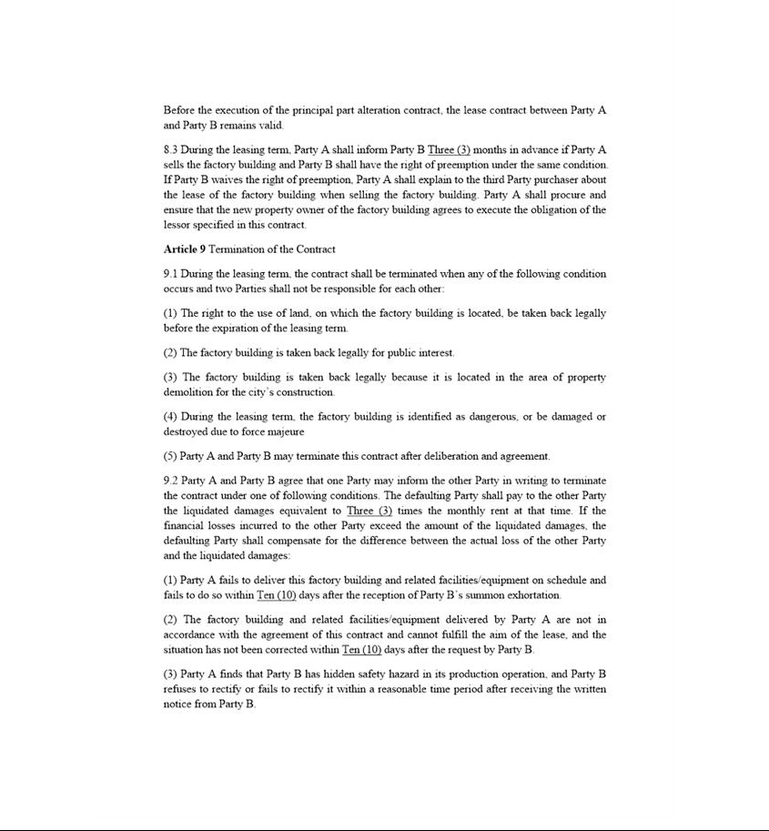

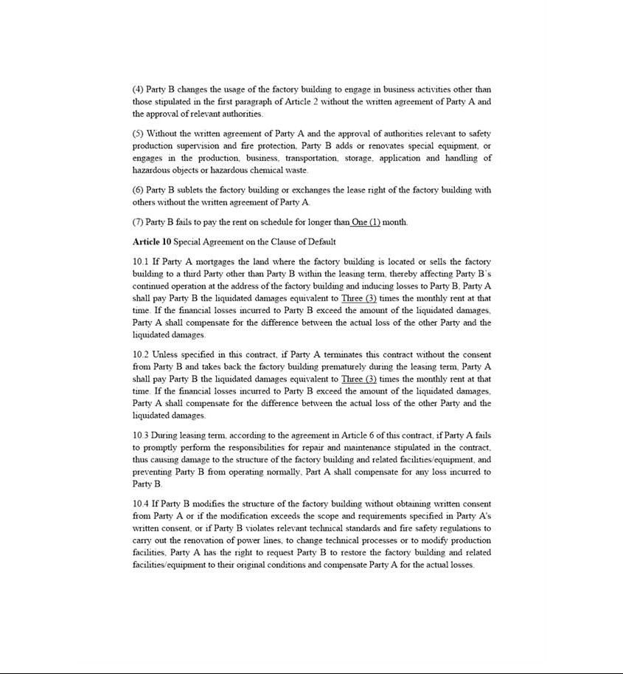

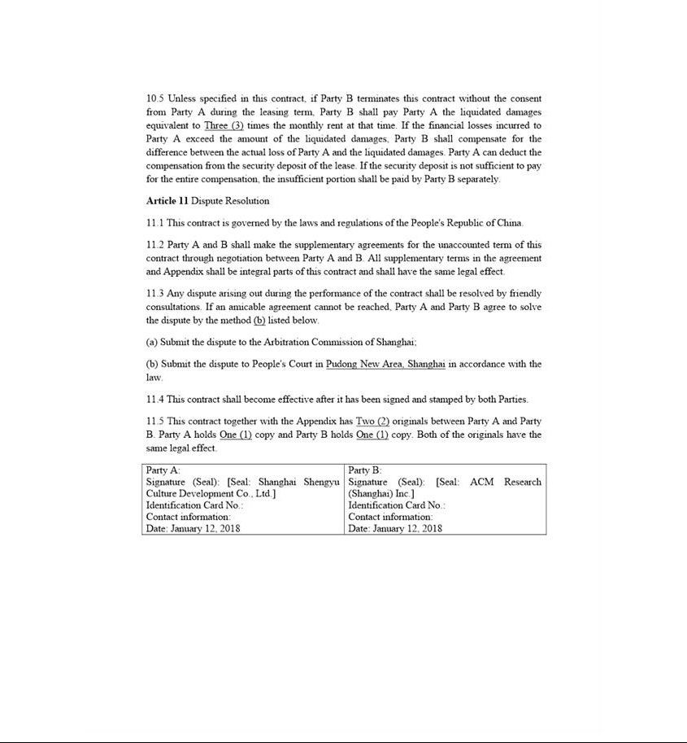

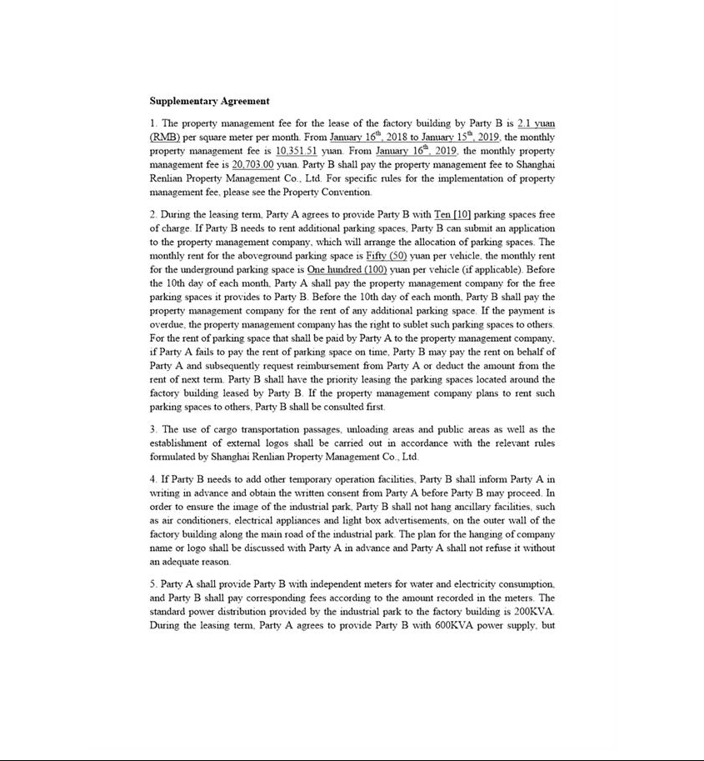

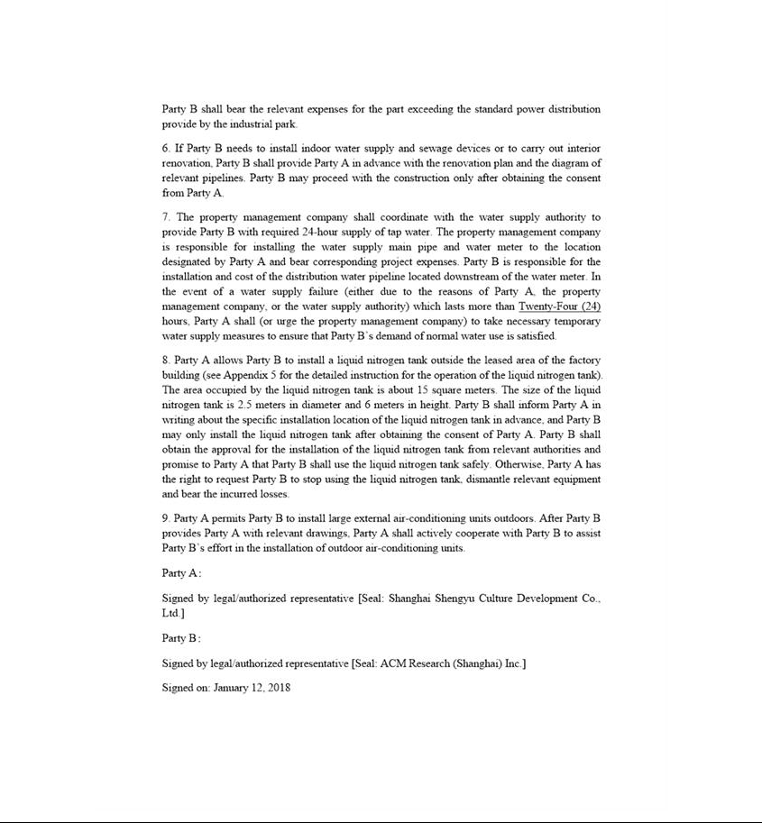

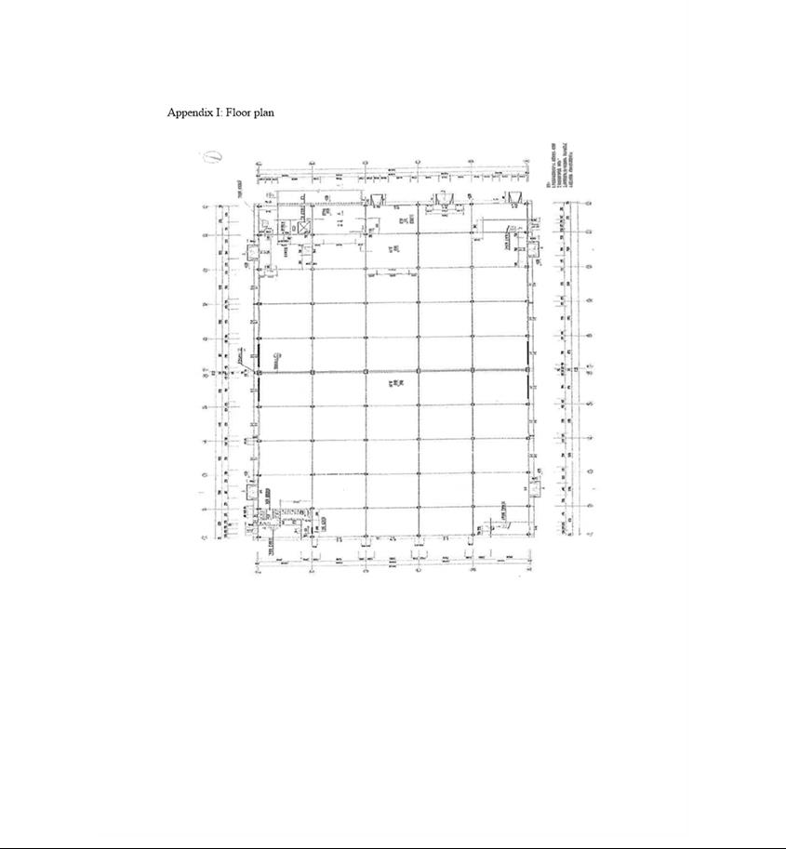

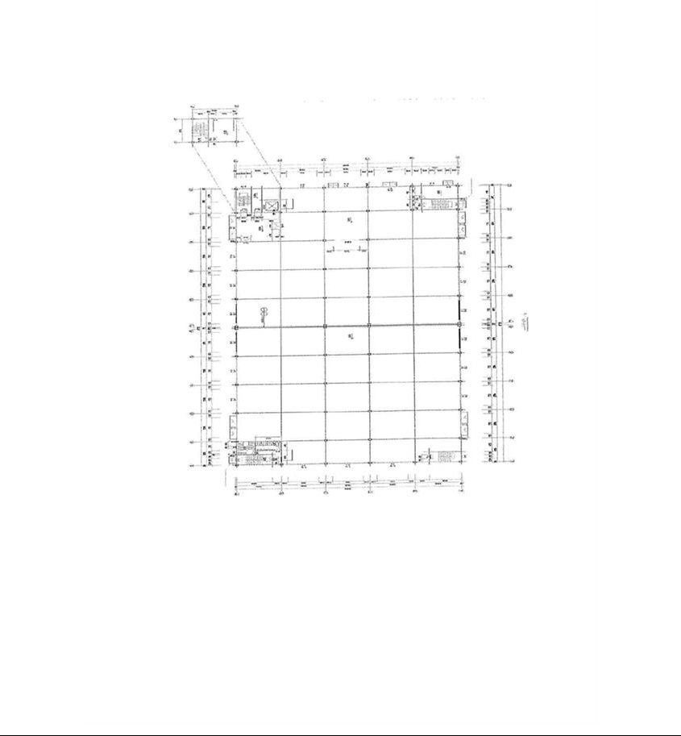

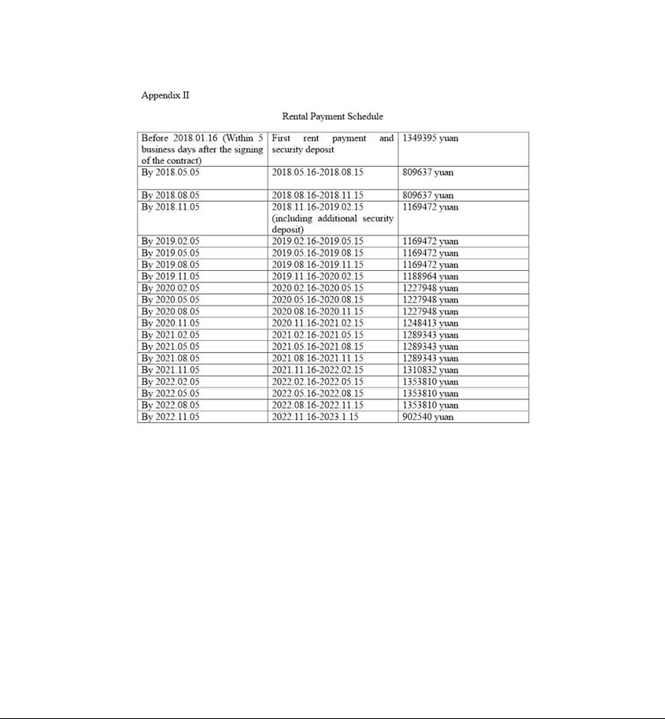

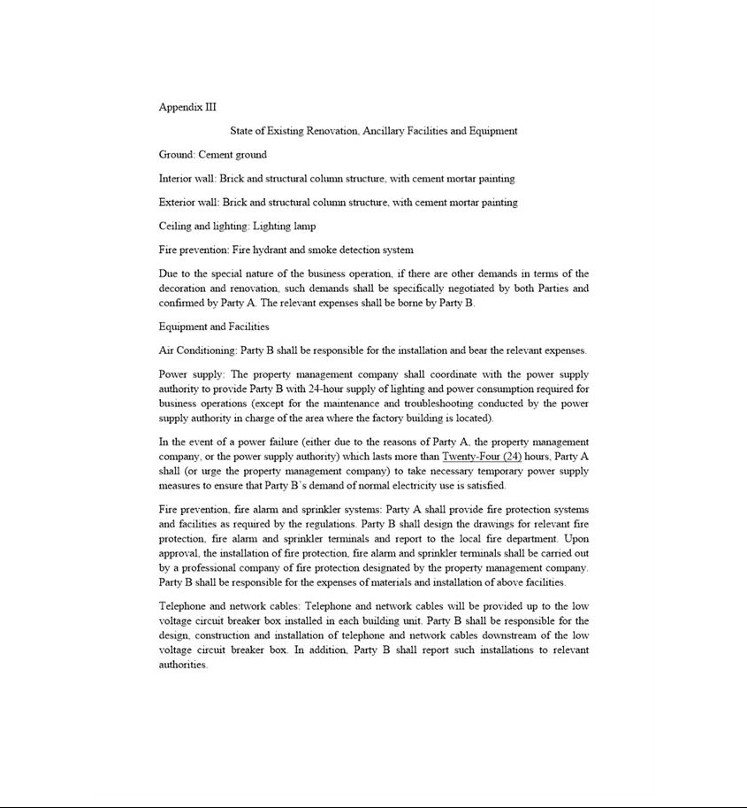

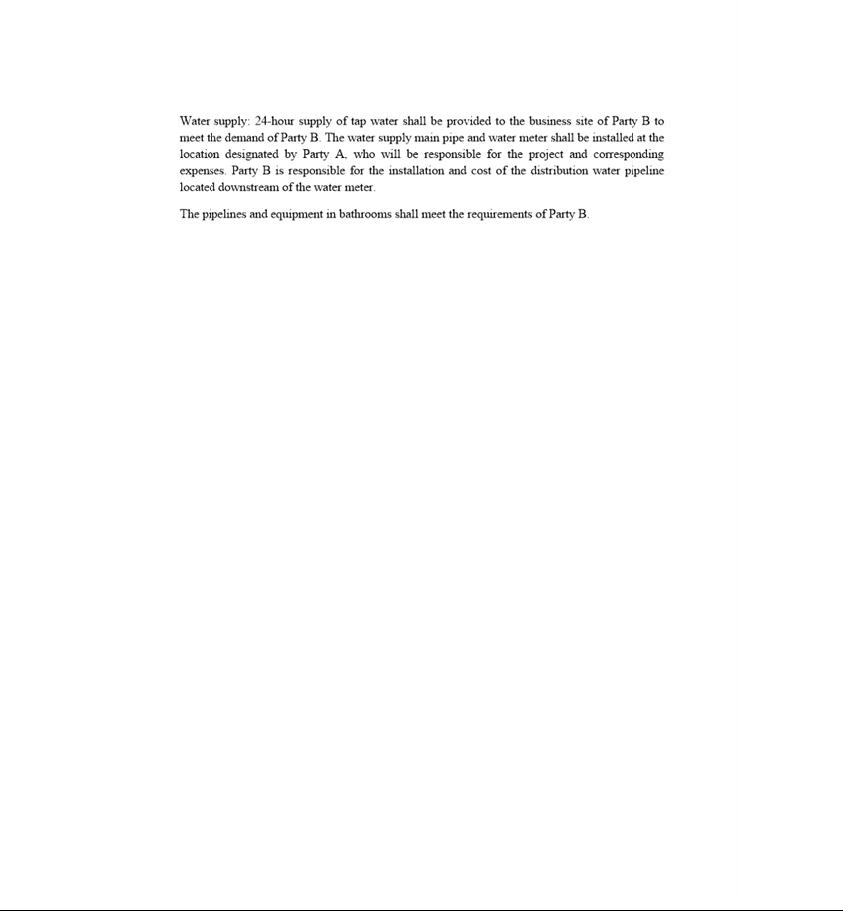

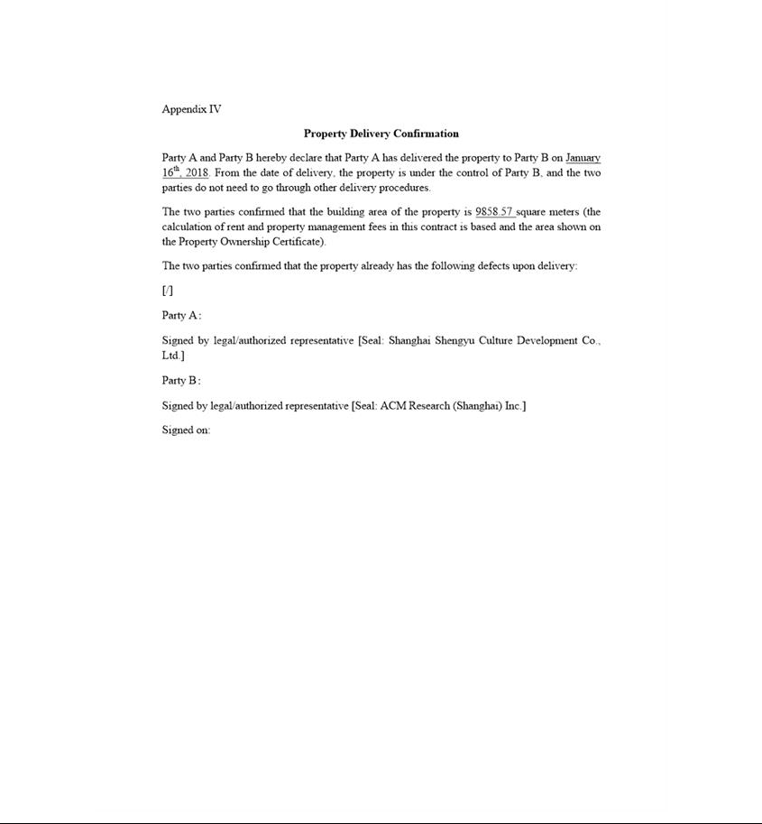

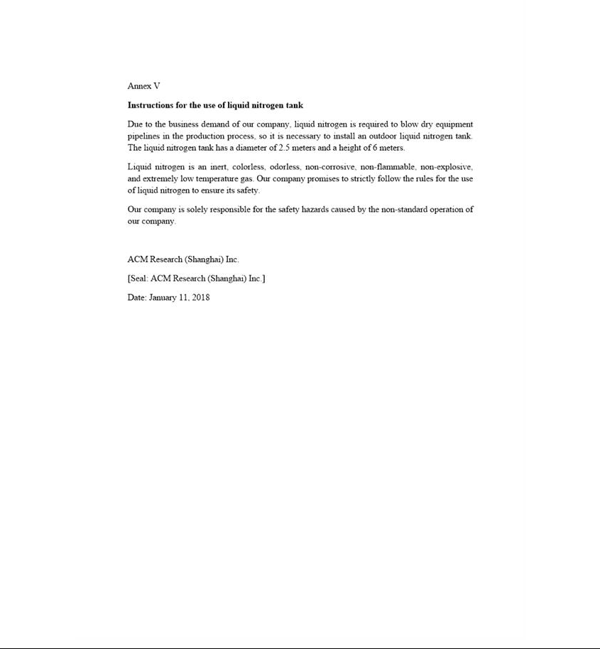

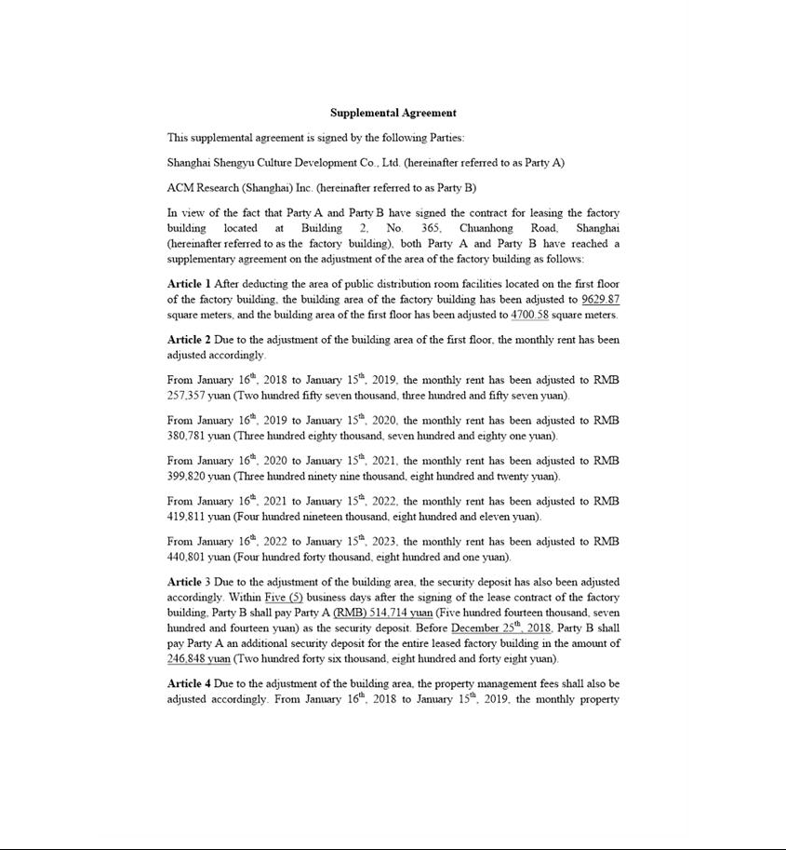

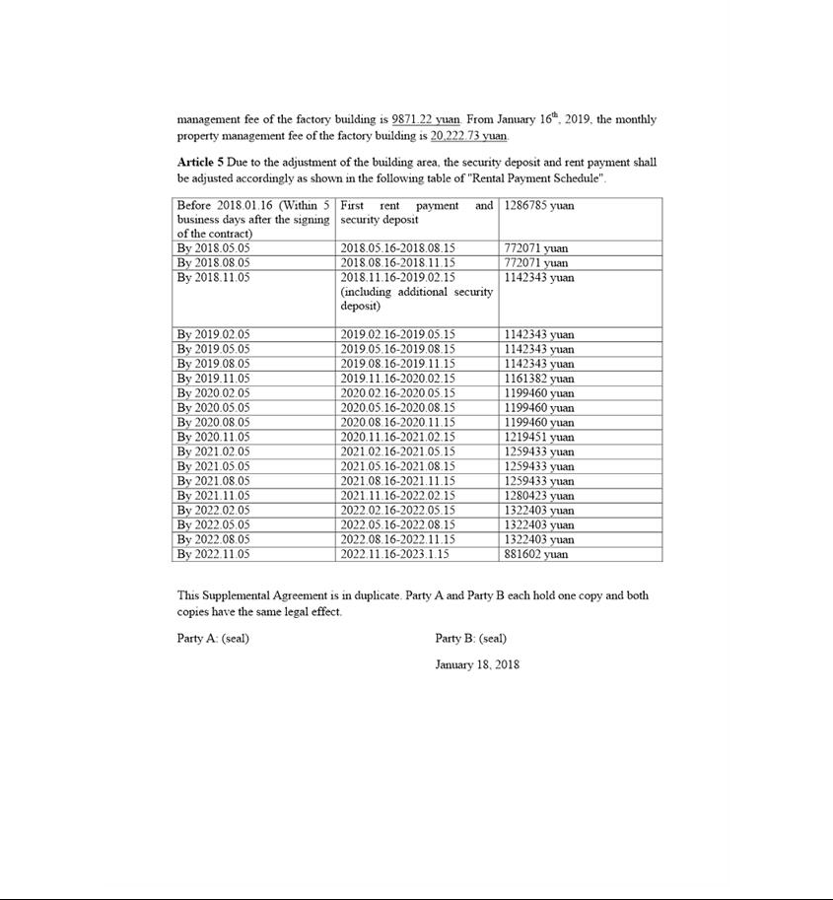

Exhibit 10.6
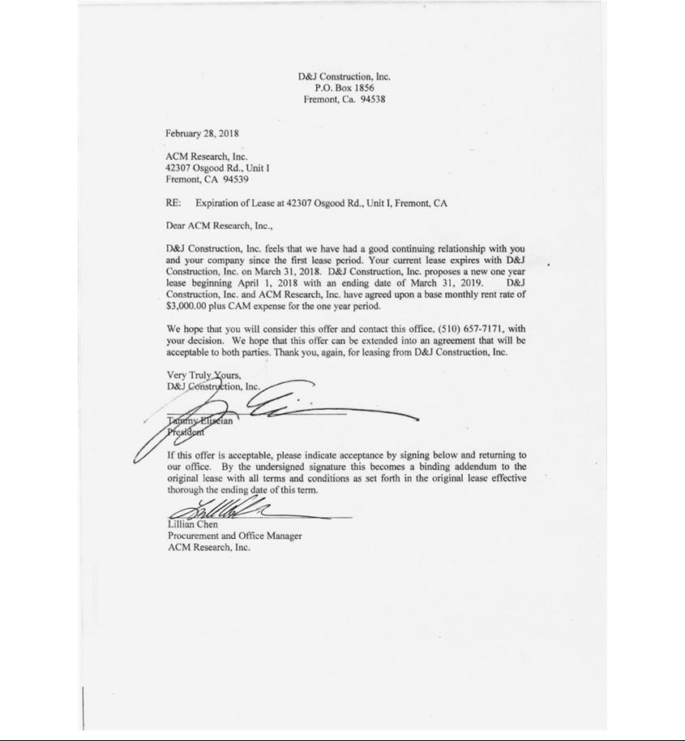

Exhibit 31.01

CERTIFICATION OF PRINCIPAL EXECUTIVE OFFICER

PURSUANT TO SECTION 302 OF THE SARBANES-OXLEY ACT OF 2002

I, David H. Wang, certify that:

- I have reviewed this Amendment No. 1 on Form 10-Q/A to the Quarterly Report on Form 10-Q of ACM Research, Inc. for the quarterly period ended March 31, 2018 (as so amended, “this quarterly report”).

- Based on my knowledge, this quarterly report does not contain any untrue statement of a material fact or omit to state a material fact necessary to make the statements made, in light of the circumstances under which such statements were made, not misleading with respect to the period covered by this quarterly report.

Dated: October 15, 2018 | By: |  | /S/ DAVID H. WANG
 |  | David H. Wang
 |  | Chief Executive Officer and President
 |  | (Principal Executive Officer)

Exhibit 31.02

CERTIFICATION OF PRINCIPAL FINANCIAL OFFICER

PURSUANT TO SECTION 302 OF THE SARBANES-OXLEY ACT OF 2002

I, Lisa Feng, certify that:

- I have reviewed this Amendment No. 1 on Form 10-Q/A to the Quarterly Report on Form 10-Q of ACM Research, Inc. for the quarterly period ended March 31, 2018 (as so amended, “this quarterly report”).

- Based on my knowledge, this quarterly report does not contain any untrue statement of a material fact or omit to state a material fact necessary to make the statements made, in light of the circumstances under which such statements were made, not misleading with respect to the period covered by this quarterly report.

Dated: October 15, 2018 | By: |  | /s/ LISA FENG
 |  | Lisa Feng
 |  | Interim Chief Financial Officer, Chief Accounting Officer and Treasurer
 |  | (Principal Financial Officer)

