Table of Contents

UNITED STATES SECURITIES AND EXCHANGE COMMISSION
Washington, D.C. 20549
FORM 10-Q
(Mark One)
☑ |  |  | QUARTERLY REPORT PURSUANT TO SECTION 13 OR 15(d) OF THE SECURITIES EXCHANGE ACT OF 1934
For the quarterly period ended June 30, 2026
or
o |  |  | TRANSITION REPORT PURSUANT TO SECTION 13 OR 15(d) OF THE SECURITIES EXCHANGE ACT OF 1934
For the transition period from _________ to _____________
Commission file number: 001-38273

ACM Research, Inc.
(Exact Name of Registrant as Specified in Its Charter)
Delaware |  |  | 94-3290283
(State or Other Jurisdiction of Incorporation or Organization) |  |  | (I.R.S. Employer Identification No.)
42307 Osgood Road, Suite I  Fremont, California |  |  | 94539
(Address of Principal Executive Offices) |  |  | (Zip Code)
Registrant’s telephone number, including area code: (510) 445-3700
Securities registered pursuant to Section 12(b) of the Act:
Title of Each Class |  |  |  |  |  | Trading Symbol |  |  |  |  |  | Name of Each Exchange on which Registered
Class A Common Stock, $0.0001 par value |  |  |  |  |  | ACMR |  |  |  |  |  | The NASDAQ Stock Market LLC
Indicate by check mark whether the registrant (1) has filed all reports required to be filed by Section 13 or 15(d) of the Securities Exchange Act of 1934 during the preceding 12 months (or for such shorter period that the registrant was required to file such reports), and (2) has been subject to such filing requirements for the past 90 days. Yes ☑ No o
Indicate by check mark whether the registrant has submitted electronically every Interactive Data file required to be submitted pursuant to Rule 405 of Regulation S-T (§232.405 of this chapter) during the preceding 12 months (or for such shorter period that the registrant was required to submit such files). Yes ☑ No o
Indicate by check mark whether the registrant is a large accelerated filer, an accelerated filer, a non-accelerated filer, a smaller reporting company or an emerging growth company. See definitions of “large accelerated filer,” “accelerated filer,” “smaller reporting company” and “emerging growth company” in Rule 12b-2 of the Exchange Act.
 |  |  | Large accelerated filer |  |  | ☑ |  |  |  |  |  | Accelerated filer |  |  | o
 |  |  | Non-accelerated filer |  |  | o |  |  |  |  |  | Smaller reporting company |  |  | o
 |  |  |  |  |  |  |  |  |  |  |  | Emerging growth company |  |  | o
If an emerging growth company, indicate by check mark if the registrant has elected not to use the extended transition period for complying with any new or revised financial accounting standards provided pursuant to Section 13(a) of the Exchange Act. o
Indicate by check mark whether the registrant is a shell company (as defined in Rule 12b-2 of the Exchange Act). Yes o No ☑
Indicate the number of shares outstanding of each of the registrant’s classes of common stock, as of the latest practicable date.
Class |  |  |  |  |  | Number of Shares Outstanding
Class A Common Stock, $0.0001 par value |  |  |  |  |  | 64,657,388 shares outstanding as of August 4, 2026
Class B Common Stock, $0.0001 par value |  |  |  |  |  | 4,991,808 shares outstanding as of August 4, 2026

Table of Contents

TABLE OF CONTENTS
PART I. |  |  |  |  |  | FINANCIAL INFORMATION |  |  | 4
 |  |  | Item 1. |  |  | Financial Statements (unaudited) |  |  | 4
 |  |  |  |  |  | Condensed Consolidated Balance Sheets as of June 30, 2026 and December 31, 2025 |  |  | 4
 |  |  |  |  |  | Condensed Consolidated Statements of Comprehensive Income for the Three and Six Months Ended June 30, 2026 and 2025 |  |  | 5
 |  |  |  |  |  | Condensed Consolidated Statements of Changes in Equity for the Three and Six Months Ended June 30, 2026 and 2025 |  |  | 6
 |  |  |  |  |  | Condensed Consolidated Statements of Cash Flows for the Six Months Ended June 30, 2026 and 2025 |  |  | 9
 |  |  |  |  |  | Notes to the Condensed Consolidated Financial Statements |  |  | 10
 |  |  | Item 2. |  |  | Management’s Discussion and Analysis of Financial Condition and Results of Operations |  |  | 27
 |  |  | Item 3. |  |  | Quantitative and Qualitative Disclosures about Market Risks |  |  | 46
 |  |  | Item 4. |  |  | Controls and Procedures |  |  | 46
PART II. |  |  |  |  |  | OTHER INFORMATION |  |  | 47
 |  |  | Item 1. |  |  | Legal Proceedings |  |  | 47
 |  |  | Item 1A. |  |  | Risk Factors |  |  | 47
 |  |  | Item 2. |  |  | Unregistered Sales of Equity Securities and Use of Proceeds |  |  | 47
 |  |  | Item 3. |  |  | Defaults Upon Senior Securities |  |  | 52
 |  |  | Item 4. |  |  | Mine Safety Disclosures |  |  | 52
 |  |  | Item 5. |  |  | Other Information |  |  | 47
 |  |  | Item 6. |  |  | Exhibits |  |  | 48
Signatures |  |  |  |  |  |  |  |  | 49

ACM Research, Inc., or ACM Research, is a Delaware corporation founded in California in 1998 to supply capital equipment developed for the global semiconductor industry. Since 2005, ACM Research has conducted its business operations principally through its subsidiary ACM Research (Shanghai), Inc., or ACM Shanghai, a corporation formed by ACM Research in the People’s Republic of China, or mainland China, in 2005. The shares of ACM Shanghai currently trade under the symbol SSEC: 688082.SS on the Shanghai SciTech innovAtion boaRd, known as the STAR Market. Unless the context requires otherwise, references in this report to “our company,” “our,” “us,” “we” and similar terms refer to ACM Research, Inc. and its subsidiaries, including ACM Shanghai, collectively.

We conduct a substantial majority of our product development, manufacturing, support and services in mainland China through ACM Shanghai. We are not a mainland China operating company, and we do not conduct our operations in mainland China through the use of a variable interest entity or any other structure designed for the purpose of avoiding mainland China legal restrictions on direct foreign investments in mainland China-based companies. For a description of certain matters relating to our operations in mainland China, including our corporate structure, the movement of cash throughout our organization, certain audit and regulatory matters, and risks associated therewith, please see “Item 2—Management’s Discussion and Analysis of Financial Condition and Results of Operations” in this report, the disclosure at the forefront of our Annual Report on Form 10-K for the fiscal year ended December 31, 2025, and the Risk Factors included therein, as referenced or updated by the disclosure included in “Part II. Item 1A—Risk Factors” in this report.
For purposes of this report, certain amounts in Renminbi, or RMB, have been translated into U.S. dollars solely for the convenience of the reader. The translations have been made based on the conversion rates published by the State Administration of Foreign Exchange of the People’s Republic of China.
SAPS, TEBO, ULTRA C, ULTRA Fn, Ultra ECP, Ultra ECP map, and Ultra ECP ap are trademarks of ACM Research. For convenience, these trademarks appear in this report without ™ symbols, but that practice does not mean that ACM Research will not assert, to the fullest extent under applicable law, ACM Research’s rights to the trademarks. This report also contains other companies’ trademarks, registered marks and trade names, which are the property of those companies.

2
Table of Contents

FORWARD-LOOKING STATEMENTS AND STATISTICAL DATA
This report contains forward-looking statements within the meaning of the Private Securities Litigation Reform Act of 1995. All statements, other than statements of historical facts, included in this report regarding our strategy, future operations, future financial position, future revenue, projected costs, prospects, plans and objectives of management are forward-looking statements. In some cases, you can identify forward-looking statements by terms such as “may,” “might,” “will,” “objective,” “intend,” “should,” “could,” “can,” “would,” “expect,” “believe,” “anticipate,” “project,” “target,” “design,” “estimate,” “predict,” “potential,” “plan” or the negative of these terms, and similar expressions intended to identify forward-looking statements. These statements reflect our current views with respect to future events and are based on our management’s belief and assumptions and on information currently available to our management. Although we believe that the expectations reflected in these forward-looking statements are reasonable, these statements relate to future events or our future operational or financial performance, and involve known and unknown risks, uncertainties and other factors, including those described or incorporated by reference in “Item 1A. Risk Factors” of Part I of this report, that may cause our actual results, performance or achievements to be materially different from any future results, performance or achievements expressed or implied by these forward-looking statements.

The information included under the heading “Item 2. Management's Discussion and Analysis of Financial Condition and Results of Operations” of Part I of this report contains statistical data and estimates, including forecasts, that are based on information provided by Frost & Sullivan (as defined below) in "Global and China Semiconductor Equipment Market Research, June 2026."
Frost & Sullivan is a trademark of Frost & Sullivan, Inc. and its affiliates (“Frost & Sullivan”).
The Frost & Sullivan content described herein (the "Frost & Sullivan Content"), represents research opinions or viewpoints published, as part of a syndicated subscription service, by Frost & Sullivan, and are not representations of fact. Frost & Sullivan speaks as of its original publication date (not as of the date of this report) and the opinions expressed in the Frost & Sullivan Content are subject to change without notice.
While we are not aware of any misstatements in the Frost & Sullivan Content, estimates, and in particular forecasts, involve numerous assumptions and are subject to risks and uncertainties, as well as change based on various factors, that could cause results to differ materially from those expressed in the data presented below.
Any forward-looking statement made by us in this report speaks only as of the date on which it is made. Except as required by law, we assume no obligation to update these statements publicly or to update the reasons actual results could differ materially from those anticipated in these statements, even if new information becomes available in the future.

You should read this report, and the documents that we reference in this report and have filed as exhibits to this report, completely and with the understanding that our actual future results may be materially different from what we expect. We qualify all of our forward-looking statements by these cautionary statements.

3
Table of Contents

PART I. FINANCIAL INFORMATION

Item 1. Financial Statements

ACM RESEARCH, INC.
Condensed Consolidated Balance Sheets
(In thousands, except per share data)

 |  |  | June 30, |  |  |  |  |  | December 31,
 |  |  | 2026 |  |  |  |  |  | 2025
Assets |  |  | (Unaudited)
Current assets:
Cash and cash equivalents (note 2) |  |  | $ | 969,229 |  |  |  |  | $ | 757,373
Restricted cash |  |  | 21,358 |  |  |  |  |  | 8,589
Short-term time deposits (note 2) |  |  | 365,055 |  |  |  |  |  | 366,591
Short-term investments (note 11) |  |  | 105,091 |  |  |  |  |  | 35,524
Account receivables, net (note 4) |  |  | 538,389 |  |  |  |  |  | 504,250
Other receivables |  |  | 66,820 |  |  |  |  |  | 48,655
Inventories, net (note 5) |  |  | 783,119 |  |  |  |  |  | 702,631
Advances to related parties (note 12) |  |  | 163 |  |  |  |  |  | 2,500
Prepaid expenses and other current assets |  |  | 25,554 |  |  |  |  |  | 10,567
Total current assets |  |  | 2,874,778 |  |  |  |  |  | 2,436,680
Property, plant and equipment, net (note 6) |  |  | 384,593 |  |  |  |  |  | 314,830
Operating lease right-of-use assets, net |  |  | 16,634 |  |  |  |  |  | 17,925
Intangible assets, net |  |  | 2,516 |  |  |  |  |  | 2,847
Deferred tax assets (note 15) |  |  | 25,904 |  |  |  |  |  | 29,389
Long-term investments (note 10) |  |  | 89,249 |  |  |  |  |  | 66,035
Other long-term assets |  |  | 5,564 |  |  |  |  |  | 4,479
Total assets |  |  | $ | 3,399,238 |  |  |  |  | $ | 2,872,185
Liabilities and Equity
Current liabilities:
Short-term borrowings (note 7) |  |  | $ | 107,218 |  |  |  |  | $ | 74,041
Current portion of long-term borrowings (note 9) |  |  | 40,787 |  |  |  |  |  | 35,082
Related parties accounts payable (note 12) |  |  | 29,799 |  |  |  |  |  | 32,060
Accounts payable |  |  | 220,601 |  |  |  |  |  | 215,440
Advances from customers (note 3) |  |  | 165,566 |  |  |  |  |  | 187,809
Deferred revenue (note 3) |  |  | 15,908 |  |  |  |  |  | 17,388
Income taxes payable (note 15) |  |  | 3,626 |  |  |  |  |  | 991
FIN-48 payable (note 15) |  |  | 28,908 |  |  |  |  |  | 27,719
Other payables and accrued expenses (note 8) |  |  | 168,944 |  |  |  |  |  | 150,396
Current portion of operating lease liabilities |  |  | 4,907 |  |  |  |  |  | 4,786
Total current liabilities |  |  | 786,264 |  |  |  |  |  | 745,712
Long-term borrowings (note 9) |  |  | 192,904 |  |  |  |  |  | 178,930
Long-term operating lease liabilities |  |  | 3,503 |  |  |  |  |  | 5,069
Other long-term liabilities |  |  | 11,444 |  |  |  |  |  | 11,965
Total liabilities |  |  | 994,115 |  |  |  |  |  | 941,676
Commitments and contingencies (note 16)
Equity:
Stockholders’ equity:
Class A Common stock (note 13) |  |  | 6 |  |  |  |  |  | 6
Class B Common stock (note 13) |  |  | 1 |  |  |  |  |  | 1
Additional paid-in capital |  |  | 1,361,841 |  |  |  |  |  | 1,115,504
Retained earnings |  |  | 456,719 |  |  |  |  |  | 350,428
Statutory surplus reserve (note 18) |  |  | 34,164 |  |  |  |  |  | 34,164
Accumulated other comprehensive income (loss) |  |  | 7,423 |  |  |  |  |  | (35,740)
Total ACM Research, Inc. stockholders’ equity |  |  | 1,860,154 |  |  |  |  |  | 1,464,363
Non-controlling interests |  |  | 544,969 |  |  |  |  |  | 466,146
Total equity |  |  | 2,405,123 |  |  |  |  |  | 1,930,509
Total liabilities and equity |  |  | $ | 3,399,238 |  |  |  |  | $ | 2,872,185

The accompanying notes are an integral part of these condensed consolidated financial statements.

4
Table of Contents

ACM RESEARCH, INC.
Condensed Consolidated Statements of Comprehensive Income
(In thousands, except share and per share data)
(Unaudited)
 |  |  | Three Months Ended June 30, |  |  |  |  |  |  |  |  |  |  |  | Six Months Ended  June 30,
 |  |  | 2026 |  |  |  |  |  | 2025 |  |  |  |  |  | 2026 |  |  |  |  |  | 2025
Revenue (note 3) |  |  | $ | 292,919 |  |  |  |  | $ | 215,372 |  |  |  |  | $ | 524,182 |  |  |  |  | $ | 387,719
Cost of revenue, including cost of revenue from related parties of $19,569 and $32,052 for the three and six months ended June 30, 2026, respectively and $16,518 and $25,917 for the three and six months ended June 30, 2025 respectively. |  |  | 158,301 |  |  |  |  |  | 110,911 |  |  |  |  |  | 282,326 |  |  |  |  |  | 200,708
Gross profit |  |  | 134,618 |  |  |  |  |  | 104,461 |  |  |  |  |  | 241,856 |  |  |  |  |  | 187,011
Operating expenses:
Sales and marketing |  |  | 23,778 |  |  |  |  |  | 22,102 |  |  |  |  |  | 44,466 |  |  |  |  |  | 38,445
Research and development |  |  | 42,254 |  |  |  |  |  | 33,817 |  |  |  |  |  | 78,803 |  |  |  |  |  | 61,320
General and administrative |  |  | 18,843 |  |  |  |  |  | 16,848 |  |  |  |  |  | 32,667 |  |  |  |  |  | 29,775
Total operating expenses |  |  | 84,875 |  |  |  |  |  | 72,767 |  |  |  |  |  | 155,936 |  |  |  |  |  | 129,540
Income from operations |  |  | 49,743 |  |  |  |  |  | 31,694 |  |  |  |  |  | 85,920 |  |  |  |  |  | 57,471
Interest income |  |  | 7,142 |  |  |  |  |  | 4,013 |  |  |  |  |  | 11,861 |  |  |  |  |  | 7,352
Interest expense |  |  | (2,059) |  |  |  |  |  | (1,757) |  |  |  |  |  | (3,992) |  |  |  |  |  | (3,315)
Realized gain on short-term investments (note 11) |  |  | — |  |  |  |  |  | 54 |  |  |  |  |  | — |  |  |  |  |  | 54
Unrealized gain on short-term investments (note 11) |  |  | 69,592 |  |  |  |  |  | 2,730 |  |  |  |  |  | 68,186 |  |  |  |  |  | 1,648
Other expense, net |  |  | (9,793) |  |  |  |  |  | (346) |  |  |  |  |  | (19,093) |  |  |  |  |  | (608)
Income from equity method investments |  |  | 21,097 |  |  |  |  |  | 1,773 |  |  |  |  |  | 22,846 |  |  |  |  |  | 2,725
Income before income taxes |  |  | 135,722 |  |  |  |  |  | 38,161 |  |  |  |  |  | 165,728 |  |  |  |  |  | 65,327
Income tax expense (note 15) |  |  | (13,472) |  |  |  |  |  | (1,891) |  |  |  |  |  | (17,243) |  |  |  |  |  | (4,044)
Net income |  |  | 122,250 |  |  |  |  |  | 36,270 |  |  |  |  |  | 148,485 |  |  |  |  |  | 61,283
Less: Net income attributable to non-controlling interests |  |  | 33,266 |  |  |  |  |  | 6,510 |  |  |  |  |  | 42,194 |  |  |  |  |  | 11,143
Net income attributable to ACM Research, Inc. |  |  | $ | 88,984 |  |  |  |  | $ | 29,760 |  |  |  |  | $ | 106,291 |  |  |  |  | $ | 50,140
Comprehensive income:
Net income |  |  | $ | 122,250 |  |  |  |  | $ | 36,270 |  |  |  |  | $ | 148,485 |  |  |  |  | $ | 61,283
Foreign currency translation adjustment, net of tax of nil |  |  | 30,141 |  |  |  |  |  | 3,905 |  |  |  |  |  | 57,938 |  |  |  |  |  | 5,655
Unrealized gain on available-for-sale investments, net of tax |  |  | 675 |  |  |  |  |  | — |  |  |  |  |  | 675 |  |  |  |  |  | —
Comprehensive income |  |  | 153,066 |  |  |  |  |  | 40,175 |  |  |  |  |  | 207,098 |  |  |  |  |  | 66,938
Less: Comprehensive income attributable to non-controlling interests |  |  | 41,477 |  |  |  |  |  | 7,250 |  |  |  |  |  | 57,644 |  |  |  |  |  | 12,207
Comprehensive income attributable to ACM Research, Inc. |  |  | $ | 111,589 |  |  |  |  | $ | 32,925 |  |  |  |  | $ | 149,454 |  |  |  |  | $ | 54,731
Net income attributable to ACM Research, Inc. per share of common stock (note 2):
Basic |  |  | $ | 1.31 |  |  |  |  | $ | 0.47 |  |  |  |  | $ | 1.59 |  |  |  |  | $ | 0.79
Diluted |  |  | $ | 1.23 |  |  |  |  | $ | 0.44 |  |  |  |  | $ | 1.49 |  |  |  |  | $ | 0.74
Weighted average shares of common stock outstanding used in computing per share amounts (note 2):
Basic |  |  | 67,890,917 |  |  |  |  |  | 63,968,763 |  |  |  |  |  | 66,853,350 |  |  |  |  |  | 63,620,235
Diluted |  |  | 71,838,908 |  |  |  |  |  | 67,464,856 |  |  |  |  |  | 70,678,872 |  |  |  |  |  | 67,138,338

The accompanying notes are an integral part of these condensed consolidated financial statements.

5
Table of Contents

ACM RESEARCH, INC.
Condensed Consolidated Statements of Changes in Equity
For the Three Months Ended June 30, 2026 and 2025
(In thousands, except share and per share data)
(Unaudited)
 |  |  | Common  Stock Class A |  |  |  |  |  |  |  |  |  |  |  | Common  Stock Class B |  |  |  |  |  |  |  |  |  |  |  | Additional Paid-  in Capital |  |  |  |  |  | Retained  Earnings |  |  |  |  |  | Statutory  Surplus  Reserve |  |  |  |  |  | Accumulated  Other  Comprehensive  (Loss) Income |  |  |  |  |  | Non-controlling  Interests |  |  | Total  Equity
 |  |  | Shares |  |  |  |  |  | Amount |  |  |  |  |  | Shares |  |  |  |  |  | Amount
Balance at March 31, 2026 |  |  | 61,223,064 |  |  |  |  |  | $ | 6 |  |  |  |  | 4,991,808 |  |  |  |  |  | $ | 1 |  |  |  |  | $ | 1,194,786 |  |  |  |  | $ | 367,735 |  |  |  |  | $ | 34,164 |  |  |  |  | $ | (15,182) |  |  |  |  | $ | 501,962 |  | $ | 2,083,472
Net income |  |  | — |  |  |  |  |  | — |  |  |  |  |  | — |  |  |  |  |  | — |  |  |  |  |  | — |  |  |  |  |  | 88,984 |  |  |  |  |  | — |  |  |  |  |  | — |  |  |  |  |  | 33,266 |  |  | 122,250
Unrealized gain on available-for-sale investments |  |  | — |  |  |  |  |  | — |  |  |  |  |  | — |  |  |  |  |  | — |  |  |  |  |  | — |  |  |  |  |  | — |  |  |  |  |  | — |  |  |  |  |  | 493 |  |  |  |  |  | 182 |  |  | 675
Proceeds from issuance of ACM Research shares, net of issuance costs |  |  | 2,884,615 |  |  |  |  |  | — |  |  |  |  |  | — |  |  |  |  |  | — |  |  |  |  |  | 148,389 |  |  |  |  |  | — |  |  |  |  |  | — |  |  |  |  |  | — |  |  |  |  |  | — |  |  | 148,389
Foreign currency translation adjustment |  |  | — |  |  |  |  |  | — |  |  |  |  |  | — |  |  |  |  |  | — |  |  |  |  |  | — |  |  |  |  |  | — |  |  |  |  |  | — |  |  |  |  |  | 22,112 |  |  |  |  |  | 8,029 |  |  | 30,141
Exercise of stock options |  |  | 543,686 |  |  |  |  |  | — |  |  |  |  |  | — |  |  |  |  |  | — |  |  |  |  |  | 13,328 |  |  |  |  |  | — |  |  |  |  |  | — |  |  |  |  |  | — |  |  |  |  |  | 12,053 |  |  | 25,381
Stock-based compensation |  |  | — |  |  |  |  |  | — |  |  |  |  |  | — |  |  |  |  |  | — |  |  |  |  |  | 5,338 |  |  |  |  |  | — |  |  |  |  |  | — |  |  |  |  |  | — |  |  |  |  |  | 1,245 |  |  | 6,583
ACM Shanghai dividend |  |  | — |  |  |  |  |  | — |  |  |  |  |  | — |  |  |  |  |  | — |  |  |  |  |  | — |  |  |  |  |  | — |  |  |  |  |  | — |  |  |  |  |  | — |  |  |  |  |  | (11,768) |  |  | (11,768)
Balance at June 30, 2026 |  |  | 64,651,365 |  |  |  |  |  | $ | 6 |  |  |  |  | 4,991,808 |  |  |  |  |  | $ | 1 |  |  |  |  | $ | 1,361,841 |  |  |  |  | $ | 456,719 |  |  |  |  | $ | 34,164 |  |  |  |  | $ | 7,423 |  |  |  |  | $ | 544,969 |  | $ | 2,405,123
 |  |  | Common  Stock Class A |  |  |  |  |  |  |  |  |  |  |  | Common  Stock Class B |  |  |  |  |  |  |  |  |  |  |  | Additional Paid-  in Capital |  |  |  |  |  | Retained  Earnings |  |  |  |  |  | Statutory  Surplus  Reserve |  |  |  |  |  | Accumulated  Other  Comprehensive  (Loss) Income |  |  |  |  |  | Non-controlling  Interests |  |  | Total  Equity
 |  |  | Shares |  |  |  |  |  | Amount |  |  |  |  |  | Shares |  |  |  |  |  | Amount
Balance at March 31, 2025 |  |  | 58,832,925 |  |  |  |  |  | $ | 6 |  |  |  |  | 5,021,811 |  |  |  |  |  | $ | 1 |  |  |  |  | $ | 700,191 |  |  |  |  | $ | 280,380 |  |  |  |  | $ | 30,514 |  |  |  |  | $ | (61,946) |  |  |  |  | $ | 206,207 |  | $ | 1,155,353
Net income |  |  | — |  |  |  |  |  | — |  |  |  |  |  | — |  |  |  |  |  | — |  |  |  |  |  | — |  |  |  |  |  | 29,760 |  |  |  |  |  | — |  |  |  |  |  | — |  |  |  |  |  | 6,510 |  |  | 36,270
Repurchase of shares held by ACM Shanghai |  |  | — |  |  |  |  |  | — |  |  |  |  |  | — |  |  |  |  |  | — |  |  |  |  |  | (4,759) |  |  |  |  |  | — |  |  | — |  |  | — |  |  |  |  |  | — |  |  |  |  |  | (2,229) |  |  | (6,988)
Foreign currency translation adjustment |  |  | — |  |  |  |  |  | — |  |  |  |  |  | — |  |  |  |  |  | — |  |  |  |  |  | — |  |  |  |  |  | — |  |  |  |  |  | — |  |  |  |  |  | 3,165 |  |  |  |  |  | 740 |  |  | 3,905
Exercise of stock options |  |  | 264,046 |  |  |  |  |  | — |  |  |  |  |  | — |  |  |  |  |  | — |  |  |  |  |  | 853 |  |  |  |  |  | — |  |  |  |  |  | — |  |  |  |  |  | — |  |  |  |  |  | — |  |  | 853
Stock-based compensation |  |  | — |  |  |  |  |  | — |  |  |  |  |  | — |  |  |  |  |  | — |  |  |  |  |  | 8,285 |  |  |  |  |  | — |  |  |  |  |  | — |  |  |  |  |  | — |  |  |  |  |  | 1,485 |  |  | 9,770
Capital contribution by non-controlling shareholder |  |  | — |  |  |  |  |  | — |  |  |  |  |  | — |  |  |  |  |  | — |  |  |  |  |  | — |  |  |  |  |  | — |  |  |  |  |  | — |  |  |  |  |  | — |  |  |  |  |  | 104 |  |  | 104
ACM Shanghai dividend |  |  | — |  |  |  |  |  | — |  |  |  |  |  | — |  |  |  |  |  | — |  |  |  |  |  | — |  |  |  |  |  | — |  |  |  |  |  | — |  |  |  |  |  | — |  |  |  |  |  | (7,578) |  |  | (7,578)
Balance at June 30, 2025 |  |  | 59,096,971 |  |  |  |  |  | $ | 6 |  |  |  |  | 5,021,811 |  |  |  |  |  | $ | 1 |  |  |  |  | $ | 704,570 |  |  |  |  | $ | 310,140 |  |  |  |  | $ | 30,514 |  |  |  |  | $ | (58,781) |  |  |  |  | $ | 205,239 |  | $ | 1,191,689
The accompanying notes are an integral part of these condensed consolidated financial statements.
6
Table of Contents

ACM RESEARCH, INC.
Condensed Consolidated Statements of Changes in Equity
For the Six Months Ended June 30, 2026 and 2025
(In thousands, except share and per share data)
(Unaudited)
 |  |  | Common  Stock Class A |  |  |  |  |  | Common  Stock Class B |  |  |  |  |  | Additional Paid-  in Capital |  |  | Retained  Earnings |  |  | Statutory  Surplus  Reserve |  |  | Accumulated  Other  Comprehensive  (Loss) Income |  |  | Non-controlling  Interests |  |  | Total  Equity
 |  |  | Shares |  |  | Amount |  |  | Shares |  |  | Amount
Balance at December 31, 2025 |  |  | 60,590,017 |  |  | $ | 6 |  | 5,021,811 |  |  | $ | 1 |  | 1,115,504 |  |  | 350,428 |  |  | 34,164 |  |  | (35,740) |  |  | 466,146 |  |  | 1,930,509
Net income |  |  | — |  |  | — |  |  | — |  |  | — |  |  | — |  |  | 106,291 |  |  | — |  |  | — |  |  | 42,194 |  |  | 148,485
Unrealized gain on available-for-sale investments |  |  | — |  |  | — |  |  | — |  |  | — |  |  | — |  |  | — |  |  | — |  |  | 493 |  |  | 182 |  |  | 675
Proceeds from issuance of ACM Research shares, net of issuance costs |  |  | 2,884,615 |  |  | — |  |  | — |  |  | — |  |  | 148,389 |  |  | — |  |  | — |  |  | — |  |  | — |  |  | 148,389
Foreign currency translation adjustment |  |  | — |  |  | — |  |  | — |  |  | — |  |  | — |  |  | — |  |  | — |  |  | 42,670 |  |  | 15,268 |  |  | 57,938
Exercise of stock options |  |  | 1,146,730 |  |  | — |  |  | — |  |  | — |  |  | 18,725 |  |  | — |  |  | — |  |  | — |  |  | 12,053 |  |  | 30,778
Stock-based compensation |  |  | — |  |  | — |  |  | — |  |  | — |  |  | 10,016 |  |  | — |  |  | — |  |  | — |  |  | 2,188 |  |  | 12,204
Sale of ACM Shanghai shares, net of tax (note 1) |  |  | — |  |  | — |  |  | — |  |  | — |  |  | 69,207 |  |  | — |  |  | — |  |  | — |  |  | 18,706 |  |  | 87,913
Conversion of Class B common stock to Class A common stock |  |  | 30,003 |  |  | — |  |  | (30,003) |  |  | — |  |  | — |  |  | — |  |  | — |  |  | — |  |  | — |  |  | —
ACM Shanghai dividend |  |  | — |  |  | — |  |  | — |  |  | — |  |  | — |  |  | — |  |  | — |  |  | — |  |  | (11,768) |  |  | (11,768)
Balance at June 30, 2026 |  |  | 64,651,365 |  |  | $ | 6 |  | 4,991,808 |  |  | $ | 1 |  | $ | 1,361,841 |  | $ | 456,719 |  | $ | 34,164 |  | $ | 7,423 |  | $ | 544,969 |  | $ | 2,405,123
7
Table of Contents

 |  |  | Common  Stock Class A |  |  |  |  |  | Common  Stock Class B |  |  |  |  |  | Additional Paid-  in Capital |  |  | Retained  Earnings |  |  | Statutory  Surplus  Reserve |  |  | Accumulated  Other  Comprehensive  Loss |  |  | Non-controlling  Interests |  |  | Total  Equity
 |  |  | Shares |  |  | Amount |  |  | Shares |  |  | Amount
Balance at December 31, 2024 |  |  | 57,938,885 |  |  | $ | 6 |  | 5,021,811 |  |  | $ | 1 |  | $ | 677,476 |  | $ | 260,000 |  | $ | 30,514 |  | $ | (63,372) |  | $ | 191,281 |  | $ | 1,095,906
Net income |  |  | — |  |  | — |  |  | — |  |  | — |  |  | — |  |  | 50,140 |  |  | — |  |  | — |  |  | 11,143 |  |  | 61,283
Repurchase of shares held by ACM Shanghai |  |  | — |  |  | — |  |  | — |  |  | — |  |  | (4,759) |  |  | — |  |  | — |  |  | — |  |  | (2,229) |  |  | (6,988)
Foreign currency translation adjustment |  |  | — |  |  | — |  |  | — |  |  | — |  |  | — |  |  | — |  |  | — |  |  | 4,591 |  |  | 1,064 |  |  | 5,655
Exercise of stock options |  |  | 1,158,086 |  |  | — |  |  | — |  |  | — |  |  | 15,266 |  |  | — |  |  | — |  |  | — |  |  | 8,316 |  |  | 23,582
Stock-based compensation |  |  | — |  |  | — |  |  | — |  |  | — |  |  | 16,587 |  |  | — |  |  | — |  |  | — |  |  | 3,000 |  |  | 19,587
Capital contribution by non-controlling shareholder |  |  | — |  |  | — |  |  | — |  |  | — |  |  | — |  |  | — |  |  | — |  |  | — |  |  | 242 |  |  | 242
ACM Shanghai dividend |  |  | — |  |  | — |  |  | — |  |  | — |  |  | — |  |  | — |  |  | — |  |  | — |  |  | (7,578) |  |  | (7,578)
Balance at June 30, 2025 |  |  | 59,096,971 |  |  | $ | 6 |  | 5,021,811 |  |  | $ | 1 |  | $ | 704,570 |  | $ | 310,140 |  | $ | 30,514 |  | $ | (58,781) |  | $ | 205,239 |  | $ | 1,191,689

The accompanying notes are an integral part of these condensed consolidated financial statements.

8
Table of Contents

ACM RESEARCH, INC.
Condensed Consolidated Statements of Cash Flows
(In thousands)
(Unaudited)
 |  |  | Six Months Ended June 30,
 |  |  | 2026 |  |  |  |  |  | 2025
Cash flows from operating activities:
Net income |  |  | $ | 148,485 |  |  |  |  | $ | 61,283
Adjustments to reconcile net income to net cash used in operating activities:
Non-cash operating lease cost |  |  | 2,384 |  |  |  |  |  | 2,081
Depreciation and amortization |  |  | 11,766 |  |  |  |  |  | 6,356
Income from equity method investments |  |  | (22,846) |  |  |  |  |  | (2,725)
Unrealized gain on short-term investments |  |  | (68,186) |  |  |  |  |  | (1,648)
Inventory provision |  |  | 12,019 |  |  |  |  |  | 5,625
Provision for credit losses |  |  | 3,710 |  |  |  |  |  | 1,435
Deferred income taxes |  |  | 4,186 |  |  |  |  |  | (7,451)
Stock-based compensation |  |  | 12,204 |  |  |  |  |  | 19,587
Dividends from unconsolidated affiliates |  |  | 2,821 |  |  |  |  |  | —
Others |  |  | — |  |  |  |  |  | 1,086
Net changes in operating assets and liabilities:
Accounts receivable |  |  | (4,369) |  |  |  |  |  | (44,508)
Other receivables |  |  | (8,862) |  |  |  |  |  | (848)
Inventories |  |  | (69,882) |  |  |  |  |  | (52,946)
Advances to related parties |  |  | 2,337 |  |  |  |  |  | 342
Prepaid expenses and other current assets |  |  | (12,035) |  |  |  |  |  | (6,433)
Other long-term assets |  |  | (1,143) |  |  |  |  |  | —
Related parties accounts payable |  |  | (2,261) |  |  |  |  |  | 3,694
Accounts payable |  |  | (10,730) |  |  |  |  |  | 7,743
Advances from customers |  |  | (25,915) |  |  |  |  |  | (24,357)
Deferred revenue |  |  | (1,480) |  |  |  |  |  | 5,123
Income taxes payable |  |  | (19,849) |  |  |  |  |  | (12,585)
FIN-48 payable |  |  | 1,189 |  |  |  |  |  | 1,908
Other payables and accrued expenses |  |  | 13,619 |  |  |  |  |  | 336
Operating lease liabilities |  |  | (2,537) |  |  |  |  |  | (2,027)
Other long-term liabilities |  |  | (521) |  |  |  |  |  | (690)
Net cash used in operating activities |  |  | (35,896) |  |  |  |  |  | (39,619)
Cash flows from investing activities:
Purchases of property and equipment |  |  | (87,311) |  |  |  |  |  | (31,458)
Purchase of intangible assets |  |  | (476) |  |  |  |  |  | (784)
Purchase of time deposits |  |  | (25,000) |  |  |  |  |  | (27,000)
Proceeds from redemption and maturity of time deposits |  |  | 38,005 |  |  |  |  |  | 27,261
Proceeds from sale of short-term investments |  |  | — |  |  |  |  |  | 686
Purchase of long-term investments |  |  | (4,698) |  |  |  |  |  | —
Net cash used in investing activities |  |  | (79,480) |  |  |  |  |  | (31,295)
Cash flows from financing activities:
Proceeds from short-term borrowings |  |  | 91,906 |  |  |  |  |  | 45,073
Repayments of short-term borrowings |  |  | (61,380) |  |  |  |  |  | (25,175)
Proceeds from long-term borrowings |  |  | 75,525 |  |  |  |  |  | 89,485
Repayments of long-term borrowings |  |  | (62,863) |  |  |  |  |  | (15,246)
Capital contribution by non-controlling shareholder |  |  | — |  |  |  |  |  | 242
Proceeds from exercise of stock options |  |  | 30,778 |  |  |  |  |  | 23,582
Gross proceeds from sales of ACM Shanghai shares |  |  | 110,243 |  |  |  |  |  | —
Repurchase of ACM Shanghai shares |  |  | — |  |  |  |  |  | (6,988)
Proceeds from issuance of ACM Research shares, net of issuance costs |  |  | 148,389 |  |  |  |  |  | —
Net cash provided by financing activities |  |  | 332,598 |  |  |  |  |  | 110,973
Effect of exchange rate changes on cash, cash equivalents and restricted cash |  |  | 7,403 |  |  |  |  |  | 1,517
Net increase in cash, cash equivalents and restricted cash |  |  | 224,625 |  |  |  |  |  | 41,576
Cash, cash equivalents and restricted cash at beginning of period |  |  | 765,962 |  |  |  |  |  | 411,310
Cash, cash equivalents and restricted cash at end of period |  |  | $ | 990,587 |  |  |  |  | $ | 452,886
Supplemental disclosure of cash flow information:
Interest paid |  |  | $ | 3,992 |  |  |  |  | $ | 3,315
Cash paid for income taxes |  |  | 30,541 |  |  |  |  |  | 23,399
Reconciliation of cash, cash equivalents and restricted cash in consolidated statements of cash flows:
Cash and cash equivalents |  |  | $ | 969,229 |  |  |  |  | $ | 442,088
Restricted cash |  |  | 21,358 |  |  |  |  |  | 10,798
Cash, cash equivalents and restricted cash |  |  | $ | 990,587 |  |  |  |  | $ | 452,886
Non-cash investing activities:
Transfer of prepayment for property to property, plant, and equipment |  |  | 125 |  |  |  |  |  | 21
Transfer from other non-current assets to long term investment |  |  | — |  |  |  |  |  | 16,737
Transfer from inventories to property, plant and equipment |  |  | — |  |  |  |  |  | 589
Purchases of property, plant and equipment through other payables and accrued expenses |  |  | 10,529 |  |  |  |  |  | 24,055
Non-cash financing activities:
Cashless exercise of stock options |  |  | $ | — |  |  |  |  | $ | 179
Deferred offering costs included in prepaid expenses and other current assets |  |  | 2,403 |  |  |  |  |  | $ | —

The accompanying notes are an integral part of these condensed consolidated financial statements.

9
Table of Contents
ACM RESEARCH, INC.
Notes to the Condensed Consolidated Financial Statements
(In thousands, except share, percentage and per share data)

NOTE 1 – DESCRIPTION OF BUSINESS

ACM Research, Inc. (“ACM” or “ACM Research”) and its subsidiaries (collectively with ACM, the “Company”) develop, manufacture and sell capital equipment to the global semiconductor industry.
The Company has direct or indirect interests in the following subsidiaries:
 |  |  |  |  |  |  |  |  | Effective interest held as at
Subsidiaries |  |  | Place and date of incorporation |  |  | Principal Activities |  |  | June 30,  2026 |  |  | December 31,  2025
ACM Research (Shanghai), Inc. ("ACM Shanghai") |  |  | Mainland China, May 2005 |  |  | Principal operating subsidiary |  |  | 73.2 |  | % | 74.6 |  | %
ACM Research (Wuxi), Inc. ("ACM Wuxi") |  |  | Mainland China, July 2011 |  |  | Sales and services |  |  | 73.2 |  | % | 74.6 |  | %
CleanChip Technologies Limited ("CleanChip") |  |  | Hong Kong, June 2017 |  |  | Trading partner between ACM Shanghai and its customers |  |  | 73.2 |  | % | 74.6 |  | %
ACM Research Korea CO., LTD. ("ACM Korea") |  |  | Republic of Korea ("South Korea), December 2017 |  |  | Sales, marketing, R&D, production |  |  | 73.2 |  | % | 74.6 |  | %
ACM Research ( Lingang), Inc. ("ACM Lingang") |  |  | Mainland China, March 2019 |  |  | Management of production activities |  |  | 73.2 |  | % | 74.6 |  | %
ACM Research (CA), Inc. ("ACM California") |  |  | USA, April 2019 |  |  | Procurement for ACM Shanghai |  |  | 73.2 |  | % | 74.6 |  | %
ACM Research (Cayman), Inc. |  |  | Cayman Islands, April 2019 |  |  | Administrative function (inactive) |  |  | 100.0 |  | % | 100.0 |  | %
ACM Research (Singapore) PTE. Ltd. ("ACM Singapore") |  |  | Singapore, August 2021 |  |  | Sales, marketing, business development |  |  | 100.0 |  | % | 100.0 |  | %
ACM Research (Beijing), Inc. ("ACM Beijing") |  |  | Mainland China, February 2022 |  |  | Sales and services |  |  | 73.2 |  | % | 74.6 |  | %
Hanguk ACM CO., LTD |  |  | South Korea, March 2022 |  |  | Sales, services, business development |  |  | 100.0 |  | % | 100.0 |  | %
Yusheng Micro Semiconductor (Shanghai) Co., Ltd. |  |  | Mainland China, June 2023 |  |  | Component development and production |  |  | 73.2 |  | % | 74.6 |  | %
ACM-Wooil Microelectronics (Shanghai) Co., Ltd. |  |  | Mainland China, June 2023 |  |  | Component development and production |  |  | 53.6 |  | % | 54.5 |  | %
ACM Research (Chengdu), Inc. ("ACM Chengdu") |  |  | Mainland China, December 2024 |  |  | Sales and services |  |  | 73.2 |  | % | 74.6 |  | %
Shengyi Micro Semiconductor (Shanghai) Co., Ltd. |  |  | Mainland China, December 2024 |  |  | Business development |  |  | 62.2 |  | % | 63.4 |  | %

On February 6, 2026, ACM completed the sale of approximately 4.8 million shares of ACM Shanghai at a price of RMB160.00 per share (approximately $23.05 per share based on the exchange rate in effect on the date of the sale), generating approximately $110.2 million in gross proceeds and approximately $86.0 million net of taxes. On May 12, 2026, ACM Shanghai's employees exercised 2,431,900 options for shares of ACM Shanghai. Following the transactions, ACM’s ownership percentage in ACM Shanghai decreased from 73.6% as of March 31, 2026 to 73.2% as of June 30,
10
Table of Contents
ACM RESEARCH, INC.
Notes to the Condensed Consolidated Financial Statements
(In thousands, except share, percentage and per share data)
2026. On May 15, 2026, ACM completed the sale of approximately 2.9 million of its shares to certain investors at a price of $52.00 per share, generating approximately $148.4 million of proceeds, net of issuance costs.

NOTE 2 – SUMMARY OF SIGNIFICANT ACCOUNTING POLICIES
Basis of Presentation and Principles of Consolidation
The Company’s condensed consolidated financial statements include the accounts of ACM and its subsidiaries. ACM’s subsidiaries are those entities in which ACM, directly or indirectly, controls a majority of the voting power. All significant intercompany transactions and balances have been eliminated upon consolidation.
The accompanying condensed consolidated financial statements of the Company have been prepared in accordance with U.S. generally accepted accounting principles (“GAAP”) for interim financial information and the rules and regulations of the Securities and Exchange Commission (the “SEC”) for reporting on Form 10-Q. Accordingly, they do not include all the information and footnotes required by GAAP for complete financial statements. The accompanying condensed consolidated financial statements should be read in conjunction with the historical consolidated financial statements of the Company for the year ended December 31, 2025 included in ACM’s 2025 Annual Report on Form 10-K.
The accompanying condensed consolidated financial statements are unaudited. In the opinion of management, these unaudited condensed consolidated financial statements of the Company reflect all adjustments that are necessary for a fair presentation of the Company’s financial position and results of operations. Such adjustments are of a normal recurring nature, unless otherwise noted. The condensed consolidated balance sheet as of June 30, 2026 and the condensed consolidated results of operations for the three and six months ended June 30, 2026 are not necessarily indicative of the results to be expected for any future period.
Use of Estimates
The preparation of the condensed consolidated financial statements in conformity with GAAP requires management to make estimates and assumptions that affect the reported amounts of assets and liabilities and disclosure of contingent assets and liabilities at the balance sheet date and the reported revenues and expenses during the reported period in the condensed consolidated financial statements and accompanying notes. The Company’s significant accounting estimates and assumptions include, but are not limited to, those used for revenue recognition and deferred revenue, stock-based compensation arrangements, uncertain tax positions, warranty liabilities, allowance for credit losses, and inventory provision.
Management evaluates these estimates and assumptions on a regular basis. Actual results could differ from those estimates and assumptions.
Cash and Cash Equivalents

Cash and cash equivalents consist of cash on hand, bank deposits that are unrestricted as to withdrawal and use, and highly liquid investments with an original maturity date of three months or less at the date of purchase. At times, cash deposits may exceed government-insured limits.

The following table presents cash and cash equivalents, according to jurisdiction as of June 30, 2026 and December 31, 2025:
11
Table of Contents
ACM RESEARCH, INC.
Notes to the Condensed Consolidated Financial Statements
(In thousands, except share, percentage and per share data)
 |  |  | June 30,  2026 |  |  |  |  |  | December 31,  2025
United States |  |  | $ | 314,256 |  |  |  |  | $ | 107,184
Mainland China |  |  | 223,718 |  |  |  |  |  | 228,777
China Hong Kong |  |  | 427,310 |  |  |  |  |  | 421,104
South Korea |  |  | 2,674 |  |  |  |  |  | 241
Singapore |  |  | 1,271 |  |  |  |  |  | 67
Total |  |  | $ | 969,229 |  |  |  |  | $ | 757,373
Cash held in the U.S. exceeds the Federal Deposit Insurance Corporation insurance limits and is subject to risk of loss. No losses have been experienced to date.
Cash amounts held in mainland China are subject to a series of risk control regulatory standards from mainland China bank regulatory authorities. ACM’s subsidiaries in mainland China are required to obtain approval from the State Administration of Foreign Exchange (“SAFE”) to transfer funds into or out of mainland China. SAFE requires a valid agreement to approve the transfers, which are processed through a bank. Other than these mainland China foreign exchange restrictions, ACM’s subsidiaries in mainland China are not subject to any restrictions and limitations on its ability to transfer funds to ACM or among our other subsidiaries. However, cash held in mainland China does exceed applicable insurance limits and is subject to risk of loss, although no such losses have been experienced to date.

ACM California periodically procures goods and services on behalf of ACM Shanghai. For these transactions, ACM Shanghai makes cash payments to ACM California in accordance with applicable transfer pricing arrangements. For the three months ended June 30, 2026 and 2025, cash payments from ACM Shanghai to ACM California for the procurement of goods and services was $191 and $3,509, respectively. For the six months ended June 30, 2026 and 2025, cash payments from ACM Shanghai to ACM California for the procurement of goods and services was $3,449 and $6,183, respectively. ACM California periodically borrows funds for working capital advances from its direct parent, CleanChip. ACM California repays or renews these intercompany loans in accordance with their terms.

For sales through CleanChip and ACM Research, a certain amount of sales or advance payments from customer proceeds is repatriated back to ACM Shanghai in accordance with applicable transfer pricing arrangements in the ordinary course of business. ACM Research provides support for tools under warranty to certain customers located in the U.S., Europe and other regions outside of mainland China on behalf of ACM Shanghai. For these transactions, ACM Shanghai makes cash payments to ACM Research in accordance with applicable transfer pricing arrangements.

Cash held in Hong Kong exceeds the Hong Kong Deposit Insurance Corporation insurance limits and is subject to risk of loss. No losses have been experienced to date. There are no additional restrictions for the transfer of cash from bank accounts in the U.S., South Korea, Singapore and Hong Kong.

For the six months ended June 30, 2026 and 2025, with the exception of sales and services-related transfer-pricing payments in the ordinary course of business, no transfers, or distributions have been made between ACM Research and its subsidiaries, including ACM Shanghai, or to holders of ACM Research Class A common stock.
Time Deposits

Time deposits are denominated in Chinese Renminbi (“RMB”) and U.S. dollars and deposited with banks in mainland China with fixed terms and interest rates and cannot be withdrawn before maturity. These deposits are presented as short-
12
Table of Contents
ACM RESEARCH, INC.
Notes to the Condensed Consolidated Financial Statements
(In thousands, except share, percentage and per share data)
term deposits in the condensed consolidated financial statements based on their expected time of collection. They are also subject to the risk control regulatory standards described above upon maturity.

Time deposits held as of June 30, 2026 had interest rates of 1.2% to 3.91% and mature between November 2026 and June 2027.
Restricted Cash
All of the Company's restricted cash was held by financial institutions located in Mainland China, Hong Kong and South Korea, and mainly represents cash secured to guarantee delivery of tools.

Financial Instruments

The Company periodically invests in equity and debt securities, and maintains an investment portfolio of various holdings, types, and maturities. For equity investments that do not have a readily determinable fair value, the Company classifies them as long-term investments, and records them using either: 1) the measurement alternative which measures the equity investments at cost minus impairment, if any, plus or minus changes resulting from qualifying observable price changes; or 2) the equity method whereby the Company recognizes its proportional share of the income or loss from the equity method investment. For equity investments that have a readily determinable fair value, the Company classifies them as short-term investments, and records them at fair market value on a recurring basis based upon quoted market prices. Realized and unrealized gains resulting from application of the measurement alternative, the impact of the application of the equity method to the Company’s equity investments, and recognition of changes in fair market value, as applicable, are recorded in non-operating income or loss in the condensed consolidated statements of comprehensive income.

The Company’s investments in debt securities have been classified as available-for-sale securities. The Company classifies its debt securities as either short-term or long-term based on each instrument’s underlying contractual maturity date. Unrealized gains on debt securities classified as available-for-sale are recognized in accumulated other comprehensive income in the condensed consolidated balance sheets.
Fair Value Measurement

The Company’s fair value measurements and hierarchy are consistent with those disclosed in the Company’s Annual Report on Form 10-K for the year ended December 31, 2025.
The Company’s financial instruments primarily include its cash, cash equivalents, restricted cash, short-term and long-term deposits, short-term and long-term investments, other receivables, accounts receivable, accounts payable, and short-term and long-term borrowings. The estimated fair value of cash and cash equivalents, restricted cash, short-term time deposits, accounts receivable, other receivables, accounts payable, and short-term borrowings approximate their respective carrying value due to the short period of time to their maturities.

All transfers between fair value hierarchy levels are recognized by the Company at the end of each reporting period. In certain cases, the inputs used to measure fair value may fall into different levels of the fair value hierarchy. In such cases, an investment’s level within the fair value hierarchy is based on the lowest level of input that is significant to the fair value measurement in its entirety, requires judgment and considers factors specific to the investment. The inputs or methodology used for valuing financial instruments are not necessarily an indication of the risks associated with investment in those instruments.

Assets measured at fair value on a recurring basis:

13
Table of Contents
ACM RESEARCH, INC.
Notes to the Condensed Consolidated Financial Statements
(In thousands, except share, percentage and per share data)
 |  |  | Quoted Prices in Active Markets for Identical Assets (Level 1) |  |  | Significant Other Observable Inputs (Level 2) |  |  | Significant Unobservable Inputs (Level 3) |  |  | Total
As of June 30, 2026:
Assets
Cash equivalents |  |  | $ | 285,303 |  | $ | — |  | $ | — |  | $ | 285,303
Short-term investments |  |  | 105,091 |  |  | — |  |  | — |  |  | 105,091
Available-for-sale debt securities |  |  | — |  |  | — |  |  | 10,684 |  |  | 10,684
 |  |  | $ | 390,394 |  | $ | — |  | $ | 10,684 |  | $ | 401,078
As of December 31, 2025:
Assets
Cash equivalents |  |  | $ | 84,627 |  | $ | — |  | $ | — |  | $ | 84,627
Short-term investments |  |  | 35,524 |  |  | — |  |  | — |  |  | 35,524
Available-for-sale debt securities |  |  | — |  |  | — |  |  | 9,703 |  |  | 9,703
 |  |  | $ | 120,151 |  | $ | — |  | $ | 9,703 |  | $ | 129,854

Refer to note 9 for fair value information related to the Company’s outstanding long-term borrowings as of June 30, 2026 and December 31, 2025. The Company did not have any assets and liabilities measured at fair value on a non-recurring basis as of June 30, 2026 and December 31, 2025.

14
Table of Contents
ACM RESEARCH, INC.
Notes to the Condensed Consolidated Financial Statements
(In thousands, except share, percentage and per share data)
Basic and Diluted Net Income per Share of Common Stock
Basic and diluted net income per share of common stock are calculated as follows:
 |  |  | Three Months Ended June 30, |  |  |  |  |  |  |  |  | Six Months Ended June 30,
 |  |  | 2026 |  |  |  |  |  | 2025 |  |  | 2026 |  |  |  |  |  | 2025
Numerator:
Net income |  |  | $ | 122,250 |  |  |  |  | $ | 36,270 |  | $ | 148,485 |  |  |  |  | $ | 61,283
Less: Net income attributable to non-controlling interests |  |  | 33,266 |  |  |  |  |  | 6,510 |  |  | 42,194 |  |  |  |  |  | 11,143
Net income available to common stockholders, basic |  |  | 88,984 |  |  |  |  |  | 29,760 |  |  | 106,291 |  |  |  |  |  | 50,140
Less: Dilutive effect arising from stock-based awards by ACM Shanghai |  |  | 820 |  |  |  |  |  | 252 |  |  | 873 |  |  |  |  |  | 542
Net income available to common stockholders, diluted |  |  | $ | 88,164 |  |  |  |  | $ | 29,508 |  | $ | 105,418 |  |  |  |  | $ | 49,598
Weighted average shares outstanding, basic |  |  | 67,890,917 |  |  |  |  |  | 63,968,763 |  |  | 66,853,350 |  |  |  |  |  | 63,620,235
Effect of dilutive securities |  |  | 3,947,991 |  |  |  |  |  | 3,496,093 |  |  | 3,825,522 |  |  |  |  |  | 3,518,103
Weighted average shares outstanding, diluted |  |  | 71,838,908 |  |  |  |  |  | 67,464,856 |  |  | 70,678,872 |  |  |  |  |  | 67,138,338
Net income per share of common stock:
Basic |  |  | $ | 1.31 |  |  |  |  | $ | 0.47 |  | $ | 1.59 |  |  |  |  | $ | 0.79
Diluted |  |  | $ | 1.23 |  |  |  |  | $ | 0.44 |  | $ | 1.49 |  |  |  |  | $ | 0.74

ACM Research is authorized to issue Class A and Class B common stock. The two classes of common stock are substantially identical in all material respects, except for voting rights. The net income per share of common stock attributable to each class is the same under the “two-class” method. As such, the two classes of common stock have been presented on a combined basis in the condensed consolidated statements of comprehensive income and in the above computation of net income per share of common stock. ACM did not have any participating securities outstanding during the three and six months ended June 30, 2026 and 2025.

Diluted net income per share of common stock reflects the potential dilution from securities, such as stock options that could share in ACM Research’s earnings. Certain potentially dilutive securities were excluded from the net income per share calculation because the impact would be anti-dilutive. The number of potentially dilutive shares that were not included in the calculation of diluted net income per share in the periods presented where their inclusion would be anti-dilutive were stock options exercisable into shares of the Company’s common stock of 35,086 and 58,456 for the three and six months ended June 30, 2026, respectively and 1,338,186 and 1,321,311 for the three and six months ended June 30, 2025, respectively.

Concentration of Credit Risk

Financial instruments that potentially subject the Company to credit risk consist principally of cash and cash equivalents, restricted cash, time deposits, and accounts receivable. The Company deposits and invests its cash with financial institutions that management believes are creditworthy.
The Company is potentially subject to concentrations of credit risks in its revenue and accounts receivable.

15
Table of Contents
ACM RESEARCH, INC.
Notes to the Condensed Consolidated Financial Statements
(In thousands, except share, percentage and per share data)
•Revenue concentration. For the three months ended June 30, 2026 and 2025, three customers accounted for 43.5% and four customers accounted for 66.5% of revenue, respectively. For the six months ended June 30, 2026 and 2025, one customer accounted for 12.7% and three customers accounted for 49.9% of revenue, respectively.
•Accounts receivable concentration. As of June 30, 2026 and December 31, 2025, four customers accounted for 52.4% and four customers accounted for 62.2%, respectively, of the Company’s accounts receivables. The Company believes that the receivable balances from these largest customers do not represent a significant credit risk based on past collection experience.
Recently issued accounting pronouncements not yet adopted

In December 2024, the FASB issued ASU 2024-03: Income Statement--Reporting Comprehensive Income--Expense Disaggregation Disclosures (Subtopic 220-40), which requires additional disclosures about specific types of expenses included in the expense captions presented on the face of the income statement as well as disclosures about selling expenses. In January 2025, the FASB issued ASU 2025-01, which clarifies the effective date of ASU 2024-03. ASU 2024-03 is effective for fiscal years beginning after December 15, 2026, and interim periods within fiscal years beginning after December 15, 2027. This ASU should be applied prospectively with the option to apply the standard retrospectively. The Company is currently evaluating the provisions of this ASU.

In December 2025, the FASB issued ASU 2025-10 – Government Grants which establishes guidance on the recognition, measurement, and presentation of government grants received by business entities. The new guidance leverages the principles in the accounting framework for government assistance in International Accounting Standard 20 – Accounting for Government Grants and Disclosure of Government Assistance. This ASU is effective for interim reporting periods within annual reporting periods beginning after December 15, 2028 and interim reporting periods within those annual periods. This ASU may be applied prospectively or retrospectively to any or all periods presented and early adoption of this ASU is permitted. The Company is currently evaluating the provisions of this ASU.

NOTE 3 – REVENUE FROM CONTRACTS WITH CUSTOMERS

The Company assesses revenues based upon the nature or type of goods or services it provides and the geographic location of the customer facility. The following table presents disaggregated revenue information:
 |  |  | Three Months Ended June 30, |  |  |  |  |  | Six Months Ended June 30,
 |  |  | 2026 |  |  | 2025 |  |  | 2026 |  |  | 2025
Single Wafer Cleaning, Tahoe and Semi-Critical Cleaning Equipment |  |  | $ | 132,978 |  | $ | 154,961 |  | $ | 255,460 |  | $ | 284,530
ECP (front-end and packaging), Furnace and Other Technologies |  |  | 128,546 |  |  | 48,016 |  |  | 212,785 |  |  | 75,646
Advanced Packaging (excluding ECP), Services & Spares |  |  | 31,395 |  |  | 12,395 |  |  | 55,937 |  |  | 27,543
Total revenue by product category |  |  | $ | 292,919 |  | $ | 215,372 |  | $ | 524,182 |  | $ | 387,719

16
Table of Contents
ACM RESEARCH, INC.
Notes to the Condensed Consolidated Financial Statements
(In thousands, except share, percentage and per share data)
During the three and six month periods ended June 30, 2026 and 2025, substantially all revenue was derived from customers in mainland China, and therefore no geographical segment information is presented.

Below are the contract liabilities balances as of:
 |  |  | June 30,  2026 |  |  |  |  |  | December 31,  2025
Advances from customers |  |  | $ | 165,566 |  |  |  |  | $ | 187,809
Deferred revenue |  |  | 15,908 |  |  |  |  |  | 17,388
Total contract liabilities |  |  | $ | 181,474 |  |  |  |  | $ | 205,197
Below are revenues recognized from amounts included in contract liabilities at the beginning of the period:
 |  |  | Three Months Ended June 30, |  |  |  |  |  | Six Months Ended June 30,
 |  |  | 2026 |  |  | 2025 |  |  | 2026 |  |  | 2025
Revenue recognized from amounts included in contract liabilities at the beginning of the periods |  |  | $ | 55,672 |  | $ | 58,122 |  | $ | 141,750 |  | $ | 120,241

NOTE 4 – ACCOUNTS RECEIVABLE, NET

At June 30, 2026 and December 31, 2025, accounts receivable consisted of the following:
 |  |  | June 30,  2026 |  |  |  |  |  | December 31,  2025
Accounts receivable |  |  | $ | 574,944 |  |  |  |  | $ | 537,095
Less: Allowance for credit losses |  |  | (36,555) |  |  |  |  |  | (32,845)
Total accounts receivable, net |  |  | $ | 538,389 |  |  |  |  | $ | 504,250

The Company assesses collectability by reviewing accounts receivable on a general basis where similar characteristics exist. In determining the amount of the allowance for credit losses, the Company considers historical collectability based on past due status, the age of the accounts receivable balances, credit quality of the Company’s customers based on ongoing credit evaluations, and other factors that may affect the Company’s ability to collect from customers.
The movement of the allowance for credit losses for the six months ended June 30, 2026 and 2025 was as follows:
 |  |  | June 30,  2026 |  |  |  |  |  | June 30,  2025
Allowance for credit losses at beginning of the year |  |  | $ | (32,845) |  |  |  |  | $ | (18,347)
Provision for credit losses |  |  | (3,710) |  |  |  |  |  | (1,435)
Allowance for credit losses at the end of the period |  |  | $ | (36,555) |  |  |  |  | $ | (19,782)

17
Table of Contents
ACM RESEARCH, INC.
Notes to the Condensed Consolidated Financial Statements
(In thousands, except share, percentage and per share data)
NOTE 5 – INVENTORIES, NET

At June 30, 2026, and December 31, 2025, inventories consisted of the following:
 |  |  | June 30,  2026 |  |  |  |  |  | December 31,  2025
Raw materials |  |  | $ | 406,136 |  |  |  |  | $ | 349,663
Work-in-process |  |  | 89,034 |  |  |  |  |  | 61,415
Finished goods |  |  | 287,949 |  |  |  |  |  | 291,553
Total inventories, net |  |  | $ | 783,119 |  |  |  |  | $ | 702,631

At June 30, 2026 and December 31, 2025, the value of finished goods inventory at customers' physical locations for which customers were contractually obligated to take ownership upon acceptance totaled $105,812 and $145,506, respectively.
During the three months ended June 30, 2026 and 2025, the provisions for inventory recognized in cost of revenues were $6,907 and $1,102, respectively. During the six months ended June 30, 2026 and 2025, the provisions for inventory recognized in cost of revenues were $12,019 and $5,625, respectively.

NOTE 6 – PROPERTY, PLANT AND EQUIPMENT, NET
At June 30, 2026 and December 31, 2025, property, plant and equipment consisted of the following:
 |  |  | June 30,  2026 |  |  |  |  |  | December 31,  2025
Buildings and plants |  |  | $ | 279,947 |  |  |  |  | $ | 229,731
Land |  |  | 2,099 |  |  |  |  |  | 2,099
Manufacturing equipment |  |  | 87,197 |  |  |  |  |  | 70,680
Office equipment |  |  | 9,758 |  |  |  |  |  | 9,339
Transportation equipment |  |  | 759 |  |  |  |  |  | 693
Leasehold improvement |  |  | 14,226 |  |  |  |  |  | 12,656
Construction in progress |  |  | 40,751 |  |  |  |  |  | 28,396
Total cost |  |  | 434,737 |  |  |  |  |  | 353,594
Less: Accumulated depreciation |  |  | (50,144) |  |  |  |  |  | (38,764)
Total property, plant and equipment, net |  |  | $ | 384,593 |  |  |  |  | $ | 314,830
Depreciation expense for the three months ended June 30, 2026 and 2025 was $6,219 and $3,517, respectively. Depreciation expense for the six months ended June 30, 2026 and 2025 was $11,380 and $5,904, respectively.
On June 5, 2026, the Company purchased a facility consisting of 3,196 square meters of general-purpose office space located in Shanghai Pudong New Area for RMB 312,699 ($45,904). To partially finance the purchase, the Company entered into a loan agreement with the Bank of China for RMB 231,518 ($33,987) at a 2.65% interest rate, with a repayment term of 120 months. The facility was subsequently pledged as security for a loan from the Bank of China in July 2026 (note 9).

At June 30, 2026, building and plants included $36,663 for the Lingang housing property, which are pledged as a security for loans from the China Merchants Bank (note 9).

18
Table of Contents
ACM RESEARCH, INC.
Notes to the Condensed Consolidated Financial Statements
(In thousands, except share, percentage and per share data)
NOTE 7 – SHORT-TERM BORROWINGS

Short-term borrowings as of June 30, 2026 and December 31, 2025 amounted to $107,218 and $74,041, respectively, which consisted of RMB denominated borrowings made by the Company’s subsidiaries from financial institutions in mainland China and were repayable within one year.

As of June 30, 2026 and December 31, 2025, the weighted average interest rates for the outstanding borrowings were 2.1% and 2.5%, respectively.

NOTE 8 – OTHER PAYABLES AND ACCRUED EXPENSES

At June 30, 2026 and December 31, 2025, other payables and accrued expenses consisted of the following:
 |  |  | June 30,  2026 |  |  | December 31,  2025
Accrued commissions |  |  | $ | 30,393 |  | $ | 26,931
Accrued warranty |  |  | 22,938 |  |  | 19,104
Accrued payroll |  |  | 21,733 |  |  | 24,830
Accrued machine sales fees |  |  | 18,431 |  |  | 13,341
Accrued Lingang construction fees |  |  | 9,680 |  |  | 24,258
Accrued payroll taxes |  |  | 30,024 |  |  | 19,552
Payable for investments |  |  | 1,028 |  |  | 4,838
ACM Shanghai dividend payable |  |  | 11,768 |  |  | —
Others |  |  | 22,949 |  |  | 17,542
Total |  |  | $ | 168,944 |  | $ | 150,396
Warranties
The Company provides standard warranties on its products. The liability amount is based on actual historical warranty spending activity by type of product, customer, and geographic region, modified for any known differences such as the impact of product reliability improvements.
Changes in the Company’s accrued warranty were as follows:
 |  |  | Three Months Ended June 30, |  |  |  |  |  |  |  |  | Six Months Ended June 30,
 |  |  | 2026 |  |  |  |  |  | 2025 |  |  | 2026 |  |  | 2025
Balance at beginning of period |  |  | $ | 19,299 |  |  |  |  | $ | 13,242 |  | $ | 19,104 |  | $ | 12,710
Additions |  |  | 4,414 |  |  |  |  |  | 3,172 |  |  | 7,728 |  |  | 5,706
Utilized |  |  | (775) |  |  |  |  |  | (2,870) |  |  | (3,894) |  |  | (4,872)
Balance at end of period |  |  | $ | 22,938 |  |  |  |  | $ | 13,544 |  | $ | 22,938 |  | $ | 13,544

19
Table of Contents
ACM RESEARCH, INC.
Notes to the Condensed Consolidated Financial Statements
(In thousands, except share, percentage and per share data)
NOTE 9 – LONG-TERM BORROWINGS

At June 30, 2026 and December 31, 2025, long-term borrowings consisted of loan facilities from the following financial institutions:
` |  |  | June 30, |  |  | December 31,
 |  |  | 2026 |  |  | 2025
China Merchants Bank |  |  | $ | 26,881 |  | $ | 9,915
Agricultural Bank of China |  |  | 42,598 |  |  | 42,007
Bank of China |  |  | 69,117 |  |  | 34,247
China CITIC Bank |  |  | — |  |  | 28,460
China Everbright Bank |  |  | 26,654 |  |  | 56,807
Industrial and Commercial Bank of China |  |  | 68,441 |  |  | 42,576
Total borrowings |  |  | 233,691 |  |  | 214,012
Less: Current portion |  |  | (40,787) |  |  | (35,082)
Total long-term borrowings, net of current portion |  |  | $ | 192,904 |  | $ | 178,930
China Merchants Bank

In January 2026, ACM Shanghai entered into a long-term loan facility, of $17,616 from China Merchants Bank. Principal repayments shall be made in six installments beginning July 2026, with final maturity in January 2029. The loan bears interest at an annual rate of 2.38%.

Bank of China

In May 2026, ACM Shanghai entered into a long-term loan facility of $33,987 from Bank of China for the purchase of new office located in Shanghai’s Pudong New Area (note 6). The loan will be paid in 120 monthly installments. The loan bears interest at an annual rate of 2.65%.

In 2025, ACM Shanghai secured a long-term loan with the Bank of China for ACM Shanghai’s project expenditures. The facility requires ACM Shanghai’s year-end outstanding interest-bearing debt not to exceed five times of its annual EBITDA, and to comply with other non-financial covenants, or Bank of China has the right to suspend the facility, or request ACM Shanghai to accelerate repayment or provide credit enhancement.

Industrial and Commercial Bank of China

In March 2026, ACM Shanghai entered into a long-term loan facility of $24,583. Principal repayments shall be made in six installments beginning September 2026, with final maturity in March 2029. The loan bears interest at an annual rate of 2.29%.

Additional long-term borrowings information

As of June 30, 2026 and December 31, 2025, the total carrying amount of long-term loans was $233,691 and $214,012, compared with an estimated fair value of $212,688 and $202,706, respectively. The fair value of the long-term loans is estimated by discounting cash flows using interest rates currently available for debts with similar terms and maturities (Level 2 fair value measurement).
20
Table of Contents
ACM RESEARCH, INC.
Notes to the Condensed Consolidated Financial Statements
(In thousands, except share, percentage and per share data)
Scheduled principal payments for the outstanding long-term loans, including the current portion, as of June 30, 2026 are as follows:
Year ending December 31,
Remainder of 2026 |  |  | $ | 3,469
2027 |  |  | 108,267
2028 |  |  | 16,662
2029 |  |  | 46,968
2030 and thereafter |  |  | 58,325
 |  |  | $ | 233,691

NOTE 10 – LONG-TERM INVESTMENTS

The Company’s long-term investment balance primarily consisted of the following:

Equity investee: |  |  | June 30,  2026 |  |  | December 31,  2025
Ninebell |  |  | $ | 51,467 |  | $ | 31,310
Wooil |  |  | 949 |  |  | 893
Shengyi |  |  | 6,203 |  |  | 4,411
Hefei Shixi |  |  | 4,375 |  |  | 5,335
Company A |  |  | 4,404 |  |  | 4,269
Subtotal |  |  | 67,398 |  |  | 46,218
Equity investments without readily determinable fair value using the measurement alternative |  |  | 11,167 |  |  | 10,114
Available for sale debt securities |  |  | 10,684 |  |  | 9,703
Total long-term investments |  |  | $ | 89,249 |  | $ | 66,035

Available-for-sale debt investments

The available-for-sale debt investments are investments in preferred shares that are redeemable at the Company’s option with no contractual maturity date, which are measured at fair value.

The following table summarizes the amortized cost and estimated fair value of the Company’s available-for-sale debt investments at June 30, 2026 and December 31, 2025:

 |  |  | June 30, 2026 |  |  | December 31, 2025
Amortized Cost |  |  | $ | 7,499 |  | $ | 7,269
Estimated fair value |  |  | 10,684 |  |  | 9,703

21
Table of Contents
ACM RESEARCH, INC.
Notes to the Condensed Consolidated Financial Statements
(In thousands, except share, percentage and per share data)
NOTE 11 – SHORT-TERM INVESTMENTS
At June 30, 2026 and December 31, 2025, the components of short-term investments were as follows:
 |  |  | June 30,  2026 |  |  | December 31,  2025
Short-term investments listed in Shanghai Stock Exchange
Cost |  |  | $ | 17,616 |  | $ | 17,076
Market value |  |  | 105,091 |  |  | 35,524
For the three and six months ended June 30, 2026 and 2025, the net gains recognized on equity securities were as follows:
 |  |  | Three Months Ended June 30, |  |  |  |  |  | Six Months Ended June 30,
 |  |  | 2026 |  |  | 2025 |  |  | 2026 |  |  | 2025
Unrealized gain recognized on short-term investments held at June 30 |  |  | $ | 69,592 |  | $ | 2,730 |  | $ | 68,186 |  | $ | 1,648
Realized gain on short-term investments |  |  | — |  |  | 54 |  |  | — |  |  | 54
Total gain recognized on short-term investments |  |  | $ | 69,592 |  | $ | 2,784 |  | $ | 68,186 |  | $ | 1,702

NOTE 12 – RELATED PARTY BALANCES AND TRANSACTIONS
Advances to related parties |  |  | June 30,  2026 |  |  | December 31,  2025
Ninebell |  |  | $ | 163 |  | $ | 163
Shengyi |  |  | — |  |  | 2,337
Total |  |  | $ | 163 |  | $ | 2,500
Accounts payable |  |  | June 30,  2026 |  |  | December 31,  2025
Ninebell |  |  | $ | 15,938 |  | $ | 20,353
Shengyi |  |  | 13,861 |  |  | 11,707
Total |  |  | $ | 29,799 |  | $ | 32,060

 |  |  | Three Months Ended June 30, |  |  |  |  |  | Six Months Ended June 30,
Purchases of materials |  |  | 2026 |  |  | 2025 |  |  | 2026 |  |  | 2025
Ninebell |  |  | $ | 21,071 |  | $ | 18,201 |  | $ | 37,772 |  | $ | 27,013
Shengyi |  |  | 3,897 |  |  | 4,082 |  |  | 7,339 |  |  | 5,986
Total |  |  | $ | 24,968 |  | $ | 22,283 |  | $ | 45,111 |  | $ | 32,999
22
Table of Contents
ACM RESEARCH, INC.
Notes to the Condensed Consolidated Financial Statements
(In thousands, except share, percentage and per share data)
 |  |  | Three Months Ended June 30, |  |  |  |  |  |  |  |  | Six Months Ended June 30,
 |  |  | 2026 |  |  |  |  |  | 2025 |  |  | 2026 |  |  |  |  |  | 2025
Service fee charged by
Shengyi |  |  | $ | 266 |  |  |  |  | $ | 1,626 |  | $ | 316 |  |  |  |  | $ | 1,899
Rental fee charged to
Ninebell |  |  | $ | 47 |  |  |  |  | $ | — |  | $ | 47 |  |  |  |  | $ | —

NOTE 13 – COMMON STOCK
ACM is authorized to issue 150,000,000 shares of Class A common stock and 5,307,816 shares of Class B common stock, each with a par value of $0.0001. Each share of Class A common stock is entitled to one vote, and each share of Class B common stock is entitled to twenty votes and is convertible at any time into one share of Class A common stock. Shares of Class A common stock and Class B common stock are treated equally, identically and ratably with respect to any dividends declared by the Board of Directors of ACM unless such Board of Directors declares different dividends to the Class A common stock and Class B common stock, which is subject to approval from a majority of common stockholders.
At June 30, 2026 and December 31, 2025, the number of shares of Class A common stock issued and outstanding was 64,651,365 and 60,590,017, respectively.
At June 30, 2026 and December 31, 2025, the number of shares of Class B common stock issued and outstanding was 4,991,808 and 5,021,811, respectively.

NOTE 14 – STOCK-BASED COMPENSATION

During the six months ended June 30, 2026, the Company issued option grants for 57,800 shares and restricted stock unit ("RSU") grants of 6,208 shares to employees under its 2016 Omnibus Incentive Plan. The share-based awards are accounted for as equity awards, are subject only to service vesting conditions, and vest over a period of 4 years for employees. The Company did not grant any non-employee stock options during the three and six months ended June 30, 2026 under the 2016 Omnibus Incentive Plan.

The fair value of options granted to employees is estimated on the grant date using the Black-Scholes valuation with following assumptions:
 |  |  | Six Months Ended June 30, 2026 |  |  | Six Months Ended June 30, 2025
Fair value of share of common stock (1) |  |  | $48.31-$64.75 |  |  | $24.33-$29.18
Expected term in years (2) |  |  | 6.25 |  |  | 5.50-6.25
Volatility (3) |  |  | 84.24%-84.46% |  |  | 83.14%-83.28%
Risk-free interest rate (4) |  |  | 3.92%-4.28% |  |  | 4.18%-4.25%
Expected dividend (5) |  |  | —% |  |  | —%
(1)Fair value of Class A common stock value was closing market price of the Class A common stock on the grant date.
(2)Expected term of share options is based on the average of the vesting period and the contractual term for each grant.
(3)Volatility is calculated based on the historical volatility of ACM in the period equal to the expected term of each grant.
(4)Risk-free interest rate is based on the yields of U.S. Treasury securities with maturities similar to the expected term of the share options in effect at the time of grant.
(5) Expected dividend is assumed to be nil as ACM has no history or expectation of paying a dividend on its Class A common stock.
23
Table of Contents
ACM RESEARCH, INC.
Notes to the Condensed Consolidated Financial Statements
(In thousands, except share, percentage and per share data)

No options were granted under ACM Shanghai 2023 Option Plan during the three and six months ended June 30, 2026.

Total Stock-Based Compensation Expense
The following table summarizes the components of stock-based compensation expense included in the condensed consolidated statements of comprehensive income:
 |  |  | Three Months Ended June 30, |  |  |  |  |  | Six Months Ended June 30,
 |  |  | 2026 |  |  | 2025 |  |  | 2026 |  |  | 2025
Stock-based compensation expense:
Cost of revenue |  |  | $ | 177 |  | $ | 356 |  | $ | 525 |  | $ | 885
Sales and marketing expense |  |  | 1,330 |  |  | 2,096 |  |  | 2,822 |  |  | 4,253
Research and development expense |  |  | 1,532 |  |  | 2,580 |  |  | 3,374 |  |  | 5,355
General and administrative expense |  |  | 3,544 |  |  | 4,738 |  |  | 5,483 |  |  | 9,094
Total stock-based compensation expense |  |  | $ | 6,583 |  | $ | 9,770 |  | $ | 12,204 |  | $ | 19,587

NOTE 15 – INCOME TAXES

 |  |  | Three Months Ended June 30, |  |  |  |  |  |  |  |  | Six Months Ended June 30,
 |  |  | 2026 |  |  | 2025 |  |  |  |  |  | 2026 |  |  | 2025
Total income tax expense |  |  | $ | (13,472) |  | $ | (1,891) |  |  |  |  | $ | (17,243) |  | $ | (4,044)

The Company’s effective tax rate differs from the statutory rates of 21% for U.S. federal income tax purposes and 25% for Chinese income tax purposes primarily due to the effects of the valuation allowance and certain permanent book-tax differences, including stock-based compensation, Subpart F income, net CFC tested income (NCTI) inclusions, and the R&D super deduction. As a result, the Company recorded income tax expense of $17,243 and $4,044 for the six months ended June 30, 2026 and 2025, respectively. The increase in the Company's effective tax rate for the six months ended June 30, 2026 compared with the corresponding period in 2025 was primarily attributable to a higher estimated annual effective tax rate resulting from changes in the mix of earnings by jurisdiction and the relative impact of valuation allowances and permanent tax adjustments, partially offset by favorable discrete tax items recognized during 2026.

Under the changes to Section 174 enacted by the Tax Cuts and Jobs Act of 2017, which became effective on January 1, 2022, the Company is required to capitalize, and subsequently amortize R&D expenses over fifteen years for research activities conducted outside of the U.S. The capitalization of foreign R&D expenses results in an increase in the Company’s global intangible low-taxed income (“GILTI”) inclusion. The enactment of the One Big Beautiful Bill Act (“OBBBA”), signed into law in July 2025, repealed the mandatory capitalization requirement for domestic R&D expenses for tax years beginning after December 31, 2025. However, the capitalization requirement for research activities conducted outside of the U.S remains unchanged.

The Company had total unrecognized tax benefits of $20,905 as of June 30, 2026 and December 31, 2025. If recognized, the net impact on the Company’s effective tax rate would be approximately $20,770. The Company does not expect any significant changes in its unrecognized tax benefits within the next 12 months. The Company recognizes interest and penalties related to uncertain tax provisions as a component of income tax expense. For the six months ended June 30, 2026 and 2025, the Company recognized $905 and $807, respectively, of interest and penalties.

Pursuant to the Corporate Income Tax Law of mainland China, all of the Company’s mainland China subsidiaries are generally subject to mainland China Corporate Income Taxes at a statutory rate of 25%, except for ACM Shanghai and ACM Lingang, which qualify for preferential tax treatments. According to Guoshuihan 2009 No. 203, an entity certified as
24
Table of Contents
ACM RESEARCH, INC.
Notes to the Condensed Consolidated Financial Statements
(In thousands, except share, percentage and per share data)
an “advanced and new technology enterprise” is entitled to a preferential income tax rate of 15%. ACM Shanghai has been certified as an “advanced and new technology enterprise” in 2012 and subsequently renewed its certification in 2016, 2018, 2021, and 2024. The current certification remains effective through December 31, 2026. ACM Lingang is eligible for preferential tax incentives that provide for an exemption from income tax during its first two profitable years following the utilization of net operating loss carryforwards, followed by a reduced tax rate equal to 50% of the statutory tax rate for the subsequent three years.

NOTE 16 – COMMITMENTS AND CONTINGENCIES
As of June 30, 2026, the Company had $780 of open capital commitments to construction contracts.
Covenants in ACM Lingang’s Grant Contract for State-owned Construction Land Use Right in Shanghai City (Category of R&D Headquarters and Industrial Projects), as amended, with the China (Shanghai) Pilot Free Trade Zone Lingang Special Area Administration require, among other things, that ACM Lingang pay liquidated damages in the event that, by December 12, 2029, the Company does not (i) generate a minimum specified amount of annual sales of products manufactured on the granted land or (ii) pay to mainland China at least 80% of RMB157.60 million ($22.8 million) in annual total taxes (including value-added taxes, corporate income tax, personal income taxes, urban maintenance and construction taxes, education surcharges, stamp taxes, and vehicle and shipping taxes) as a result of operations in connection with the granted land.
Legal Matters
In the normal course of business, the Company is subject to contingencies, including legal proceedings, investigations, and environmental claims arising out of the normal course of business that relate to a wide range of matters, including among others, contracts breach liability. The Company records accruals for such contingencies based upon the assessment of the probability of occurrence and, where determinable, an estimate of the liability. Management may consider many factors in making these assessments including past history, scientific evidence and the specifics of each matter. Some of these contingencies involve claims that are subject to substantial uncertainties and un-estimable damages.

The Company’s management has evaluated all proceedings and claims that existed as of June 30, 2026. In the opinion of management, no additional provision for liability nor disclosure was required as of June 30, 2026 related to any claim against the Company because: (a) there is not a reasonable possibility that a loss exceeding amounts already recognized (if any) may be incurred with respect to such claim; (b) a reasonably possible loss or range of loss cannot be estimated; or (c) such estimate is immaterial.
As of June 30, 2026, the Company had no material outstanding legal proceedings.

NOTE 17 – SEGMENT INFORMATION

The Company identifies operating segments according to how the business activities are managed and evaluated. The Company’s chief operating decision maker (“CODM”) has been identified as ACM’s Chief Executive Officer. The Company's operating segments include ACM Research and ACM Shanghai. As the Company is engaged in the development, manufacture and sale of capital equipment to global semiconductor manufacturers, and each of the operating segments share similar economic and other qualitative characteristics, the results of the Company’s operating segments are aggregated into one reportable segment.

The CODM assesses financial performance for the Company and decides how to allocate resources based on consolidated revenue, gross margin and income from operations. The CODM considers forecasts and actual results on a regular basis when assessing the operating results and making resource decisions.

Significant expenses within income from operations, as well as within net income, include consolidated cost of revenue, sales and marketing, research and development, and general and administrative, and which are each separately presented on the Company’s condensed consolidated statements of comprehensive income. Other segment items within net income include interest income, interest expense, income from equity method investments and other expense, net, which are each
25
Table of Contents
ACM RESEARCH, INC.
Notes to the Condensed Consolidated Financial Statements
(In thousands, except share, percentage and per share data)
separately presented on the Company’s condensed consolidated statements of comprehensive income. The measure of segment assets is reported on the Company’s condensed consolidated balance sheets as total assets.

Revenue by geographic location is determined by the location of customers’ facilities to which products were shipped. Long-lived assets consist primarily of property, plant and equipment, and right-of-use assets are attributed to the geographic location in which they are located.

Long-lived assets by geographic region were as follows:
 |  |  | June 30,  2026 |  |  | December 31,  2025
Long-lived assets by geography:
Mainland China |  |  | $ | 389,842 |  | $ | 321,748
South Korea |  |  | 6,783 |  |  | 8,868
United States |  |  | 12,682 |  |  | 9,465
Total |  |  | $ | 409,307 |  | $ | 340,081

NOTE 18 – STATUTORY SURPLUS RESERVE
In accordance with mainland China’s Foreign Enterprise Law, ACM Shanghai, ACM Lingang, and ACM Wuxi are required to make appropriation to reserve funds, comprising the statutory surplus reserve and discretionary surplus reserve, based on after-tax net income in accordance with generally accepted accounting principles of mainland China (“mainland China GAAP”).
Appropriations to the statutory surplus reserve are required to be at least 10% of the after-tax net income determined in accordance with mainland China GAAP until the reserve is equal to 50% of the entities’ registered capital. The amount is calculated annually at the end of each calendar year. The balances of statutory reserve funds was $34,164 as of both June 30, 2026 and December 31, 2025, and is presented as statutory surplus reserve on the Company’s condensed consolidated balance sheets.

26
Table of Contents
Item 2. Management’s Discussion and Analysis of Financial Condition and Results of Operations

You should read the following discussion of our financial condition and results of operations together with our condensed consolidated financial statements and the related notes and other financial information included elsewhere in this report and our Annual Report on Form 10-K for the fiscal year ended December 31, 2025, or our 2025 Annual Report. The following discussion contains forward-looking statements that reflect our plans, estimates, and beliefs. Our actual results could differ materially from those discussed in the forward-looking statements. Factors that could cause or contribute to these differences include those discussed in Part I, Item 1A. “Risk Factors” in our 2025 Annual Report, as well as those discussed below and elsewhere in this report, particularly in the section titled “Item 1A – Risk Factors” in Part II below.

ACM Research, Inc., or ACM Research, is a Delaware corporation founded in California in 1998 to supply capital equipment developed for the global semiconductor industry. Since 2005, ACM Research has conducted its business operations principally through its subsidiary ACM Research (Shanghai), Inc., or ACM Shanghai, a corporation formed by ACM Research in the People’s Republic of China, or mainland China, in 2005. Unless the context requires otherwise, references in this report to “our company,” “our,” “us,” “we” and similar terms refer to ACM Research, Inc. and its subsidiaries, including ACM Shanghai, collectively.

Our principal corporate office is located in Fremont, California. We conduct a substantial majority of our product development, manufacturing, support and services in mainland China through ACM Shanghai. We perform, through a subsidiary of ACM Shanghai, additional product development and subsystem production in Korea, and we conduct, through ACM Research, sales and marketing activities focused on sales of ACM Shanghai products in North America, Europe and certain regions in Asia outside mainland China.

ACM Research is not a mainland China operating company, and we do not conduct our operations in mainland China through the use of a variable interest entity, or VIE, or any other structure designed for the purpose of avoiding mainland China legal restrictions on direct foreign investments in mainland China-based companies. ACM Research has a direct ownership interest in ACM Shanghai as the result of its holding 73.2% of the outstanding shares of ACM Shanghai. Stockholders of ACM Research may never directly own equity interests in ACM Shanghai. We do not believe that our corporate structure or any other matters relating to our business operations require that we obtain any permissions or approvals from the China Securities Regulatory Commission, the Cyberspace Administration of China, or any other mainland China central government authority in order to continue to list shares of Class A common stock of ACM Research on the Nasdaq Global Select Market. This determination was based on the facts aforementioned and mainland China Company Law, mainland China Securities Law, cybersecurity regulations and other relevant laws, regulations and regulatory requirements in mainland China currently in effect. However, if this determination proves to be incorrect, then it could have a material adverse effect on ACM Research. See “Item IA. Risk Factors—Risks Related to International Aspects of Our Business—If any mainland China central government authority were to determine that existing mainland China laws or regulations require that ACM Shanghai obtain the authority’s permission or approval to continue the listing of ACM Research’s Class A common stock in the United States or if those existing mainland China laws and regulations, or interpretations thereof, were to change to require such permission or approval, ACM Shanghai may be unable to obtain the required permission or approval or may only be able to obtain such permission or approval on terms and conditions that impose material new restrictions and limitations on operation of ACM Shanghai, either of which could have a material adverse effect on our business, financial condition, results of operations, reputation and prospects and on the trading price of ACM Research Class A common stock, which could decline in value or become worthless” in our 2025 Annual Report.

In addition, in the ordinary course of business, ACM Shanghai is required to obtain certain operating permits and licenses necessary for it to operate in mainland China, including business licenses, certifications relating to quality management standards, import and export-related qualifications from customs, as well as environmental and construction permits, licenses and approvals relating to construction projects. We believe ACM Shanghai has all such required permits and licenses. However, from time to time mainland China government issues new regulations, which may require additional actions on the part of ACM Shanghai to comply. If ACM Shanghai does not, or is unable to, obtain any such additional permits or licenses, ACM Shanghai may be subjected to restrictions and penalties imposed by the relevant mainland China regulatory authorities, and it could have a material adverse effect on our business, financial condition, results of operations, reputation and prospects and on the trading price of ACM Research Class A common stock, which could decline in value or become worthless.

On February 6, 2026, ACM completed the sale of approximately 4.8 million shares of ACM Shanghai at a price of RMB160.00 per share (approximately $23.05 per share based on the exchange rate in effect on the date of the sale), generating approximately $110.2 million in gross proceeds and approximately $86 million net of taxes.
27
Table of Contents
On May 12, 2026, ACM Shanghai's employees exercised 2,431,900 options for shares of ACM Shanghai stock. Following this transactions, ACM’s ownership percentage in ACM Shanghai decreased from 73.6% as of March 31, 2025 to 73.2% as of June 30, 2026.
The following chart depicts our corporate organization as of June 30, 2026:
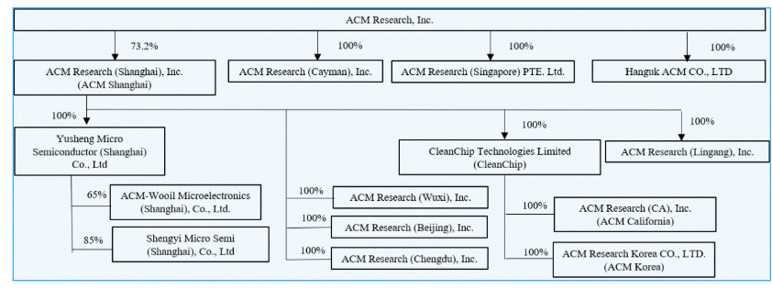
A detailed description of how cash is transferred through our organization is set forth under “Note 2 – Summary of Significant Accounting Policies – Cash and Cash Equivalents” to the Condensed Consolidated Financial Statements of this report.

The U.S. Holding Foreign Companies Accountable Act, or the HFCA Act, requires that the Public Company Accounting Oversight Board, or the PCAOB, determine whether it is unable to inspect or investigate completely registered public accounting firms located in a non-U.S. jurisdiction because of a position taken by one or more authorities in any non-U.S. jurisdiction. Under current regulations, if ACM Research were to be included on the SEC's "Conclusive list of issuers identified under the HFCA Act" for two consecutive years due to our independent auditor being located in a jurisdiction that does not allow for PCAOB inspections, the SEC would prohibit trading in our securities and this ultimately could cause our securities to be delisted in the U.S., and their value may significantly decline or become worthless. See “Item 1A. Risk Factors—Risks Related to International Aspects of Our Business—We could be adversely affected if we are unable to comply with legislation and regulations regarding improved access to audit and other information and audit inspections of accounting firms, including registered public accounting firms, such as our prior and current audit firms, operating in mainland China” in our 2025 Annual Report for more information.

Effective on December 2, 2024, the U.S. Department of Commerce’s Bureau of Industry and Security (“BIS”) promulgated a final rule naming a number of companies to the BIS Entity List (the "BIS Entity List"). Among the 140 companies added to the BIS Entity List were two subsidiaries of ACM Research, ACM Shanghai, located in the People’s Republic of China, and ACM Korea, a direct subsidiary of ACM Shanghai, which is located in the Republic of Korea, and other related entities. In general terms, the new BIS Entity List designations prohibit any party worldwide from furnishing hardware, software, or technologies that are subject to U.S. export controls jurisdiction, directly or indirectly to ACM Shanghai or ACM Korea without obtaining authorization. See “Item 1A. Risk Factors—Regulatory Risks—Our operations in mainland China and Korea, including the import of components, technology, and activities of U.S. personnel therein, may be further impacted by the addition of ACM Shanghai, ACM Korea and related entities to the BIS Entity List” in our 2025 Annual Report for more information.

On November 15, 2024, the U.S. Department of the Treasury published a final rule implementing a framework for the regulation of outbound foreign investment from the United States. The new program, known as the Outbound Investment Security Program (“OISP”) was codified in the United States Code of Federal Regulations at 31 C.F.R. Part 850, effective as of January 2, 2025. The OISP was amended by the Comprehensive Outbound Investment National Security Act (“COINS Act”) which was signed into law on December 18, 2025, although the provisions of the COINS Act will not come into effect until the Department of the Treasury issues implementing regulations, which by law must occur by March 2027. The OISP marks a shift in U.S. economic policy, as historically the United States government declined to restrict outbound investment from the United States for national security reasons. Going forward, the investment activities of multinational companies, including ACM Research are subject to both CFIUS and OISP requirements, which together will limit cross-border investment opportunities, especially as they relate to China. The OISP regulations in effect today could
28
Table of Contents
be interpreted to restrict certain types of private investment in ACM Research in the United States, although these measures do not impact investment in ACM Research’s publicly traded securities. The COINS Act reverses the possible application of the OISP to certain U.S. companies, including ACM Research, and therefore it appears ACM Research will not be subject to the OISP’s private investment restrictions once the provisions of the COINS Act enter into force in 2026 or 2027. See “Item 1A. Risk Factors—Regulatory Risks—The U.S. Government has implemented an outbound investment review mechanism, which may prevent us from taking advantage of investment opportunities hat could otherwise be advantageous to our stockholders” in our 2025 Annual Report for more information.

In addition to the matters discussed above, we are also subject to a number of legal and operational risks associated with our corporate structure, including, as the result of a substantial portion of our operations being conducted in mainland China. Consequences of any of those risks could result in a material adverse change in our operations or cause the value of ACM Research Class A common stock to significantly decline in value or become worthless. Please carefully read the information included in “Item 1A. Risk Factors” in our 2025 Annual Report, in particular, the risk factors addressing the following issues:

• If any mainland China central government authority were to determine that existing mainland China laws or regulations require that ACM Shanghai obtain the authority’s permission or approval to continue the listing of ACM Research’s Class A common stock in the United States or if those existing mainland China laws and regulations, or interpretations thereof, were to change to require such permission or approval, or if we inadvertently conclude that such permissions or approvals are not required, ACM Shanghai may be unable to obtain the required permission or approval or may only be able to obtain such permission or approval on terms and conditions that impose material new restrictions and limitations on operation of ACM Shanghai, either of which could have a material adverse effect on our business, financial condition, results of operations, reputation and prospects and on the trading price of ACM Research Class A common stock, which could decline in value or become worthless.
•Mainland China central government authorities may intervene in, or influence, ACM Shanghai’s mainland China-based operations at any time, and those authorities’ rules and regulations in mainland China can change quickly with little or no advance notice.
•The mainland China central government may determine to exert additional control over offerings conducted overseas or foreign investment in mainland China-based issuers, which could result in a material change in operations of ACM Shanghai and cause significant declines in the value of ACM Research Class A common stock, or make them worthless.

Recent statements and regulatory actions by mainland China central government authorities with respect to the use of VIEs and to data security and anti-monopoly concerns have not affected our ability to conduct our business operations in China. For further information, see “Item 1A. Risk Factors —Risks Related to International Aspects of Our Business” of our 2025 Annual Report for more information.

Overview

We supply advanced, innovative capital equipment developed for the global semiconductor industry. Fabricators of advanced integrated circuits, or chips, can use our wet-cleaning and other front-end processing tools in numerous steps to improve product yield, even at increasingly advanced process nodes. We have designed these tools for use in fabricating foundry, logic and memory chips, including dynamic random-access memory, or DRAM, and 3D NAND-flash memory chips. We also develop, manufacture and sell a range of advanced packaging tools to wafer assembly and packaging customers.

Since 2009 we have delivered more than 1,590 tools to our customers, more than 1,430 of which were repeat orders or acceptances upon contractual performance obligations that have been met and thereby generated revenue to us. The balance of the delivered tools is subject to the customer's acceptance of the tool upon the tool's satisfaction of applicable contractual requirements or subject to the customer's subsequent discretionary commitment to purchase the tool. To date, substantially all of our sales of equipment for semiconductor-manufacturing have been to customers located in Asia, and we anticipate that a substantial majority of our revenue from these products will continue to come from customers located in this region for the foreseeable future. We have begun to add to our efforts to further address customers in North America, Western Europe and Southeast Asia, by expanding our direct sales teams and increasing our global marketing activities.

We estimate, based on third-party reports, customer feedback and other information, that our current product portfolio addresses approximately $22 billion of the 2025 global wafer fab equipment, or WFE, market. By product line, we estimate an approximately $7.4 billion market opportunity is addressed by our wafer cleaning equipment, $6.2 billion by our
29
Table of Contents
Plasma-Enhanced Chemical Vapor Deposition, or PECVD, equipment, $3.5 billion by our Track equipment, $1.7 billion by our furnace equipment, $1.8 billion by our electro-chemical plating, or ECP, equipment, and $1.5 billion by our stress-free polishing, advanced packaging, wafer processing, and other processing equipment.
Frost & Sullivan estimates the total worldwide semiconductor equipment market grew by 16.3% from $122.2 billion in 2024 to $142.1 billion in 2025, and is expected to increase by 7.3% to $152.5 billion in 2026. Frost & Sullivan estimates the China semiconductor equipment market increased by 11.8%, from $46.8 billion in 2024 to $52.3 billion in 2025, and is expected to increase by 10.1% to $57.6 billion in 20261.

Recent Developments
ACM Registered Direct Offering

On May 12, 2026, we entered into a Securities Purchase Agreement (the “Securities Purchase Agreement”) with certain U.S. institutional investors named therein managed by Tekne Capital Management, LLC (the “Investors”). Pursuant to the Securities Purchase Agreement, we agreed to issue and sell to the Investors in a registered direct offering (the “Direct Offering”) an aggregate of 2,884,615 shares (the “Direct Offering Shares”) of our Class A common stock at an offering price of $52.00 per Direct Offering Share pursuant to an effective shelf registration statement on Form S-3 (File No. 333-278041) and a related prospectus supplement filed with the SEC on May 12, 2026. The transaction closed on May 15, 2026 and generated proceeds of approximately $148.4 million, net of issuance costs.
ACM Shanghai Proposed IPO listing on The Stock Exchange of Hong Kong Limited
On May 26, 2026, ACM Shanghai issued an announcement (the “Announcement”) to the SSE regarding the Resolutions of the Fifth Meeting of the Third Board of Directors. At the meeting, the board of directors of ACM Shanghai approved, among other matters, the proposal on the offering of H shares and listing on the Main Board of The Stock Exchange of Hong Kong Limited (the “H Share Listing”) and, on an item-by-item basis, the proposal on the plan for the H Share Listing. These proposals have been approved by ACM Shanghai’s board of directors and remain subject to approval by its shareholders. Pursuant to the approved plan, ACM Shanghai proposes to issue H shares representing no more than 7% of its total issued share capital upon completion of the proposed offering (prior to the exercise of any over-allotment option), and may grant the overall coordinators an over-allotment option to purchase up to 15% of the number of H shares initially offered. The H shares to be issued will be ordinary shares of H share class, with a par value of RMB 1.00 per share, to be listed and traded on the Main Board of The Stock Exchange of Hong Kong Limited. Net proceeds from the proposed H Share Listing, after deduction of offering expenses, are intended to be used for purposes including, but not limited to, further product development and enhancement of independent research and development capabilities, improvement of global market expansion and service capabilities, replenishment of general working capital and repayment of bank loans. The proposed H Share Listing remains subject to market conditions and the obtaining of necessary filings, approvals and/or other regulatory clearances, including those from the China Securities Regulatory Commission, The Stock Exchange of Hong Kong Limited and the Securities and Futures Commission of Hong Kong.
ACM Shanghai Facility Purchase
On June 5, 2026, we purchased a facility consisting of 3,196-square-meters of general-purpose office space located in Shanghai’s Pudong New Area for RMB 312.7 million ($45.9 million). To partially finance the purchase, we entered into a loan agreement with the Bank of China in the loan amount of RMB 231.5 million ($34.0 million) at a 2.65% interest rate, with a repayment term of 120 months. The facility was subsequently pledged as security for loan from the Bank of China in July 2026.

Mainland China Government Research and Development Funding
Since 2008, ACM Shanghai has received various government grants for the development and commercialization of certain technologies, and the development of the R&D and production center in the Lingang Special Area of Shanghai.

1The information contains statistical data and estimates, including forecasts, that are based on information provided by Frost & Sullivan, "Global and China Semiconductor Equipment Market Research, June 2026."
30
Table of Contents
The governmental grants contain certain operating conditions, and we are required to complete a government due diligence process once the project is complete. The grants therefore are recorded as long-term liabilities upon receipt, although we are not required to return any funds received by ACM Shanghai.

Grant amounts are recognized in our condensed consolidated statements of comprehensive income as follows:
•Government subsidies relating to current expenses are recorded as reductions of those expenses in the periods in which the current expenses are recorded. Such subsidies included in our condensed consolidated statements of comprehensive income were both $0.5 million, in each of the three months ended June 30, 2026 and 2025, respectively, and $1.1 million and $0.8 million in the six months ended June 30, 2026 and 2025, respectively.
•Government subsidies related to depreciable assets are credited to income over the useful lives of the related assets for which the grant was received. Government subsidies related to VAT reduction are credited to income in the period received. Such subsidies included in our condensed consolidated statements of comprehensive income were $1.2 million and $0.4 million, in the three months ended June 30, 2026 and 2025, respectively, and $1.4 million and $0.7 million in the six months ended June 30, 2026 and 2025, respectively.

Recent Accounting Pronouncements

A discussion of recent accounting pronouncements is included in our 2025 Annual Report and is updated in Note 2 to the condensed consolidated financial statements included in this report.

Net Income Attributable to Non-Controlling Interests

Net income attributable to non-controlling interests is attributable to the minority holders of shares of ACM Shanghai stock. As a result, we reflect the portion of our net income allocable to the minority holders of ACM Shanghai shares as net income attributable to non-controlling interests. As of June 30, 2026, ACM Research held 73.2% of ACM Shanghai’s outstanding shares.

Critical Accounting Policies and Estimates

In preparing our condensed consolidated financial statements in conformity with GAAP, we make assumptions, judgments and estimates in applying our accounting policies that can have a significant impact on our revenue, operating income and net income, as well as on the value of certain assets and liabilities on our condensed consolidated balance sheets. We base our assumptions, judgments and estimates on historical experience and various other factors that we believe to be reasonable under the circumstances. At least quarterly, we evaluate our assumptions, judgments and estimates and make changes as deemed necessary. Actual results could differ materially from these estimates under different assumptions or conditions.

We believe that the assumptions, judgments and estimates involved in the accounting for the following accounting policies have the greatest potential impact on our condensed consolidated financial statements, and we therefore consider these to be our critical accounting estimates. For information on our significant accounting policies, see Note 2 in the notes to condensed consolidated financial statements in Part I, Item 1 of this report and in the Notes to Condensed Consolidated Financial Statements in Part II, Item 8 of our 2025 Annual Report, describe the significant accounting policies and methods used in the preparation of the Company’s condensed consolidated financial statements. There have been no material changes to the Company’s critical accounting estimates included in our 2025 Annual Report.

31
Table of Contents
Results of Operations
The following table sets forth our results of operations for the periods presented, as percentages of revenue:
 |  |  | Three Months Ended June 30, |  |  |  |  |  |  |  |  |  |  |  | Six Months Ended June 30,
 |  |  | 2026 |  |  |  |  |  | 2025 |  |  |  |  |  | 2026 |  |  |  |  |  | 2025
Revenue |  |  | 100.0 |  | % |  |  |  | 100.0 |  | % |  |  |  | 100.0 |  | % |  |  |  | 100.0 |  | %
Cost of revenue |  |  | 54.0 |  |  |  |  |  | 51.5 |  |  |  |  |  | 53.9 |  |  |  |  |  | 51.8
Gross margin |  |  | 46.0 |  |  |  |  |  | 48.5 |  |  |  |  |  | 46.1 |  |  |  |  |  | 48.2
Operating expenses:
Sales and marketing |  |  | 8.1 |  |  |  |  |  | 10.3 |  |  |  |  |  | 8.5 |  |  |  |  |  | 9.9
Research and development |  |  | 14.4 |  |  |  |  |  | 15.7 |  |  |  |  |  | 15.0 |  |  |  |  |  | 15.8
General and administrative |  |  | 6.4 |  |  |  |  |  | 7.8 |  |  |  |  |  | 6.2 |  |  |  |  |  | 7.7
Total operating expenses |  |  | 28.9 |  |  |  |  |  | 33.8 |  |  |  |  |  | 29.7 |  |  |  |  |  | 33.4
Income from operations |  |  | 17.1 |  |  |  |  |  | 14.7 |  |  |  |  |  | 16.4 |  |  |  |  |  | 14.8
Interest income, net |  |  | 1.7 |  |  |  |  |  | 1.1 |  |  |  |  |  | 1.5 |  |  |  |  |  | 1.0
Unrealized gain on short-term investments |  |  | 23.8 |  |  |  |  |  | 1.3 |  |  |  |  |  | 13.0 |  |  |  |  |  | 0.4
Other expense, net |  |  | (3.3) |  |  |  |  |  | (0.2) |  |  |  |  |  | (3.6) |  |  |  |  |  | (0.2)
Income from equity method investments |  |  | 7.2 |  |  |  |  |  | 0.8 |  |  |  |  |  | 4.4 |  |  |  |  |  | 0.7
Income before income taxes |  |  | 46.5 |  |  |  |  |  | 17.7 |  |  |  |  |  | 31.7 |  |  |  |  |  | 16.7
Income tax expense |  |  | (4.6) |  |  |  |  |  | (0.9) |  |  |  |  |  | (3.3) |  |  |  |  |  | (1.0)
Net income |  |  | 41.9 |  |  |  |  |  | 16.8 |  |  |  |  |  | 28.4 |  |  |  |  |  | 15.7
Less: Net income attributable to non-controlling interests |  |  | 11.4 |  |  |  |  |  | 3.0 |  |  |  |  |  | 8.0 |  |  |  |  |  | 2.9
Net income attributable to ACM Research, Inc. |  |  | 30.5 |  | % |  |  |  | 13.8 |  | % |  |  |  | 20.4 |  | % |  |  |  | 12.8 |  | %
Comparison of Three Months Ended June 30, 2026 and 2025
Revenue
 |  |  | Three Months Ended June 30,
 |  |  | 2026 |  |  |  |  |  | 2025 |  |  |  |  |  | % Change  2026 v 2025 |  |  |  |  |  | Absolute Change  2026 v 2025
 |  |  | (Dollars in thousands)
Single wafer cleaning, Tahoe and semi-critical cleaning equipment |  |  | $ | 132,978 |  |  |  |  | $ | 154,961 |  |  |  |  | (14.2) |  | % |  |  |  | $ | (21,983)
ECP (front-end and packaging), furnace and other technologies |  |  | 128,546 |  |  |  |  |  | 48,016 |  |  |  |  |  | 167.7 |  | % |  |  |  | 80,530
Advanced packaging (excluding ECP), services & spares |  |  | 31,395 |  |  |  |  |  | 12,395 |  |  |  |  |  | 153.3 |  | % |  |  |  | 19,000
Total Revenue by Product Category |  |  | $ | 292,919 |  |  |  |  | $ | 215,372 |  |  |  |  | 36.0 |  | % |  |  |  | $ | 77,547

The increase in revenue for three months ended June 30, 2026 as compared to the same period in 2025 reflects higher sales of ECP (front-end and packaging), furnace and other technologies, and Advanced packaging (excluding ECP), services and
32
Table of Contents
spares, partially offset by lower sales of single wafer cleaning, Tahoe and semi-critical cleaning equipment. We attribute the increase to a longer-term commitment by our mainland China-based customers to increase production capacity to achieve a greater share of the global semiconductor market together with the market share changes and product cycles.
Cost of Revenue and Gross Margin
 |  |  | Three Months Ended June 30,
 |  |  | 2026 |  |  |  |  |  | 2025 |  |  |  |  |  | % Change  2026 v 2025 |  |  |  |  |  | Absolute Change  2026 v 2025
 |  |  | (Dollars in thousands)
Cost of revenue |  |  | $ | 158,301 |  |  |  |  | $ | 110,911 |  |  |  |  | 42.7 |  | % |  |  |  | $ | 47,390
Gross profit |  |  | 134,618 |  |  |  |  |  | 104,461 |  |  |  |  |  | 28.9 |  | % |  |  |  | 30,157
Gross margin |  |  | 46.0 |  | % |  |  |  | 48.5 |  | % |  |  |  | (5.2) |  | % |  |  |  | (255) bps

Cost of revenue and gross profit increased due to the increased sales volume together with a decrease in gross margin. The decrease in gross margin versus the prior-year period was primarily due to revenue mix between product categories. Gross margin may vary from period to period, primarily related to the level of utilization and the timing and mix of revenue. We expect gross margin to be between 42.0% and 48.0% for the foreseeable future.
Operating Expenses
 |  |  | Three Months Ended June 30,
 |  |  | 2026 |  |  |  |  |  | 2025 |  |  |  |  |  | % Change  2026 v 2025 |  |  |  |  |  | Absolute Change  2026 v 2025
 |  |  | (Dollars in thousands)
Sales and marketing expense |  |  | $ | 23,778 |  |  |  |  | $ | 22,102 |  |  |  |  | 7.6 |  | % |  |  |  | $ | 1,676
Research and development expense |  |  | 42,254 |  |  |  |  |  | 33,817 |  |  |  |  |  | 24.9 |  | % |  |  |  | 8,437
General and administrative expense |  |  | 18,843 |  |  |  |  |  | 16,848 |  |  |  |  |  | 11.8 |  | % |  |  |  | 1,995
Total operating expenses |  |  | $ | 84,875 |  |  |  |  | $ | 72,767 |  |  |  |  | 16.6 |  | % |  |  |  | $ | 12,108

Sales and marketing expense increased due to a $1.5 million increase in commissions, professional services, and other expenses, and a $1.0 million increase in personnel costs, offset by a $0.8 million decrease in stock-based compensation. We expect that, for the foreseeable future, sales and marketing expense will increase in absolute dollars, as we continue to invest in sales and marketing by hiring additional employees and expanding marketing programs in existing or new markets. We must invest in sales and marketing processes to develop and maintain close relationships with customers. We are making dollar-based investments to support the growth of our customer base in the United States and global markets.

Research and development expense increased due to an increase of $4.7 million in personnel, and travel and entertainment costs, a net increase of $2.7 million in depreciation, outside services and other research and development costs, an increase of $2.1 million in costs of components for tools built for product development purposes, and partially offset by a $1.0 million decrease in stock-based compensation. We expect that, for the foreseeable future, research and development expense will increase in absolute dollars as we continue to invest in research and development to advance our technologies. We intend to continue to invest in research and development to support and enhance our cleaning, plating, advanced packaging, furnace, track, PECVD and future product offerings to build and maintain our technology leadership position.

General and administrative expense increased primarily reflecting a $3.3 million net increase in personnel costs, professional services costs, and other costs related to general and administrative expenses, partially offset by a $1.2 million decrease in stock-based compensation. We expect that, for the foreseeable future, general and administrative expense will
33
Table of Contents
increase in absolute dollars, as we continue to invest in general and administrative by hiring additional employees and expanding in existing or new markets.
Interest income, Interest expense, and Other expense, net
 |  |  | Three Months Ended June 30,
 |  |  | 2026 |  |  |  |  |  | 2025 |  |  |  |  |  | % Change  2026 v 2025 |  |  |  |  |  | Absolute Change  2026 v 2025
 |  |  | (Dollars in thousands)
Interest income |  |  | $ | 7,142 |  |  |  |  | $ | 4,013 |  |  |  |  | 78.0 |  | % |  |  |  | $ | 3,129
Interest expense |  |  | (2,059) |  |  |  |  |  | (1,757) |  |  |  |  |  | 17.2 |  | % |  |  |  | (302)
Other expense, net |  |  | (9,793) |  |  |  |  |  | (346) |  |  |  |  |  | 2,730 |  | % |  |  |  | (9,447)

Other expense, net primarily reflects (a) the impact of exchange rates between the RMB and U.S. dollar on our working capital which resulted in a loss of $10.9 million for the three months ended June 30, 2026, and a loss of $0.9 million in the three months ended June 30, 2025, and (b) government subsidies, as described under “—Mainland China Government Research and Development Funding” above, and other factors.
Realized and unrealized gain on short-term investments, and income from equity method investments
 |  |  | Three Months Ended June 30,
 |  |  | 2026 |  |  |  |  |  | 2025 |  |  |  |  |  | % Change  2026 v 2025 |  |  |  |  |  | Absolute Change  2026 v 2025
 |  |  | (Dollars in thousands)
Realized gain on short term investments |  |  | $ | — |  |  |  |  | $ | 54 |  |  |  |  | 100.0 |  | % |  |  |  | $ | (54)
Unrealized gain on short term investments |  |  | 69,592 |  |  |  |  |  | 2,730 |  |  |  |  |  | 2,449.2 |  | % |  |  |  | 66,862
Income from equity method investments |  |  | 21,097 |  |  |  |  |  | 1,773 |  |  |  |  |  | 1,089.9 |  | % |  |  |  | 19,324

The increase in the unrealized gain from short term investments for the three months ended June 30, 2026 is mainly due to a significant increase during the period in the market price of certain of our holdings of publicly traded stocks which are listed on the Shanghai Stock Exchange. The increase in the income from equity investments for the three months ended June 30, 2026 is mainly derived from gain on disposal of available-for-sale securities held by our equity method investee.
34
Table of Contents
Income Tax Expense
The following presents components of income tax expense for the indicated periods:
 |  |  | Three Months Ended June 30,
 |  |  | 2026 |  |  |  |  |  | 2025
 |  |  | (Dollars in thousands)
Income tax expense |  |  | $ | (13,472) |  |  |  |  | $ | (1,891)

The tax expense for the three months ended June 30, 2026 primarily resulted from tax effect of an increase in operating profit for the period.
 |  |  | Three Months Ended June 30,
 |  |  | 2026 |  |  |  |  |  | 2025 |  |  |  |  |  | % Change  2026 v 2025 |  |  |  |  |  | Absolute Change  2026 v 2025
 |  |  | (Dollars in thousands)
Net income attributable to non-controlling interests |  |  | $ | 33,266 |  |  |  |  | $ | 6,510 |  |  |  |  | 411.0 |  | % |  |  |  | $ | 26,756

ACM Research owns 73.2% of ACM Shanghai’s (note 1) outstanding shares, which is reflected in our condensed consolidated financial statements. We reflect the portion of net income allocable to the minority holders of ACM Shanghai shares as net income attributable to non-controlling interests. The significant increase was due to the overall increase in net income.
Foreign currency translation adjustment
 |  |  | Three Months Ended June 30,
 |  |  | 2026 |  |  |  |  |  | 2025 |  |  |  |  |  | % Change  2026 v 2025 |  |  |  |  |  | Absolute Change  2026 v 2025
 |  |  | (Dollars in thousands)
Foreign currency translation adjustment |  |  | $ | 30,141 |  |  |  |  | $ | 3,905 |  |  |  |  | 671.9 |  | % |  |  |  | $ | 26,236

We recorded a gain of foreign currency translation adjustment primarily due to the strengthening of RMB to U.S. dollar exchange rate fluctuations for the period on the converted value of ACM Shanghai’s RMB-denominated balances to U.S. dollar equivalents.
35
Table of Contents

Comprehensive income attributable to non-controlling interests

 |  |  | Three Months Ended June 30,
 |  |  | 2026 |  |  |  |  |  | 2025 |  |  |  |  |  | % Change  2026 v 2025 |  |  |  |  |  | Absolute Change  2026 v 2025
 |  |  | (Dollars in thousands)
Comprehensive income attributable to non-controlling interests |  |  | $ | 41,477 |  |  |  |  | $ | 7,250 |  |  |  |  | 472.1 |  | % |  |  |  | $ | 34,227

Comprehensive income attributable to non-controlling interests represents the portions of ACM Shanghai's operating results attributable to shares of ACM Shanghai stock held by unaffiliated shareholders.
Comparison of Six Months Ended June 30, 2026 and 2025
Revenue
 |  |  | Six Months Ended June 30,
 |  |  | 2026 |  |  |  |  |  | 2025 |  |  |  |  |  | % Change  2026 v 2025 |  |  |  |  |  | Absolute Change  2026 v 2025
 |  |  | (Dollars in thousands)
Single wafer cleaning, Tahoe and semi-critical cleaning equipment |  |  | $ | 255,460 |  |  |  |  | $ | 284,530 |  |  |  |  | (10.2) |  | % |  |  |  | $ | (29,070)
ECP (front-end and packaging), furnace and other technologies |  |  | 212,785 |  |  |  |  |  | 75,646 |  |  |  |  |  | 181.3 |  | % |  |  |  | 137,139
Advanced packaging (excluding ECP), services & spares |  |  | 55,937 |  |  |  |  |  | 27,543 |  |  |  |  |  | 103.1 |  | % |  |  |  | 28,394
Total Revenue by Product Category |  |  | $ | 524,182 |  |  |  |  | $ | 387,719 |  |  |  |  | 35.2 |  | % |  |  |  | $ | 136,463
The increase in revenue reflects higher sales of ECP (front-end and packaging), furnace and other technologies and Advanced packaging (excluding ECP), services and spares, offset by the lower sales of single wafer cleaning, Tahoe and semi-critical cleaning equipment. We attribute the increase to a longer-term commitment by our mainland China-based customers to increase production capacity to achieve a greater share of the global semiconductor market together with the market share changes and product cycles.
Cost of Revenue and Gross Margin
 |  |  | Six Months Ended June 30,
 |  |  | 2026 |  |  |  |  |  | 2025 |  |  |  |  |  | % Change  2026 v 2025 |  |  |  |  |  | Absolute Change  2026 v 2025
 |  |  | (Dollars in thousands)
Cost of revenue |  |  | $ | 282,326 |  |  |  |  | $ | 200,708 |  |  |  |  | 40.7 |  | % |  |  |  | $ | 81,618
Gross profit |  |  | 241,856 |  |  |  |  |  | 187,011 |  |  |  |  |  | 29.3 |  | % |  |  |  | 54,845
Gross margin |  |  | 46.1 |  | % |  |  |  | 48.2 |  | % |  |  |  | (4.4) |  | % |  |  |  | (210 bps)
Cost of revenue and gross profit increased due to the increased sales volume, partly offset by a decrease in gross margin. The decrease in gross margin versus the prior-year period was primarily due to revenue mix between product categories, and a higher provision for inventory.
Operating Expenses
36
Table of Contents
 |  |  | Six Months Ended June 30,
 |  |  | 2026 |  |  |  |  |  | 2025 |  |  |  |  |  | % Change  2026 v 2025 |  |  |  |  |  | Absolute Change  2026 v 2025
 |  |  | (Dollars in thousands)
Sales and marketing expense |  |  | $ | 44,466 |  |  |  |  | $ | 38,445 |  |  |  |  | 15.7 |  | % |  |  |  | $ | 6,021
Research and development expense |  |  | 78,803 |  |  |  |  |  | 61,320 |  |  |  |  |  | 28.5 |  | % |  |  |  | 17,483
General and administrative expense |  |  | 32,667 |  |  |  |  |  | 29,775 |  |  |  |  |  | 9.7 |  | % |  |  |  | 2,892
Total operating expenses |  |  | $ | 155,936 |  |  |  |  | $ | 129,540 |  |  |  |  | 20.4 |  | % |  |  |  | $ | 26,396

Sales and marketing expense increased due to a $3.0 million increase in personnel costs, a $2.0 million increase in commissions and travel and entertainment, a $1.3 million increase in promotional tools, a $1.2 million net increase in professional services, outside services and other sales and marketing related expenses, offset by a $1.4 million decrease in stock-based compensation.
Research and development expense increased due to a $7.4 million increase in personnel costs, a $6.7 million increase in costs of components for tools built for product development purposes, a net increase of $5.4 million in outside services and other R&D-related costs, offset by a $2.0 million decrease in stock-based compensation.
General and administrative expense increased primarily reflecting a $2.0 million increase in allowance for credit losses, a $2.6 million increase in outside services and others, a $1.9 million increase in personnel and professional services costs, offset by a $3.6 million decrease in stock-based compensation.
Interest income, Interest expense and Other expense, net
 |  |  | Six Months Ended June 30,
 |  |  | 2026 |  |  |  |  |  | 2025 |  |  |  |  |  | % Change  2026 v 2025 |  |  |  |  |  | Absolute Change  2026 v 2025
 |  |  | (Dollars in thousands)
Interest income |  |  | $ | 11,861 |  |  |  |  | $ | 7,352 |  |  |  |  | 61.3 |  | % |  |  |  | $ | 4,509
Interest expense |  |  | (3,992) |  |  |  |  |  | (3,315) |  |  |  |  |  | 20.4 |  | % |  |  |  | (677)
Other expense, net |  |  | (19,093) |  |  |  |  |  | (608) |  |  |  |  |  | 3,040.3 |  | % |  |  |  | (18,485)
Other expense, net primarily reflects (a) loss recognized from the impact of exchange rates on our working-capital which was $20.4 million for the six months ended June 30, 2026 compared to $1.5 million for the six months ended June 30, 2025, and (b) government subsidies, as described under “Mainland China Government Research and Development Funding” above, and other factors.
Realized and unrealized gain on short-term investments, and income from equity method investments
 |  |  | Six Months Ended June 30,
 |  |  | 2026 |  |  |  |  |  | 2025 |  |  |  |  |  | % Change  2026 v 2025 |  |  |  |  |  | Absolute Change  2026 v 2025
 |  |  | (Dollars in thousands)
Realized gain from sale of short-term investments |  |  | $ | — |  |  |  |  | $ | 54 |  |  |  |  | (100.0) |  | % |  |  |  | $ | (54)
Unrealized gain on short-term investments |  |  | 68,186 |  |  |  |  |  | 1,648 |  |  |  |  |  | 4,037.5 |  | % |  |  |  | 66,538
Income from equity method investments |  |  | 22,846 |  |  |  |  |  | 2,725 |  |  |  |  |  | 738.4 |  | % |  |  |  | 20,121

37
Table of Contents
Realized gain on short-term investments includes dividends and net gains from sales of short-term investments during the period. The increase in unrealized gain on short-term investments is mainly due to a significant increase during the period in the market price of certain of our holdings of publicly traded stocks which are listed on the Shanghai Stock Exchange. The increase in the income from equity investments for the six months ended June 30, 2026 is mainly derived from gain on disposal of available-for-sale securities held by our equity method investee.
Income Tax Expense
The following presents components of income tax expense for the indicated periods:
 |  |  | Six Months Ended June 30,
 |  |  | 2026 |  |  |  |  |  | 2025
 |  |  | (in thousands)
Income tax expense |  |  | $ | (17,243) |  |  |  |  | $ | (4,044)

The tax expense for the six months ended June 30, 2026 primarily resulted from the tax effect of an increase in operating profit for the period and increase in certain discrete items.
Net Income Attributable to Non-Controlling Interests
 |  |  | Six Months Ended June 30,
 |  |  | 2026 |  |  |  |  |  | 2025 |  |  |  |  |  | % Change  2026 v 2025 |  |  |  |  |  | Absolute Change  2026 v 2025
 |  |  | (Dollars in thousands)
Net income attributable to non-controlling interests |  |  | $ | 42,194 |  |  |  |  | $ | 11,143 |  |  |  |  | 278.7 |  | % |  |  |  | $ | 31,051
ACM Research owns 73.2% of ACM Shanghai’s (note 1) outstanding shares, which is reflected in our condensed consolidated financial statements. We reflect the portion of net income allocable to the minority holders of ACM Shanghai shares as net income attributable to non-controlling interests. The significant increase was due to the overall increase in net income.
Foreign currency translation adjustment
 |  |  | Six Months Ended June 30,
 |  |  | 2026 |  |  |  |  |  | 2025 |  |  |  |  |  | % Change  2026 v 2025 |  |  |  |  |  | Absolute Change  2026 v 2025
 |  |  | (Dollars in thousands)
Foreign currency translation adjustment |  |  | $ | 57,938 |  |  |  |  | $ | 5,655 |  |  |  |  | 924.5 |  | % |  |  |  | $ | 52,283
The foreign currency translation adjustment is primarily based on the net effect of RMB to dollar exchange rate fluctuations for the period on the converted value of ACM Shanghai’s RMB-denominated balances to U.S. dollar equivalents.
38
Table of Contents

Comprehensive income attributable to non-controlling interests

 |  |  | Six Months Ended June 30,
 |  |  | 2026 |  |  |  |  |  | 2025 |  |  |  |  |  | % Change  2026 v 2025 |  |  |  |  |  | Absolute Change  2026 v 2025
 |  |  | (Dollars in thousands)
Comprehensive income attributable to non-controlling interests |  |  | $ | 57,644 |  |  |  |  | $ | 12,207 |  |  |  |  | 372.2 |  | % |  |  |  | $ | 45,437

Liquidity and Capital Resources

A detailed description of how cash is transferred through our organization is set forth under “note 2 – Summary of Significant Accounting Policies – Cash and Cash Equivalents” to the Consolidated Financial Statements of this report.

During the first six months of 2026, we funded our technology development and operations principally through our beginning global cash balances, including the cash balances at ACM Shanghai, borrowings by ACM Shanghai from local financial institutions, proceeds from issuance of ACMR shares, and proceeds from the sales of our shares and shares of our subsidiary. The $223.1 million increase in cash and time deposits was primarily driven by $332.6 million in net cash provided by financing activities, and a $18.9 million increase from the effect of exchange rate on cash, cash equivalents, restricted cash and non-cash items, offset by $35.9 million of cash used in operations, and $92.5 million of net cash used in investing activities, excluding the change in net cash related to time deposits.

 |  |  | June 30,  2026 |  |  |  |  |  | December 31,  2025
 |  |  | (In thousands)
Cash and cash equivalents, restricted cash, and time deposits:
Cash and cash equivalents and restricted cash |  |  | $ | 990,587 |  |  |  |  | $ | 765,962
Short-term time deposits |  |  | 365,055 |  |  |  |  |  | 366,591
Total |  |  | $ | 1,355,642 |  |  |  |  | $ | 1,132,553

Our future working capital needs beyond the next twelve months will depend on many factors, including the rate of our business and revenue growth, the payment schedules of our customers, the timing and magnitude of our capital expenditures, and the timing of investment in our research and development as well as sales and marketing. We believe our existing cash and cash equivalents, and short-term time deposits, our cash flow from operating activities, and bank borrowings by us and ACM Shanghai will be sufficient to meet our anticipated cash needs within our longer term planning horizon.

ACM Shanghai has historically participated in certain mainland China government-sponsored grant and subsidy programs, as described under “—Mainland China Government Research and Development Funding” and “—Contractual Obligations” and we expect that ACM Shanghai will continue to take advantage of these programs when they are available and fit with our business strategy. ACM Shanghai generally applies for these grants and subsidies through the applicable mainland China government agency’s defined processes. Periodically, the public relations department researches the availability of these grants and subsidies through mainland China government agencies with whom ACM Shanghai files business surveys and taxes. Management of ACM Shanghai then assesses which grants and subsidies for which ACM Shanghai may be eligible and submits the relevant application. The decision to award the grant to ACM Shanghai is made by the relevant mainland China government agencies based on suitability and the merits of the application. Neither ACM Research, nor ACM Shanghai or any of our other subsidiaries, has any direct relationship with any mainland China government agency, and our anticipated cash needs for the next twelve months neither anticipate, nor require, receipt of any mainland China government grants or subsidies.

39
Table of Contents
To the extent our cash and cash equivalents, cash flow from operating activities and short-term and long-term bank borrowings are insufficient to fund our future activities in accordance with our strategic plan, we may determine to raise additional funds through public or private debt or equity financings or additional bank credit arrangements. We also may need to raise additional funds in the event we determine in the future to effect one or more acquisitions of businesses, technologies and products. If additional funding is necessary or desirable, we may not be able to obtain bank credit arrangements or to obtain an equity or debt financing on terms acceptable to us or at all.

Restrictions under mainland China laws and regulations as well as restrictions under ACM Shanghai’s bank loan agreements, may significantly restrict ACM Shanghai’s ability to transfer a portion of ACM Shanghai’s net assets to ACM Research, other subsidiaries of ACM Research and to holders of ACM Research Class A common stock. See “Item 1A. Risk Factors – Regulatory Risks – Mainland China's currency exchange control and government restrictions on investment repatriation may impact our ability to transfer funds outside of mainland China, which could materially and adversely affect our ability to grow, make investments or acquisitions that could benefit our business, otherwise fund and conduct our business, or pay dividends on our common stock” in our 2025 Annual Report.

For the six months ended June 30, 2026 and 2025, with the exception of sales and services-related transfer-pricing payments in the ordinary course of business, no transfers or distributions have been made between ACM Research, and its subsidiaries, including ACM Shanghai, or to holders of ACM Research Class A common stock.

Our cash and cash equivalents at June 30, 2026 were held for working capital purposes and other potential investments. ACM Shanghai, our only direct mainland China subsidiary, is, however, subject to mainland China restrictions on distributions to equity holders.

The use of proceeds raised by the sales of shares by ACM Shanghai, and the STAR Market IPO, without further approvals, are limited to specific usage. We currently intend for ACM Shanghai, with the exception of dividends paid to shareholders of ACM Shanghai, to retain all available funds from any future earnings for use in the operation of its business. Our accounts receivable balance fluctuates from period to period, which affects our cash flow from operating activities. Fluctuations vary depending on cash collections, client mix, and the timing of shipment and acceptance of our tools.

ACM Research has never declared or paid cash dividends on our capital stock. ACM Research intends to retain all available funds and any future earnings to support the operation of and to finance the growth and development of our business and does not anticipate paying any cash dividends in the foreseeable future.
Cash Flow Used in Operating Activities. Net cash used in operating activities during the six months ended June 30, 2026 and 2025 consisted of:
 |  |  | Six Months Ended June 30,
 |  |  | 2026 |  |  |  |  |  | 2025
 |  |  | (In thousands)
Net income |  |  | $ | 148,485 |  |  |  |  | $ | 61,283
Non-cash operating lease cost |  |  | 2,384 |  |  |  |  |  | 2,081
Provision for inventory |  |  | 12,019 |  |  |  |  |  | 5,625
Provision for credit losses |  |  | 3,710 |  |  |  |  |  | 1,435
Depreciation and amortization |  |  | 11,766 |  |  |  |  |  | 6,356
Income from equity method investments |  |  | (22,846) |  |  |  |  |  | (2,725)
Unrealized gain on short-term investments |  |  | (68,186) |  |  |  |  |  | (1,648)
Deferred income taxes |  |  | 4,186 |  |  |  |  |  | (7,451)
Stock-based compensation |  |  | 12,204 |  |  |  |  |  | 19,587
Dividends from unconsolidated affiliates |  |  | 2,821 |  |  |  |  |  | —
Others |  |  | — |  |  |  |  |  | 1,086
Net changes in operating assets and liabilities |  |  | (142,439) |  |  |  |  |  | (125,248)
Net cash used in operating activities |  |  | $ | (35,896) |  |  |  |  | $ | (39,619)

40
Table of Contents
Significant changes in operating asset and liability accounts during the six months ended June 30, 2026 included the following uses of cash: an increase in inventories of $69.9 million (note 5), a decrease in customer advances of $25.9 million (note 3), a decrease in income tax payable impacting income tax expense of $19.8 million, an increase in prepaid expenses and other current assets of $14.3 million, a $10.7 million increase in accounts payable, an increase in accounts receivable of $4.4 million (note 4), and a decrease in deferred revenue of $1.5 million. The uses of cash were partially offset by a decrease in other payables and accrued expenses of $13.6 million.
Cash Flow Used in Investing Activities. Net cash used in investing activities, excluding the change in net cash related to time deposits, for the six months ended June 30, 2026 was $92.5 million, primarily consisting of purchases of property, plant and equipment of $87.3 million and purchase of long-term investments of $4.7 million with the remaining use attributable to intangible assets.

Cash Flow Provided by Financing Activities. Net cash provided by financing activities for the six months ended June 30, 2026 was $332.6 million, primarily consisting of $43.2 million in net proceeds and repayments of short-term and long-term borrowing (note 11), $148.4 million of proceeds from issuance of ACMR shares, $110.2 million of gross proceeds from sales of ACM Shanghai's shares, and $30.8 million of proceeds from the exercise of stock options.

We and ACM Shanghai, together with the subsidiaries of ACM Shanghai, have short-term and long-term borrowings with the following banks:
41
Table of Contents
Lender |  |  |  |  |  | Agreement Date |  |  |  |  |  | Maturity Date |  |  |  |  |  | Annual  Interest Rate |  |  |  |  |  | Maximum Borrowing  Amount (1) |  |  |  |  |  | Amount Outstanding  at June 30, 2026
 |  |  |  |  |  |  |  |  |  |  |  |  |  |  |  |  |  |  |  |  |  |  |  | (in thousands)
China Everbright Bank |  |  |  |  |  | December 2024 |  |  |  |  |  | September 2027 |  |  |  |  |  | 2.60% |  |  |  |  |  | RMB600,000 |  |  |  |  |  | RMB181,567
 |  |  |  |  |  |  |  |  |  |  |  |  |  |  |  |  |  |  |  |  |  |  |  | $ | 88,080 |  |  |  |  | $ | 26,654
China Merchants Bank |  |  |  |  |  | December 2025 |  |  |  |  |  | May 2036 |  |  |  |  |  | 2.11%-2.38% |  |  |  |  |  | RMB500,000 |  |  |  |  |  | RMB500,251
 |  |  |  |  |  |  |  |  |  |  |  |  |  |  |  |  |  |  |  |  |  |  |  | $ | 73,400 |  |  |  |  | $ | 73,437
Bank of China (3) |  |  |  |  |  | September 2025 |  |  |  |  |  | May 2036 |  |  |  |  |  | 2.11%-2.62% |  |  |  |  |  | RMB831,518 |  |  |  |  |  | RMB620,903
 |  |  |  |  |  |  |  |  |  |  |  |  |  |  |  |  |  |  |  |  |  |  |  | $ | 122,067 |  |  |  |  | $ | 91,149
Shanghai Pudong Development Bank |  |  |  |  |  | January 2026 |  |  |  |  |  | January 2027 |  |  |  |  |  | 2.11% |  |  |  |  |  | RMB300,000 |  |  |  |  |  | RMB100,053
 |  |  |  |  |  |  |  |  |  |  |  |  |  |  |  |  |  |  |  |  |  |  |  | $ | 44,040 |  |  |  |  | $ | 14,688
Industrial and Commercial Bank of China |  |  |  |  |  | November 2024 |  |  |  |  |  | March 2029 |  |  |  |  |  | 2.25%-2.65% |  |  |  |  |  | RMB500,000 |  |  |  |  |  | RMB466,224
 |  |  |  |  |  |  |  |  |  |  |  |  |  |  |  |  |  |  |  |  |  |  |  | $ | 73,400 |  |  |  |  | $ | 68,440
China Merchants Bank (2) |  |  |  |  |  | November 2020 |  |  |  |  |  | Repayable by installments and the last installments repayable in November 2030 |  |  |  |  |  | 2.95% |  |  |  |  |  | RMB128,500 |  |  |  |  |  | RMB63,042
 |  |  |  |  |  |  |  |  |  |  |  |  |  |  |  |  |  |  |  |  |  |  |  | $ | 18,568 |  |  |  |  | $ | 9,255
Agricultural Bank of China |  |  |  |  |  | April 2024 |  |  |  |  |  | Repayable by installments and the last installments repayable in April 2034 |  |  |  |  |  | 2.43% |  |  |  |  |  | RMB300,000 |  |  |  |  |  | RMB290,177
 |  |  |  |  |  |  |  |  |  |  |  |  |  |  |  |  |  |  |  |  |  |  |  | $ | 44,040 |  |  |  |  | $ | 42,598
China CITIC Bank |  |  |  |  |  | September 2025 |  |  |  |  |  | September 2026 |  |  |  |  |  | 2.11% |  |  |  |  |  | RMB100,000 |  |  |  |  |  | RMB100,053
 |  |  |  |  |  |  |  |  |  |  |  |  |  |  |  |  |  |  |  |  |  |  |  | $ | 14,680 |  |  |  |  | $ | 14,688
 |  |  |  |  |  |  |  |  |  |  |  |  |  |  |  |  |  | Total US Dollars |  |  |  |  |  | $ | 478,275 |  |  |  |  | $ | 340,909
(1)Converted from RMB to dollars as of June 30, 2026.
(2)The loan from China Merchants Bank is secured by a pledge of the property of ACM Lingang and guaranteed by ACM Shanghai, as described above under “—Contractual Obligations.”
(3)In May 2026, the Company entered into a loan agreement of RMB231,518 ($33,987) at a 2.65% interest rate, which was subsequently secured by a pledge of the property of ACM Shanghai (note 6) in July 2026.
Loan Covenants
In 2025, ACM Shanghai secured a long-term loan with the Bank of China (note 9) for ACM Shanghai’s project expenditures. The loan requires ACM Shanghai’s year-end outstanding interest-bearing debt not to exceed five times of its
42
Table of Contents
annual EBITDA, and to comply with other non-financial covenants, or Bank of China has the right to suspend the loan, or request ACM Shanghai to accelerate repayment or provide credit enhancement.
Effect of exchange rate changes on cash, cash equivalents and restricted cash

The impact of fluctuations of the RMB to U.S. dollar currency exchange rate in RMB-denominated accounts (note 2) contributed to a $7.4 million increase in the value of these items during the six months ended June 30, 2026.

Contractual Obligations

Grant Contract for State-owned Construction Land Use Right in Shanghai City

In 2020, ACM Shanghai, through its wholly-owned subsidiary ACM Lingang, entered into a Grant Contract for State-owned Construction Land Use Right in Shanghai City (Category of R&D Headquarters and Industrial Projects), or the Grant Agreement, with the China (Shanghai) Pilot Free Trade Zone Lin-gang Special Area Administration, or the Grantor. ACM Lingang obtained rights to use approximately 43,000 square meters (10.6 acres) of land in the East China Silicon Hub of Lin-gang Special Area of China (Shanghai) Pilot Free Trade Zone for a period of fifty years, commencing on the date of delivery of the land in July 2020. For a description of the material terms of the Grant Agreement, see “Item 7. Management’s Discussion and Analysis of Financial Condition and Results of Operations—Contractual Obligations” in our 2025 Annual Report and see note 16 for additional detail.

How We Evaluate Our Operations
We present information below with respect to four measures of financial performance:
•We define shipments of tools to include (a) a repeat shipment to a customer of a type of tool that the customer has previously accepted, for which we recognize revenue upon shipment or delivery, and (b) a first-time shipment of a first tool to a customer on an approval basis, for which we may recognize revenue in the future if contractual conditions are met, or if a purchase order is received.
•We define “adjusted EBITDA” as net income excluding interest expense (net), income tax benefit (expense), depreciation and amortization, unrealized (gain) loss on short-term investments, and stock-based compensation. We define adjusted EBITDA to also exclude restructuring costs, although we have not incurred any such costs to date.
•We define “free cash flow” as net cash provided by operating activities less purchases of property and equipment (net of proceeds from disposals) and purchase of short-term and long-term investments.
•We define “adjusted operating income (loss)” as our income (loss) from operations excluding stock-based compensation.
These financial measures are not based on any standardized methodologies prescribed by accounting principles generally accepted in the United States, or GAAP, and are not necessarily comparable to similarly titled measures presented by other companies.
We have presented shipments, adjusted EBITDA, free cash flow and adjusted operating income (loss) because they are key measures used by our management and board of directors to understand and evaluate our operating performance, to establish budgets and to develop operational goals for managing our business. We believe that these financial measures help identify underlying trends in our business that could otherwise be masked by the effect of the expenses that we exclude. In particular, we believe that the exclusion of the expenses eliminated in calculating adjusted EBITDA and adjusted operating income (loss) can provide useful measures for period-to-period comparisons of our core operating performance and that the exclusion of property and equipment purchases from operating cash flow can provide a usual means to gauge our capability to generate cash. Accordingly, we believe that these financial measures provide useful information to investors and others in understanding and evaluating our operating results, enhancing the overall understanding of our past performance and future prospects, and allowing for greater transparency with respect to key financial metrics used by our management in its financial and operational decision-making.
Shipments, adjusted EBITDA, free cash flow and adjusted operating income (loss) are not prepared in accordance with GAAP, and should not be considered in isolation of, or as an alternative to, measures prepared in accordance with GAAP.
43
Table of Contents
Shipments
We consider shipments a key operating metric as it reflects the total value of products delivered to customers and prospective customers by our productive assets.
Shipments consist of two components:
•a shipment to a customer of a type of tool that the customer has previously accepted, for which we recognize revenue when the tool is delivered; and
•a shipment to a customer of a type of tool that the customer is receiving and evaluating for the first time, in each case a first tool, for which we may recognize revenue at a later date, subject to the customer’s acceptance of the tool upon the tool’s satisfaction of applicable contractual requirements or subject to the customer’s subsequent discretionary commitment to purchase the tool.
First tool shipments can be made to either an existing customer that has not previously accepted that specific type of tool in the past ─ for example, a delivery of a SAPS V tool to a customer that previously had received only SAPS II tools ─ or to a new customer that has never purchased any tool from us.
Shipments in the six months ended June 30, 2026 totaled $522.2 million, as compared to $363.1 million for the same period in 2025. Repeat tool shipments in the six months ended June 30, 2026 totaled $266.2 million, as compared to $167.9 million for same period in 2025. First tool shipments in the six months ended June 30, 2026 totaled $256.0 million, as compared to $195.1 million for the same period in 2025.
The dollar amount attributed to a first tool shipment is equal to the consideration we expect to receive if any and all contractual requirements are satisfied and the customer accepts the tool, or if the customer subsequently determines in its discretion to purchase the tool. There are a number of limitations related to the use of shipments in evaluating our business, including that customers have significant, or in some cases total, discretion in determining whether to accept or purchase our tools after evaluation and their decision not to accept or purchase delivered tools is likely to result in our inability to recognize revenue from the delivered tools. “First tool” shipments reflect the value of incremental new products under evaluation delivered to our customers or prospective customers for a given period and is used as an internal key metric to reflect future potential revenue opportunity. The cumulative cost of “first tool” shipments under evaluation at customers which have not been accepted by the customer is carried at cost and reflected in finished goods inventory (see Note 5 to the condensed consolidated financial statements included in this report). “First tool” shipments exclude deliveries to customers for which ACM Research does not have a basis to expect future revenue.
Adjusted EBITDA
There are a number of limitations related to the use of adjusted EBITDA rather than net income (loss), which is the nearest GAAP equivalent. Some of these limitations are:
•adjusted EBITDA excludes depreciation and amortization and, although these are non-cash expenses, the assets being depreciated or amortized may have to be replaced in the future;
•we exclude stock-based compensation expense from adjusted EBITDA and adjusted operating income (loss), although (a) it has been, and will continue to be for the foreseeable future, a significant recurring expense for our business and an important part of our compensation strategy and (b) if we did not pay out a portion of our compensation in the form of stock-based compensation, the cash salary expense included in operating expenses would be higher, which would affect our cash position;
•the expenses and other items that we exclude in our calculation of adjusted EBITDA may differ from the expenses and other items, if any, that other companies may exclude from adjusted EBITDA when they report their operating results;
•adjusted EBITDA does not reflect changes in, or cash requirements for, working capital needs;
•adjusted EBITDA does not reflect interest expense, or the requirements necessary to service interest or principal payments on debt;
•adjusted EBITDA does not reflect income tax expense (benefit) or the cash requirements to pay taxes;
•adjusted EBITDA does not reflect historical cash expenditures or future requirements for capital expenditures or contractual commitments; and
•adjusted EBITDA includes expense reductions and non-operating other income attributable to mainland China governmental grants, which may mask the effect of underlying developments in net income, including trends in
44
Table of Contents
current expenses and interest expense, and free cash flow includes mainland China governmental grants, the amount and timing of which can be difficult to predict and are outside our control.
The following table reconciles net income, the most directly comparable GAAP financial measure, to adjusted EBITDA:
 |  |  | Six Months Ended June 30,
 |  |  | 2026 |  |  |  |  |  | 2025 |  |  |  |  |  | % Change  2026 v 2025 |  |  |  |  |  | Absolute Change  2026 v 2025
 |  |  | (Dollars in thousands)
Adjusted EBITDA Data:
Net income |  |  | $ | 148,485 |  |  |  |  | $ | 61,283 |  |  |  |  | 142.3 |  | % |  |  |  | $ | 87,202
Interest income, net |  |  | (7,869) |  |  |  |  |  | (4,037) |  |  |  |  |  | 94.9 |  | % |  |  |  | (3,832)
Income tax expense |  |  | 17,243 |  |  |  |  |  | 4,044 |  |  |  |  |  | 326.4 |  | % |  |  |  | 13,199
Depreciation and amortization |  |  | 11,766 |  |  |  |  |  | 6,356 |  |  |  |  |  | 85.1 |  | % |  |  |  | 5,410
Stock based compensation |  |  | 12,204 |  |  |  |  |  | 19,587 |  |  |  |  |  | (37.7 |  | %) |  |  |  | (7,383)
Unrealized gain on short-term investments |  |  | (68,186) |  |  |  |  |  | (1,648) |  |  |  |  |  | 4,037.5 |  | % |  |  |  | (66,538)
Adjusted EBITDA |  |  | $ | 113,643 |  |  |  |  | $ | 85,585 |  |  |  |  | 32.8 |  | % |  |  |  | $ | 28,058

We do not exclude from adjusted EBITDA expense reductions and non-operating other income attributable to mainland China governmental grants because we consider and incorporate the expected amounts and timing of those grants in incurring expenses and capital expenditures. If we did not receive the grants, our cash expenses therefore would be lower, and our cash position would not be affected, to the extent we have accurately anticipated the amounts of the grants. For additional information regarding our mainland China grants, please see “—Mainland China Government Research and Development Funding.”
Free Cash Flow

The following table reconciles net cash (used in) provided by operating activities, the most directly comparable GAAP financial measure, to free cash flow:
 |  |  | Six Months Ended June 30,
 |  |  | 2026 |  |  |  |  |  | 2025 |  |  |  |  |  | % Change  2026 v 2025 |  |  |  |  |  | Absolute Change  2026 v 2025
 |  |  | (Dollars in thousands)
Free Cash Flow Data:
Net cash used in operating activities |  |  | $ | (35,896) |  |  |  |  | $ | (39,619) |  |  |  |  | (9.4 |  | %) |  |  |  | $ | 3,723
Purchase of property and equipment |  |  | (87,311) |  |  |  |  |  | (31,458) |  |  |  |  |  | 177.5 |  | % |  |  |  | (55,853)
Purchase of short-term and long-term investments |  |  | (4,698) |  |  |  |  |  | — |  |  |  |  |  | NM |  |  |  |  |  | (4,698)
Free cash flow |  |  | $ | (127,905) |  |  |  |  | $ | (71,077) |  |  |  |  | 80.0 |  | % |  |  |  | $ | (56,828)

The reduction in free cash flow for the six months ended June 30, 2026 as compared to the same period in 2025 reflected the factors driving net cash used in operating activities, an increase of purchases of property and equipment, and long-term investments. Consistent with our methodology for calculating adjusted EBITDA, we do not adjust free cash flow for the effects of mainland China government subsidies, because we take those subsidies into account in incurring expenses and capital expenditures. We do not adjust free cash flow for the effects of time-deposits, which for our internal purposes are considered as largely similar to cash.
45
Table of Contents
Adjusted Operating Income

Adjusted operating income excludes stock-based compensation from income from operations. Although stock-based compensation is an important aspect of the compensation of our employees and executives, determining the fair value of certain of the stock-based instruments we utilize involves a high degree of judgment and estimation and the expense recorded may bear little resemblance to the actual value realized upon the vesting or future exercise of the related stock-based awards. Furthermore, unlike cash compensation, the value of stock options, which is an element of our ongoing stock-based compensation expense, is determined using a complex formula that incorporates factors, such as market volatility, that are beyond our control. Management believes it is useful to exclude stock-based compensation in order to better understand the long-term performance of our core business and to facilitate comparison of our results to those of peer companies. The use of non-GAAP financial measures excluding stock-based compensation has limitations. If we did not pay out a portion of our compensation in the form of stock-based compensation, the cash salary expense included in operating expenses would be higher and our cash holdings would be less. The following tables reflect the exclusion of stock-based compensation, or SBC, from line items comprising income from operations:
 |  |  | Six Months Ended June 30,
 |  |  | 2026 |  |  |  |  |  |  |  |  |  |  |  |  |  |  |  |  |  | 2025
 |  |  | Actual  (GAAP) |  |  |  |  |  | SBC |  |  |  |  |  | Adjusted  (Non-  GAAP) |  |  |  |  |  | Actual  (GAAP) |  |  |  |  |  | SBC |  |  |  |  |  | Adjusted  (Non-GAAP)
 |  |  | (in thousands)
Revenue |  |  | $ | 524,182 |  |  |  |  | $ | - |  |  |  |  | $ | 524,182 |  |  |  |  | $ | 387,719 |  |  |  |  | $ | - |  |  |  |  | $ | 387,719
Cost of revenue |  |  | (282,326) |  |  |  |  |  | (525) |  |  |  |  |  | (281,801) |  |  |  |  |  | (200,708) |  |  |  |  |  | (885) |  |  |  |  |  | (199,823)
Gross profit |  |  | 241,856 |  |  |  |  |  | (525) |  |  |  |  |  | 242,381 |  |  |  |  |  | 187,011 |  |  |  |  |  | (885) |  |  |  |  |  | 187,896
Operating expenses:
Sales and marketing |  |  | (44,466) |  |  |  |  |  | (2,822) |  |  |  |  |  | (41,644) |  |  |  |  |  | (38,445) |  |  |  |  |  | (4,253) |  |  |  |  |  | (34,192)
Research and development |  |  | (78,803) |  |  |  |  |  | (3,374) |  |  |  |  |  | (75,429) |  |  |  |  |  | (61,320) |  |  |  |  |  | (5,355) |  |  |  |  |  | (55,965)
General and administrative |  |  | (32,667) |  |  |  |  |  | (5,483) |  |  |  |  |  | (27,184) |  |  |  |  |  | (29,775) |  |  |  |  |  | (9,094) |  |  |  |  |  | (20,681)
Income (loss) from operations |  |  | $ | 85,920 |  |  |  |  | $ | (12,204) |  |  |  |  | $ | 98,124 |  |  |  |  | $ | 57,471 |  |  |  |  | $ | (19,587) |  |  |  |  | $ | 77,058

Item 3. Quantitative and Qualitative Disclosures About Market Risks
Our market risks and the ways we manage them are summarized in the section captioned “Part II, Item 7A. Quantitative and Qualitative Disclosures About Market Risk” in our 2025 Annual Report. There have been no material changes in the first six months of 2026 to our market risks or to our management of such risks.

Item 4. Controls and Procedures

Evaluation of Disclosure Controls and Procedures

Our management, with the participation of our Chief Executive Officer and Chief Financial Officer, evaluated the effectiveness of our disclosure controls and procedures pursuant to Rule 13a-15 under the Securities Exchange Act of 1934, or the Exchange Act, as of June 30, 2026. In designing and evaluating the disclosure controls and procedures, our management recognizes that any controls and procedures, no matter how well designed and operated, can provide only reasonable assurance of achieving the desired control objectives. In addition, the design of disclosure controls and procedures must reflect the fact that there are resource constraints and that our management is required to apply its judgment in evaluating the benefits of possible controls and procedures relative to their costs.

Based on such evaluation, our Chief Executive Officer and Chief Financial Officer concluded that, as of June 30, 2026, our disclosure controls and procedures were effective to provide reasonable assurance that information we are required to disclose in reports that we file or submit under the Exchange Act is recorded, processed, summarized and reported within the time periods specified in the Securities and Exchange Commission rules and forms, and that such information is accumulated and communicated to our management, including our Chief Executive Officer and Chief Financial Officer, as appropriate, to allow timely decisions regarding required disclosure.
46
Table of Contents

Changes in Internal Control Over Financial Reporting

There were no changes in our internal control over financial reporting that occurred during the quarter ended June 30, 2026, that have materially affected, or are reasonably likely to materially affect, our internal control over financial reporting.

PART II. OTHER INFORMATION

Item 1. Legal Proceedings

From time to time, we may become involved in legal proceedings or may be subject to claims arising in the ordinary course of our business. Although the results of these proceedings and claims cannot be predicted with certainty, we currently believe that the final outcome of these ordinary course matters will not have a material adverse effect on our business, operating results, financial condition or cash flows. Regardless of the outcome, litigation can have an adverse impact on us because of defense and settlement costs, diversion of management resources and other factors.

Item 1A. Risk Factors

There were no material changes to the risk factors discussed in Item 1A. “Risk Factors” of Part I in our 2025 Annual Report. In addition to the other information set forth in this report, you should carefully consider those risk factors, which could materially affect our business, financial condition and future operating results. Those risk factors are not the only risks facing our company. Additional risks and uncertainties not currently known to us or that we currently deem to be immaterial also may have a material adverse effect on our business, financial condition and operating results.

Item 2. Unregistered Sales of Equity Securities and Use of Proceeds

None

Item 3. Defaults Upon Senior Securities

None

Item 4. Mine Safety Disclosures

None

Item 5. Other Information

On May 21, 2026, Mark McKechnie, Chief Financial Officer of ACM Research, Inc., adopted a Rule 10b5-1 trading arrangement (the “McKechnie Plan”) that is intended to satisfy the affirmative defense of Rule 10b5-1(c) of the Exchange Act. The McKechnie Plan allows for the contemporaneous exercise of options and sale of up to 105,199 shares of Class A Common Stock, at specific market prices, commencing on August 20, 2026, and continuing until (i) all such options are exercised and the underlying shares are sold, (ii) May 19, 2028, or (iii) such date that the McKechnie Plan is otherwise terminated according to its terms, whichever comes first.

On June 5, 2026, Hui Wang, Chief Executive Officer of ACM Research, Inc. adopted a Rule 10b5-1 trading arrangement (the “Wang Plan”) that is intended to satisfy the affirmative defense of Rule 10b5-1(c) of the Exchange Act. The Wang Plan allows for the contemporaneous exercise of options and sale of up to 270,000 shares of Class A Common Stock, at specific market prices, commencing on September 8, 2026, and continuing until (i) all such options are exercised and the underlying shares are sold, (ii) November 30, 2026, or (iii) such date that the Wang Plan is otherwise terminated according to its terms, whichever comes first.

On June 8, 2026, Sotheara Cheav, Senior Vice President, Manufacturing of ACM Research, Inc., adopted a Rule 10b5-1 trading arrangement (the “Cheav Plan”) that is intended to satisfy the affirmative defense of Rule 10b5-1(c) of the Exchange Act. The Cheav Plan allows for the contemporaneous exercise of options and sale of up to 13,750 shares of Class A Common Stock, at specific market prices, commencing on September 8, 2026, and continuing until (i) all such options
47
Table of Contents
are exercised and the underlying shares are sold, (ii) September 9, 2027, or (iii) such date that the Cheav Plan is otherwise terminated according to its terms, whichever comes first.

On June 15, 2026, Lisa Feng, Chief Executive Officer of ACM Shanghai, Inc. adopted a Rule 10b5-1 trading arrangement (the “Feng Plan”) that is intended to satisfy the affirmative defense of Rule 10b5-1(c) of the Exchange Act. The Feng Plan allows for the contemporaneous exercise of options and sale of up to 7,596 shares of Class A Common Stock, at specific market prices, commencing on September 14, 2026, and continuing until (i) all such options are exercised and the underlying shares are sold, (ii) September 14, 2027, or (iii) such date that the Feng Plan is otherwise terminated according to its terms, whichever comes first.

Item 6. Exhibits
The following exhibits are filed as part of this report:
Exhibit  No. |  |  |  |  |  | Description
10.01 |  |  |  |  |  | Unofficial English Translation of the Loan Agreement for the purchase of new facility in Shanghai Pudong New Area entered on May 12, 2026
10.02 |  |  |  |  |  | Unofficial English Translation of the Purchase Agreement for the purchase of new facility in Shanghai Pudong New Area entered on June 5, 2026
31.01 |  |  |  |  |  | Certification of Principal Executive Officer Pursuant to Rules 13a-14(a) and 15d-14(a) under the Securities Exchange Act of 1934, as Adopted Pursuant to Section 302 of the Sarbanes-Oxley Act of 2002
31.02 |  |  |  |  |  | Certification of Principal Financial Officer Pursuant to Rules 13a-14(a) and 15d-14(a) under the Securities Exchange Act of 1934, as Adopted Pursuant to Section 302 of the Sarbanes-Oxley Act of 2002
32.01 |  |  |  |  |  | Certification of Principal Executive Officer and Principal Financial Officer Pursuant to 18 U.S.C. Section 1350, as Adopted Pursuant to Section 906 of the Sarbanes-Oxley Act of 2002
101.INS |  |  |  |  |  | Inline XBRL Instance Document (the instance document does not appear in the Interactive Data File because its XBRL tags are embedded within the Inline XBRL document)
101.SCH |  |  |  |  |  | Inline XBRL Taxonomy Extension Schema Document
101.CAL |  |  |  |  |  | Inline XBRL Taxonomy Extension Calculation Linkbase Document
101.DEF |  |  |  |  |  | Inline XBRL Taxonomy Extension Definition Linkbase Document
101.LAB |  |  |  |  |  | Inline XBRL Taxonomy Extension Label Linkbase Document
101.PRE |  |  |  |  |  | Inline XBRL Taxonomy Extension Presentation Linkbase Document
104 |  |  |  |  |  | Cover Page Interactive Data File (formatted as inline XBRL and contained in exhibit 101)

48
Table of Contents
SIGNATURES
Pursuant to the requirements of the Securities Exchange Act of 1934, the registrant has duly caused this report to be signed on its behalf by the undersigned, thereunto duly authorized.
 |  |  | ACM RESEARCH, INC.
Date: August 7, 2026 |  |  | By: |  |  | /s/ Mark McKechnie
 |  |  |  |  |  | Mark McKechnie
Chief Financial Officer, Executive Vice President and
Treasurer
(Principal Financial Officer)
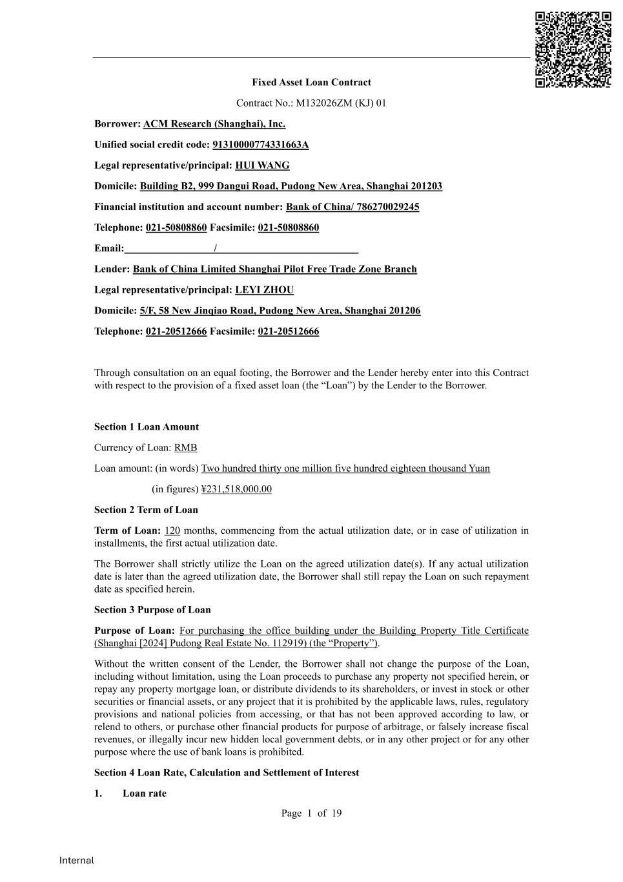
49
Page 1 of 19 Internal Fixed Asset Loan Contract Contract No.: M132026ZM (KJ) 01 Borrower: ACM Research (Shanghai), Inc. Unified social credit code: 91310000774331663A Legal representative/principal: HUI WANG Domicile: Building B2, 999 Dangui Road, Pudong New Area, Shanghai 201203 Financial institution and account number: Bank of China/ 786270029245 Telephone: 021-50808860 Facsimile: 021-50808860 Email: / Lender: Bank of China Limited Shanghai Pilot Free Trade Zone Branch Legal representative/principal: LEYI ZHOU Domicile: 5/F, 58 New Jinqiao Road, Pudong New Area, Shanghai 201206 Telephone: 021-20512666 Facsimile: 021-20512666 Through consultation on an equal footing, the Borrower and the Lender hereby enter into this Contract with respect to the provision of a fixed asset loan (the “Loan”) by the Lender to the Borrower. Section 1 Loan Amount Currency of Loan: RMB Loan amount: (in words) Two hundred thirty one million five hundred eighteen thousand Yuan (in figures) ¥231,518,000.00 Section 2 Term of Loan Term of Loan: 120 months, commencing from the actual utilization date, or in case of utilization in installments, the first actual utilization date. The Borrower shall strictly utilize the Loan on the agreed utilization date(s). If any actual utilization date is later than the agreed utilization date, the Borrower shall still repay the Loan on such repayment date as specified herein. Section 3 Purpose of Loan Purpose of Loan: For purchasing the office building under the Building Property Title Certificate (Shanghai [2024] Pudong Real Estate No. 112919) (the “Property”). Without the written consent of the Lender, the Borrower shall not change the purpose of the Loan, including without limitation, using the Loan proceeds to purchase any property not specified herein, or repay any property mortgage loan, or distribute dividends to its shareholders, or invest in stock or other securities or financial assets, or any project that it is prohibited by the applicable laws, rules, regulatory provisions and national policies from accessing, or that has not been approved according to law, or relend to others, or purchase other financial products for purpose of arbitrage, or falsely increase fiscal revenues, or illegally incur new hidden local government debts, or in any other project or for any other purpose where the use of bank loans is prohibited. Section 4 Loan Rate, Calculation and Settlement of Interest 1. Loan rate

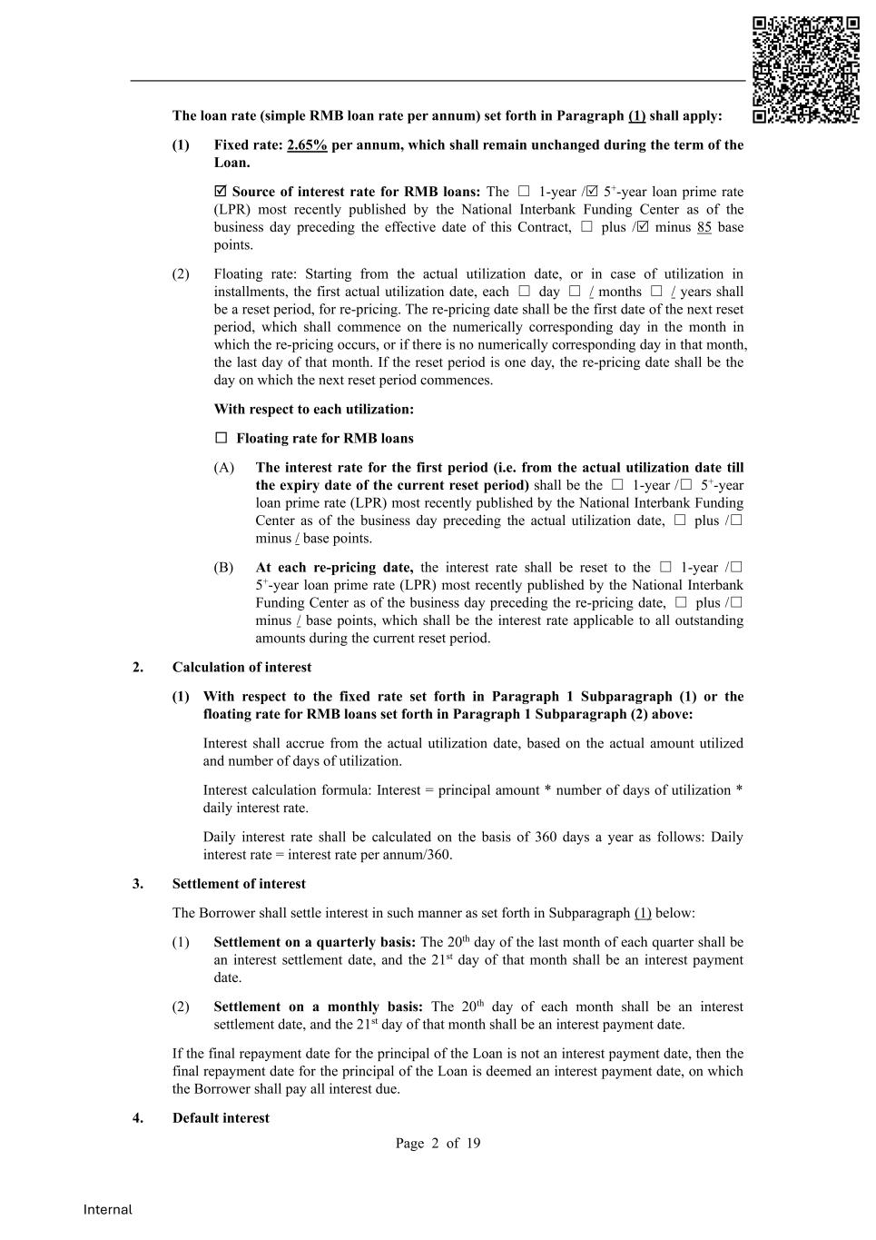
Page 2 of 19 Internal The loan rate (simple RMB loan rate per annum) set forth in Paragraph (1) shall apply: (1) Fixed rate: 2.65% per annum, which shall remain unchanged during the term of the Loan.  Source of interest rate for RMB loans: The □ 1-year / 5+-year loan prime rate (LPR) most recently published by the National Interbank Funding Center as of the business day preceding the effective date of this Contract, □ plus / minus 85 base points. (2) Floating rate: Starting from the actual utilization date, or in case of utilization in installments, the first actual utilization date, each □ day □ / months □ / years shall be a reset period, for re-pricing. The re-pricing date shall be the first date of the next reset period, which shall commence on the numerically corresponding day in the month in which the re-pricing occurs, or if there is no numerically corresponding day in that month, the last day of that month. If the reset period is one day, the re-pricing date shall be the day on which the next reset period commences. With respect to each utilization: □ Floating rate for RMB loans (A) The interest rate for the first period (i.e. from the actual utilization date till the expiry date of the current reset period) shall be the □ 1-year /□ 5+-year loan prime rate (LPR) most recently published by the National Interbank Funding Center as of the business day preceding the actual utilization date, □ plus /□ minus / base points. (B) At each re-pricing date, the interest rate shall be reset to the □ 1-year /□ 5+-year loan prime rate (LPR) most recently published by the National Interbank Funding Center as of the business day preceding the re-pricing date, □ plus /□ minus / base points, which shall be the interest rate applicable to all outstanding amounts during the current reset period. 2. Calculation of interest (1) With respect to the fixed rate set forth in Paragraph 1 Subparagraph (1) or the floating rate for RMB loans set forth in Paragraph 1 Subparagraph (2) above: Interest shall accrue from the actual utilization date, based on the actual amount utilized and number of days of utilization. Interest calculation formula: Interest = principal amount * number of days of utilization * daily interest rate. Daily interest rate shall be calculated on the basis of 360 days a year as follows: Daily interest rate = interest rate per annum/360. 3. Settlement of interest The Borrower shall settle interest in such manner as set forth in Subparagraph (1) below: (1) Settlement on a quarterly basis: The 20th day of the last month of each quarter shall be an interest settlement date, and the 21st day of that month shall be an interest payment date. (2) Settlement on a monthly basis: The 20th day of each month shall be an interest settlement date, and the 21st day of that month shall be an interest payment date. If the final repayment date for the principal of the Loan is not an interest payment date, then the final repayment date for the principal of the Loan is deemed an interest payment date, on which the Borrower shall pay all interest due. 4. Default interest

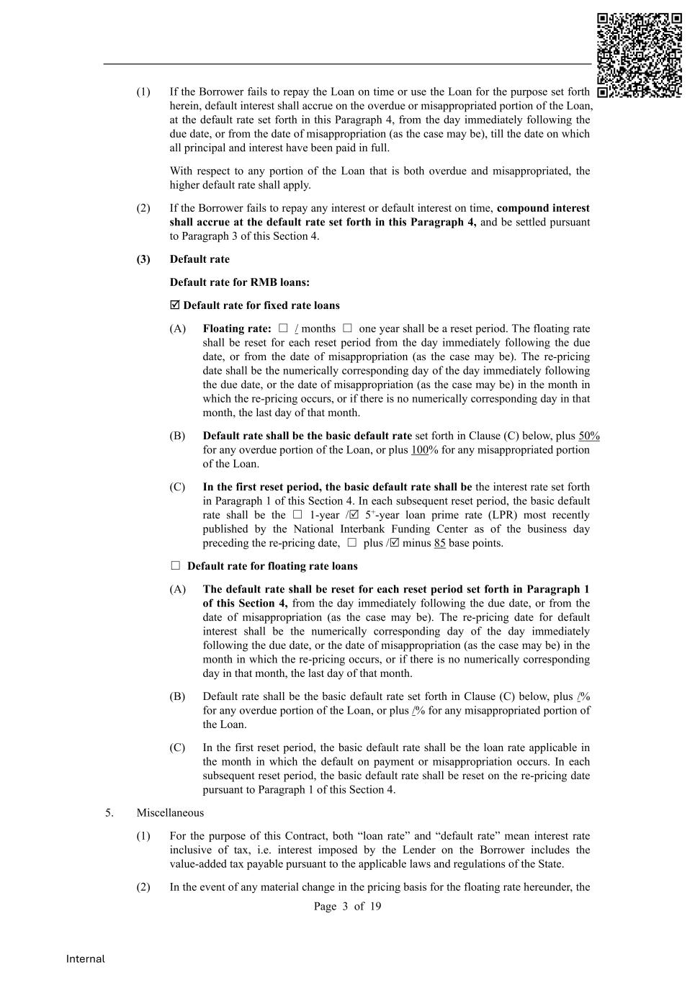
Page 3 of 19 Internal (1) If the Borrower fails to repay the Loan on time or use the Loan for the purpose set forth herein, default interest shall accrue on the overdue or misappropriated portion of the Loan, at the default rate set forth in this Paragraph 4, from the day immediately following the due date, or from the date of misappropriation (as the case may be), till the date on which all principal and interest have been paid in full. With respect to any portion of the Loan that is both overdue and misappropriated, the higher default rate shall apply. (2) If the Borrower fails to repay any interest or default interest on time, compound interest shall accrue at the default rate set forth in this Paragraph 4, and be settled pursuant to Paragraph 3 of this Section 4. (3) Default rate Default rate for RMB loans:  Default rate for fixed rate loans (A) Floating rate: □ / months □ one year shall be a reset period. The floating rate shall be reset for each reset period from the day immediately following the due date, or from the date of misappropriation (as the case may be). The re-pricing date shall be the numerically corresponding day of the day immediately following the due date, or the date of misappropriation (as the case may be) in the month in which the re-pricing occurs, or if there is no numerically corresponding day in that month, the last day of that month. (B) Default rate shall be the basic default rate set forth in Clause (C) below, plus 50% for any overdue portion of the Loan, or plus 100% for any misappropriated portion of the Loan. (C) In the first reset period, the basic default rate shall be the interest rate set forth in Paragraph 1 of this Section 4. In each subsequent reset period, the basic default rate shall be the □ 1-year / 5+-year loan prime rate (LPR) most recently published by the National Interbank Funding Center as of the business day preceding the re-pricing date, □ plus / minus 85 base points. □ Default rate for floating rate loans (A) The default rate shall be reset for each reset period set forth in Paragraph 1 of this Section 4, from the day immediately following the due date, or from the date of misappropriation (as the case may be). The re-pricing date for default interest shall be the numerically corresponding day of the day immediately following the due date, or the date of misappropriation (as the case may be) in the month in which the re-pricing occurs, or if there is no numerically corresponding day in that month, the last day of that month. (B) Default rate shall be the basic default rate set forth in Clause (C) below, plus /% for any overdue portion of the Loan, or plus /% for any misappropriated portion of the Loan. (C) In the first reset period, the basic default rate shall be the loan rate applicable in the month in which the default on payment or misappropriation occurs. In each subsequent reset period, the basic default rate shall be reset on the re-pricing date pursuant to Paragraph 1 of this Section 4. 5. Miscellaneous (1) For the purpose of this Contract, both “loan rate” and “default rate” mean interest rate inclusive of tax, i.e. interest imposed by the Lender on the Borrower includes the value-added tax payable pursuant to the applicable laws and regulations of the State. (2) In the event of any material change in the pricing basis for the floating rate hereunder, the

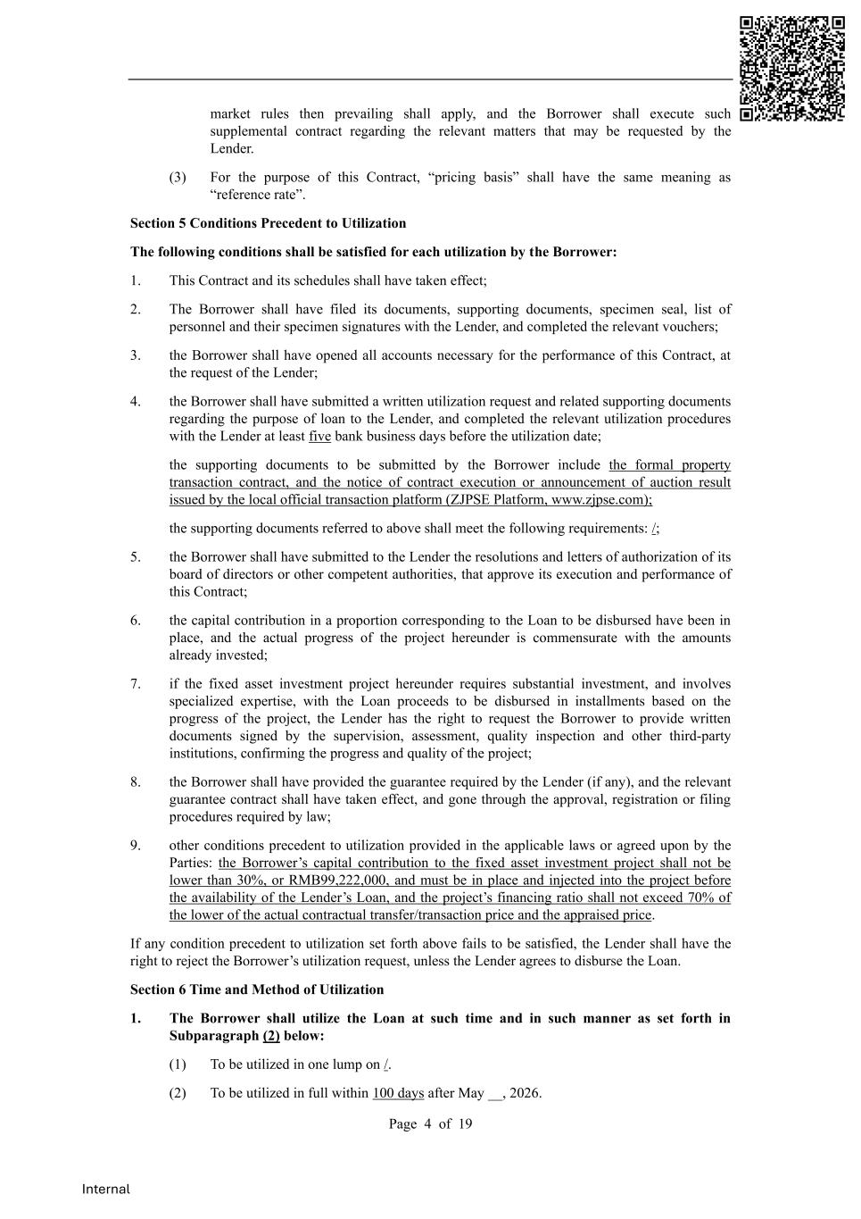
Page 4 of 19 Internal market rules then prevailing shall apply, and the Borrower shall execute such supplemental contract regarding the relevant matters that may be requested by the Lender. (3) For the purpose of this Contract, “pricing basis” shall have the same meaning as “reference rate”. Section 5 Conditions Precedent to Utilization The following conditions shall be satisfied for each utilization by the Borrower: 1. This Contract and its schedules shall have taken effect; 2. The Borrower shall have filed its documents, supporting documents, specimen seal, list of personnel and their specimen signatures with the Lender, and completed the relevant vouchers; 3. the Borrower shall have opened all accounts necessary for the performance of this Contract, at the request of the Lender; 4. the Borrower shall have submitted a written utilization request and related supporting documents regarding the purpose of loan to the Lender, and completed the relevant utilization procedures with the Lender at least five bank business days before the utilization date; the supporting documents to be submitted by the Borrower include the formal property transaction contract, and the notice of contract execution or announcement of auction result issued by the local official transaction platform (ZJPSE Platform, www.zjpse.com); the supporting documents referred to above shall meet the following requirements: /; 5. the Borrower shall have submitted to the Lender the resolutions and letters of authorization of its board of directors or other competent authorities, that approve its execution and performance of this Contract; 6. the capital contribution in a proportion corresponding to the Loan to be disbursed have been in place, and the actual progress of the project hereunder is commensurate with the amounts already invested; 7. if the fixed asset investment project hereunder requires substantial investment, and involves specialized expertise, with the Loan proceeds to be disbursed in installments based on the progress of the project, the Lender has the right to request the Borrower to provide written documents signed by the supervision, assessment, quality inspection and other third-party institutions, confirming the progress and quality of the project; 8. the Borrower shall have provided the guarantee required by the Lender (if any), and the relevant guarantee contract shall have taken effect, and gone through the approval, registration or filing procedures required by law; 9. other conditions precedent to utilization provided in the applicable laws or agreed upon by the Parties: the Borrower’s capital contribution to the fixed asset investment project shall not be lower than 30%, or RMB99,222,000, and must be in place and injected into the project before the availability of the Lender’s Loan, and the project’s financing ratio shall not exceed 70% of the lower of the actual contractual transfer/transaction price and the appraised price. If any condition precedent to utilization set forth above fails to be satisfied, the Lender shall have the right to reject the Borrower’s utilization request, unless the Lender agrees to disburse the Loan. Section 6 Time and Method of Utilization 1. The Borrower shall utilize the Loan at such time and in such manner as set forth in Subparagraph (2) below: (1) To be utilized in one lump on /. (2) To be utilized in full within 100 days after May __, 2026.

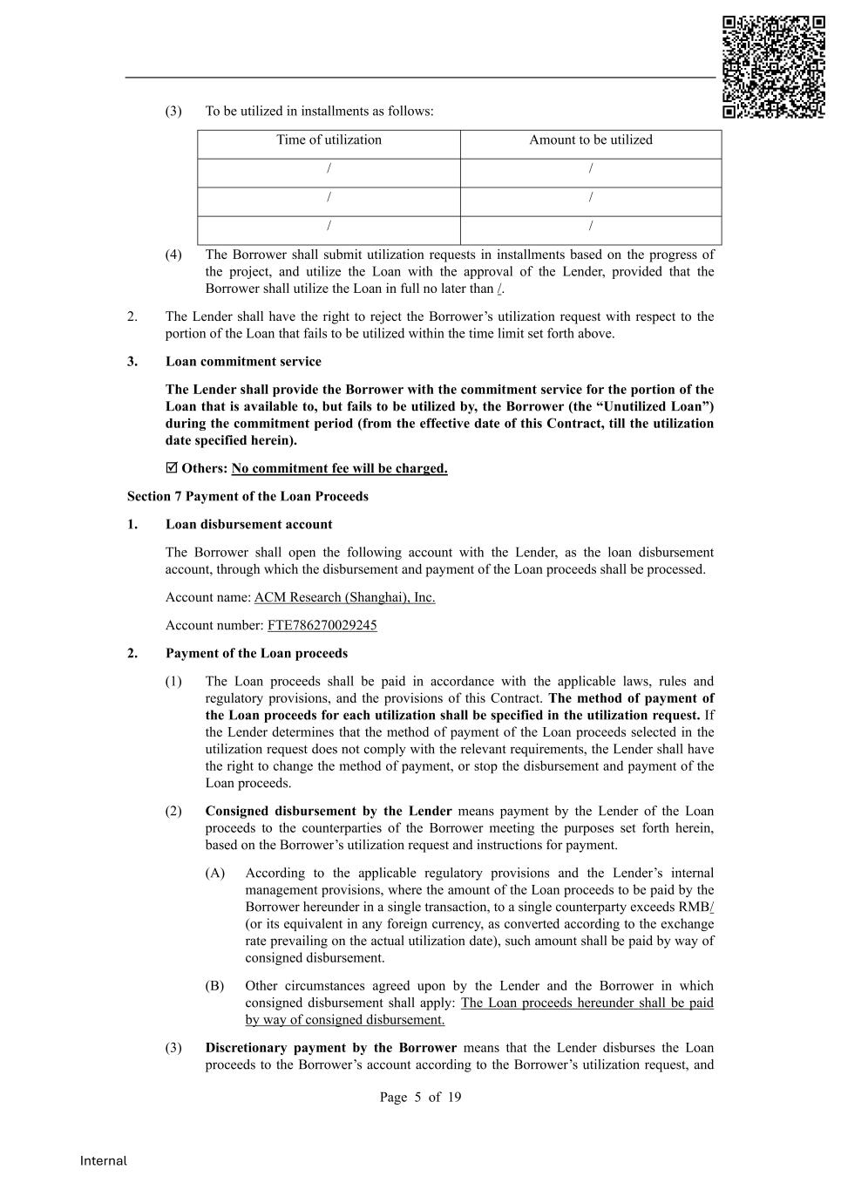
Page 5 of 19 Internal (3) To be utilized in installments as follows: Time of utilization Amount to be utilized / / / / / / (4) The Borrower shall submit utilization requests in installments based on the progress of the project, and utilize the Loan with the approval of the Lender, provided that the Borrower shall utilize the Loan in full no later than /. 2. The Lender shall have the right to reject the Borrower’s utilization request with respect to the portion of the Loan that fails to be utilized within the time limit set forth above. 3. Loan commitment service The Lender shall provide the Borrower with the commitment service for the portion of the Loan that is available to, but fails to be utilized by, the Borrower (the “Unutilized Loan”) during the commitment period (from the effective date of this Contract, till the utilization date specified herein).  Others: No commitment fee will be charged. Section 7 Payment of the Loan Proceeds 1. Loan disbursement account The Borrower shall open the following account with the Lender, as the loan disbursement account, through which the disbursement and payment of the Loan proceeds shall be processed. Account name: ACM Research (Shanghai), Inc. Account number: FTE786270029245 2. Payment of the Loan proceeds (1) The Loan proceeds shall be paid in accordance with the applicable laws, rules and regulatory provisions, and the provisions of this Contract. The method of payment of the Loan proceeds for each utilization shall be specified in the utilization request. If the Lender determines that the method of payment of the Loan proceeds selected in the utilization request does not comply with the relevant requirements, the Lender shall have the right to change the method of payment, or stop the disbursement and payment of the Loan proceeds. (2) Consigned disbursement by the Lender means payment by the Lender of the Loan proceeds to the counterparties of the Borrower meeting the purposes set forth herein, based on the Borrower’s utilization request and instructions for payment. (A) According to the applicable regulatory provisions and the Lender’s internal management provisions, where the amount of the Loan proceeds to be paid by the Borrower hereunder in a single transaction, to a single counterparty exceeds RMB/ (or its equivalent in any foreign currency, as converted according to the exchange rate prevailing on the actual utilization date), such amount shall be paid by way of consigned disbursement. (B) Other circumstances agreed upon by the Lender and the Borrower in which consigned disbursement shall apply: The Loan proceeds hereunder shall be paid by way of consigned disbursement. (3) Discretionary payment by the Borrower means that the Lender disburses the Loan proceeds to the Borrower’s account according to the Borrower’s utilization request, and

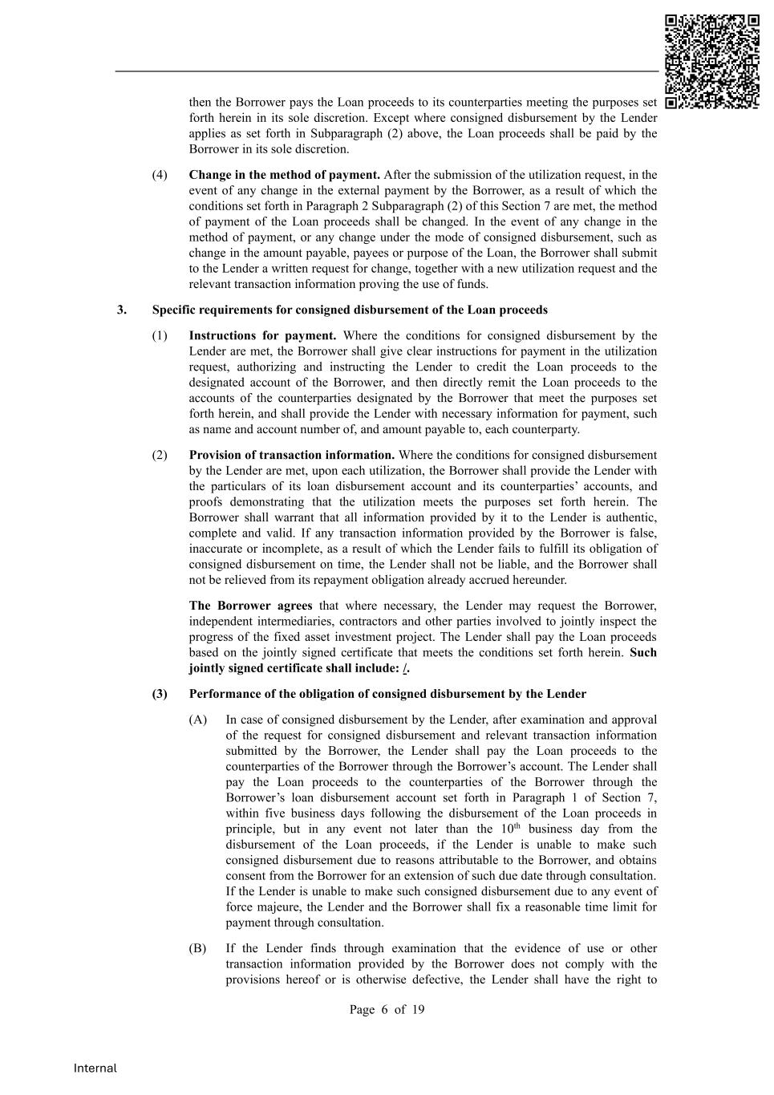
Page 6 of 19 Internal then the Borrower pays the Loan proceeds to its counterparties meeting the purposes set forth herein in its sole discretion. Except where consigned disbursement by the Lender applies as set forth in Subparagraph (2) above, the Loan proceeds shall be paid by the Borrower in its sole discretion. (4) Change in the method of payment. After the submission of the utilization request, in the event of any change in the external payment by the Borrower, as a result of which the conditions set forth in Paragraph 2 Subparagraph (2) of this Section 7 are met, the method of payment of the Loan proceeds shall be changed. In the event of any change in the method of payment, or any change under the mode of consigned disbursement, such as change in the amount payable, payees or purpose of the Loan, the Borrower shall submit to the Lender a written request for change, together with a new utilization request and the relevant transaction information proving the use of funds. 3. Specific requirements for consigned disbursement of the Loan proceeds (1) Instructions for payment. Where the conditions for consigned disbursement by the Lender are met, the Borrower shall give clear instructions for payment in the utilization request, authorizing and instructing the Lender to credit the Loan proceeds to the designated account of the Borrower, and then directly remit the Loan proceeds to the accounts of the counterparties designated by the Borrower that meet the purposes set forth herein, and shall provide the Lender with necessary information for payment, such as name and account number of, and amount payable to, each counterparty. (2) Provision of transaction information. Where the conditions for consigned disbursement by the Lender are met, upon each utilization, the Borrower shall provide the Lender with the particulars of its loan disbursement account and its counterparties’ accounts, and proofs demonstrating that the utilization meets the purposes set forth herein. The Borrower shall warrant that all information provided by it to the Lender is authentic, complete and valid. If any transaction information provided by the Borrower is false, inaccurate or incomplete, as a result of which the Lender fails to fulfill its obligation of consigned disbursement on time, the Lender shall not be liable, and the Borrower shall not be relieved from its repayment obligation already accrued hereunder. The Borrower agrees that where necessary, the Lender may request the Borrower, independent intermediaries, contractors and other parties involved to jointly inspect the progress of the fixed asset investment project. The Lender shall pay the Loan proceeds based on the jointly signed certificate that meets the conditions set forth herein. Such jointly signed certificate shall include: /. (3) Performance of the obligation of consigned disbursement by the Lender (A) In case of consigned disbursement by the Lender, after examination and approval of the request for consigned disbursement and relevant transaction information submitted by the Borrower, the Lender shall pay the Loan proceeds to the counterparties of the Borrower through the Borrower’s account. The Lender shall pay the Loan proceeds to the counterparties of the Borrower through the Borrower’s loan disbursement account set forth in Paragraph 1 of Section 7, within five business days following the disbursement of the Loan proceeds in principle, but in any event not later than the 10th business day from the disbursement of the Loan proceeds, if the Lender is unable to make such consigned disbursement due to reasons attributable to the Borrower, and obtains consent from the Borrower for an extension of such due date through consultation. If the Lender is unable to make such consigned disbursement due to any event of force majeure, the Lender and the Borrower shall fix a reasonable time limit for payment through consultation. (B) If the Lender finds through examination that the evidence of use or other transaction information provided by the Borrower does not comply with the provisions hereof or is otherwise defective, the Lender shall have the right to

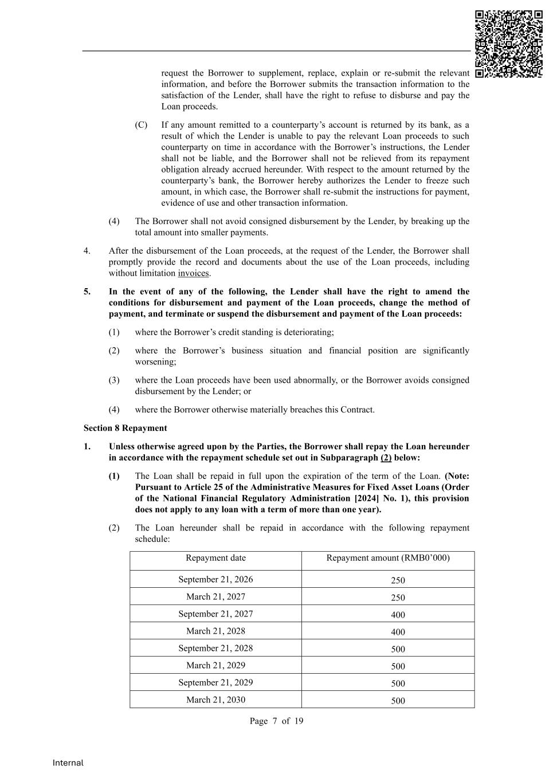
Page 7 of 19 Internal request the Borrower to supplement, replace, explain or re-submit the relevant information, and before the Borrower submits the transaction information to the satisfaction of the Lender, shall have the right to refuse to disburse and pay the Loan proceeds. (C) If any amount remitted to a counterparty’s account is returned by its bank, as a result of which the Lender is unable to pay the relevant Loan proceeds to such counterparty on time in accordance with the Borrower’s instructions, the Lender shall not be liable, and the Borrower shall not be relieved from its repayment obligation already accrued hereunder. With respect to the amount returned by the counterparty’s bank, the Borrower hereby authorizes the Lender to freeze such amount, in which case, the Borrower shall re-submit the instructions for payment, evidence of use and other transaction information. (4) The Borrower shall not avoid consigned disbursement by the Lender, by breaking up the total amount into smaller payments. 4. After the disbursement of the Loan proceeds, at the request of the Lender, the Borrower shall promptly provide the record and documents about the use of the Loan proceeds, including without limitation invoices. 5. In the event of any of the following, the Lender shall have the right to amend the conditions for disbursement and payment of the Loan proceeds, change the method of payment, and terminate or suspend the disbursement and payment of the Loan proceeds: (1) where the Borrower’s credit standing is deteriorating; (2) where the Borrower’s business situation and financial position are significantly worsening; (3) where the Loan proceeds have been used abnormally, or the Borrower avoids consigned disbursement by the Lender; or (4) where the Borrower otherwise materially breaches this Contract. Section 8 Repayment 1. Unless otherwise agreed upon by the Parties, the Borrower shall repay the Loan hereunder in accordance with the repayment schedule set out in Subparagraph (2) below: (1) The Loan shall be repaid in full upon the expiration of the term of the Loan. (Note: Pursuant to Article 25 of the Administrative Measures for Fixed Asset Loans (Order of the National Financial Regulatory Administration [2024] No. 1), this provision does not apply to any loan with a term of more than one year). (2) The Loan hereunder shall be repaid in accordance with the following repayment schedule: Repayment date Repayment amount (RMB0’000) September 21, 2026 250 March 21, 2027 250 September 21, 2027 400 March 21, 2028 400 September 21, 2028 500 March 21, 2029 500 September 21, 2029 500 March 21, 2030 500

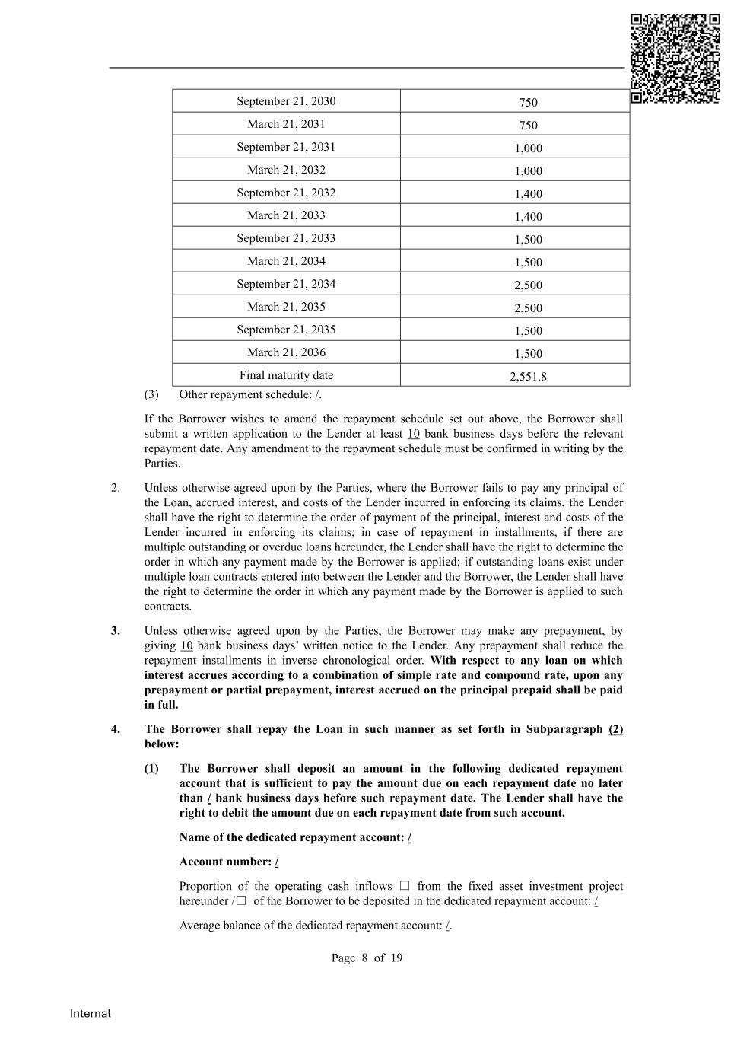
Page 8 of 19 Internal September 21, 2030 750 March 21, 2031 750 September 21, 2031 1,000 March 21, 2032 1,000 September 21, 2032 1,400 March 21, 2033 1,400 September 21, 2033 1,500 March 21, 2034 1,500 September 21, 2034 2,500 March 21, 2035 2,500 September 21, 2035 1,500 March 21, 2036 1,500 Final maturity date 2,551.8 (3) Other repayment schedule: /. If the Borrower wishes to amend the repayment schedule set out above, the Borrower shall submit a written application to the Lender at least 10 bank business days before the relevant repayment date. Any amendment to the repayment schedule must be confirmed in writing by the Parties. 2. Unless otherwise agreed upon by the Parties, where the Borrower fails to pay any principal of the Loan, accrued interest, and costs of the Lender incurred in enforcing its claims, the Lender shall have the right to determine the order of payment of the principal, interest and costs of the Lender incurred in enforcing its claims; in case of repayment in installments, if there are multiple outstanding or overdue loans hereunder, the Lender shall have the right to determine the order in which any payment made by the Borrower is applied; if outstanding loans exist under multiple loan contracts entered into between the Lender and the Borrower, the Lender shall have the right to determine the order in which any payment made by the Borrower is applied to such contracts. 3. Unless otherwise agreed upon by the Parties, the Borrower may make any prepayment, by giving 10 bank business days’ written notice to the Lender. Any prepayment shall reduce the repayment installments in inverse chronological order. With respect to any loan on which interest accrues according to a combination of simple rate and compound rate, upon any prepayment or partial prepayment, interest accrued on the principal prepaid shall be paid in full. 4. The Borrower shall repay the Loan in such manner as set forth in Subparagraph (2) below: (1) The Borrower shall deposit an amount in the following dedicated repayment account that is sufficient to pay the amount due on each repayment date no later than / bank business days before such repayment date. The Lender shall have the right to debit the amount due on each repayment date from such account. Name of the dedicated repayment account: / Account number: / Proportion of the operating cash inflows □ from the fixed asset investment project hereunder /□ of the Borrower to be deposited in the dedicated repayment account: / Average balance of the dedicated repayment account: /.

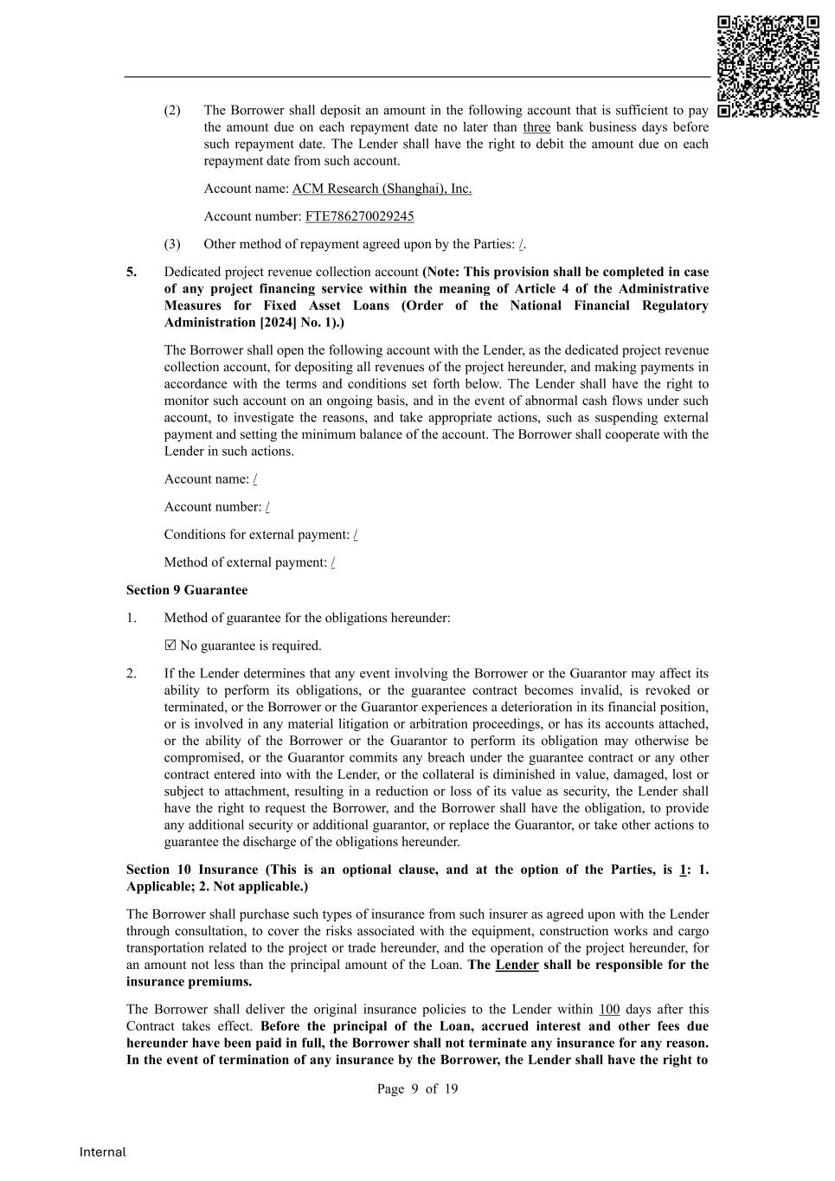
Page 9 of 19 Internal (2) The Borrower shall deposit an amount in the following account that is sufficient to pay the amount due on each repayment date no later than three bank business days before such repayment date. The Lender shall have the right to debit the amount due on each repayment date from such account. Account name: ACM Research (Shanghai), Inc. Account number: FTE786270029245 (3) Other method of repayment agreed upon by the Parties: /. 5. Dedicated project revenue collection account (Note: This provision shall be completed in case of any project financing service within the meaning of Article 4 of the Administrative Measures for Fixed Asset Loans (Order of the National Financial Regulatory Administration [2024] No. 1).) The Borrower shall open the following account with the Lender, as the dedicated project revenue collection account, for depositing all revenues of the project hereunder, and making payments in accordance with the terms and conditions set forth below. The Lender shall have the right to monitor such account on an ongoing basis, and in the event of abnormal cash flows under such account, to investigate the reasons, and take appropriate actions, such as suspending external payment and setting the minimum balance of the account. The Borrower shall cooperate with the Lender in such actions. Account name: / Account number: / Conditions for external payment: / Method of external payment: / Section 9 Guarantee 1. Method of guarantee for the obligations hereunder:  No guarantee is required. 2. If the Lender determines that any event involving the Borrower or the Guarantor may affect its ability to perform its obligations, or the guarantee contract becomes invalid, is revoked or terminated, or the Borrower or the Guarantor experiences a deterioration in its financial position, or is involved in any material litigation or arbitration proceedings, or has its accounts attached, or the ability of the Borrower or the Guarantor to perform its obligation may otherwise be compromised, or the Guarantor commits any breach under the guarantee contract or any other contract entered into with the Lender, or the collateral is diminished in value, damaged, lost or subject to attachment, resulting in a reduction or loss of its value as security, the Lender shall have the right to request the Borrower, and the Borrower shall have the obligation, to provide any additional security or additional guarantor, or replace the Guarantor, or take other actions to guarantee the discharge of the obligations hereunder. Section 10 Insurance (This is an optional clause, and at the option of the Parties, is 1: 1. Applicable; 2. Not applicable.) The Borrower shall purchase such types of insurance from such insurer as agreed upon with the Lender through consultation, to cover the risks associated with the equipment, construction works and cargo transportation related to the project or trade hereunder, and the operation of the project hereunder, for an amount not less than the principal amount of the Loan. The Lender shall be responsible for the insurance premiums. The Borrower shall deliver the original insurance policies to the Lender within 100 days after this Contract takes effect. Before the principal of the Loan, accrued interest and other fees due hereunder have been paid in full, the Borrower shall not terminate any insurance for any reason. In the event of termination of any insurance by the Borrower, the Lender shall have the right to

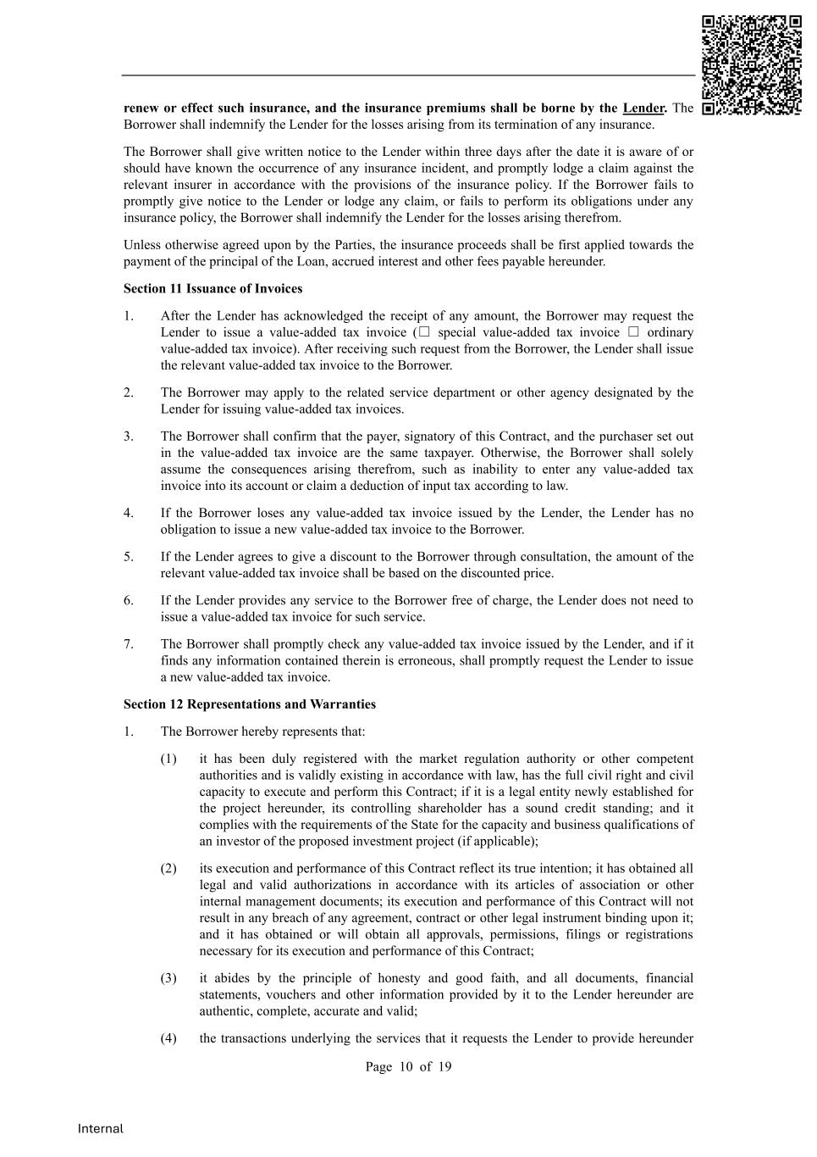
Page 10 of 19 Internal renew or effect such insurance, and the insurance premiums shall be borne by the Lender. The Borrower shall indemnify the Lender for the losses arising from its termination of any insurance. The Borrower shall give written notice to the Lender within three days after the date it is aware of or should have known the occurrence of any insurance incident, and promptly lodge a claim against the relevant insurer in accordance with the provisions of the insurance policy. If the Borrower fails to promptly give notice to the Lender or lodge any claim, or fails to perform its obligations under any insurance policy, the Borrower shall indemnify the Lender for the losses arising therefrom. Unless otherwise agreed upon by the Parties, the insurance proceeds shall be first applied towards the payment of the principal of the Loan, accrued interest and other fees payable hereunder. Section 11 Issuance of Invoices 1. After the Lender has acknowledged the receipt of any amount, the Borrower may request the Lender to issue a value-added tax invoice (□ special value-added tax invoice □ ordinary value-added tax invoice). After receiving such request from the Borrower, the Lender shall issue the relevant value-added tax invoice to the Borrower. 2. The Borrower may apply to the related service department or other agency designated by the Lender for issuing value-added tax invoices. 3. The Borrower shall confirm that the payer, signatory of this Contract, and the purchaser set out in the value-added tax invoice are the same taxpayer. Otherwise, the Borrower shall solely assume the consequences arising therefrom, such as inability to enter any value-added tax invoice into its account or claim a deduction of input tax according to law. 4. If the Borrower loses any value-added tax invoice issued by the Lender, the Lender has no obligation to issue a new value-added tax invoice to the Borrower. 5. If the Lender agrees to give a discount to the Borrower through consultation, the amount of the relevant value-added tax invoice shall be based on the discounted price. 6. If the Lender provides any service to the Borrower free of charge, the Lender does not need to issue a value-added tax invoice for such service. 7. The Borrower shall promptly check any value-added tax invoice issued by the Lender, and if it finds any information contained therein is erroneous, shall promptly request the Lender to issue a new value-added tax invoice. Section 12 Representations and Warranties 1. The Borrower hereby represents that: (1) it has been duly registered with the market regulation authority or other competent authorities and is validly existing in accordance with law, has the full civil right and civil capacity to execute and perform this Contract; if it is a legal entity newly established for the project hereunder, its controlling shareholder has a sound credit standing; and it complies with the requirements of the State for the capacity and business qualifications of an investor of the proposed investment project (if applicable); (2) its execution and performance of this Contract reflect its true intention; it has obtained all legal and valid authorizations in accordance with its articles of association or other internal management documents; its execution and performance of this Contract will not result in any breach of any agreement, contract or other legal instrument binding upon it; and it has obtained or will obtain all approvals, permissions, filings or registrations necessary for its execution and performance of this Contract; (3) it abides by the principle of honesty and good faith, and all documents, financial statements, vouchers and other information provided by it to the Lender hereunder are authentic, complete, accurate and valid; (4) the transactions underlying the services that it requests the Lender to provide hereunder

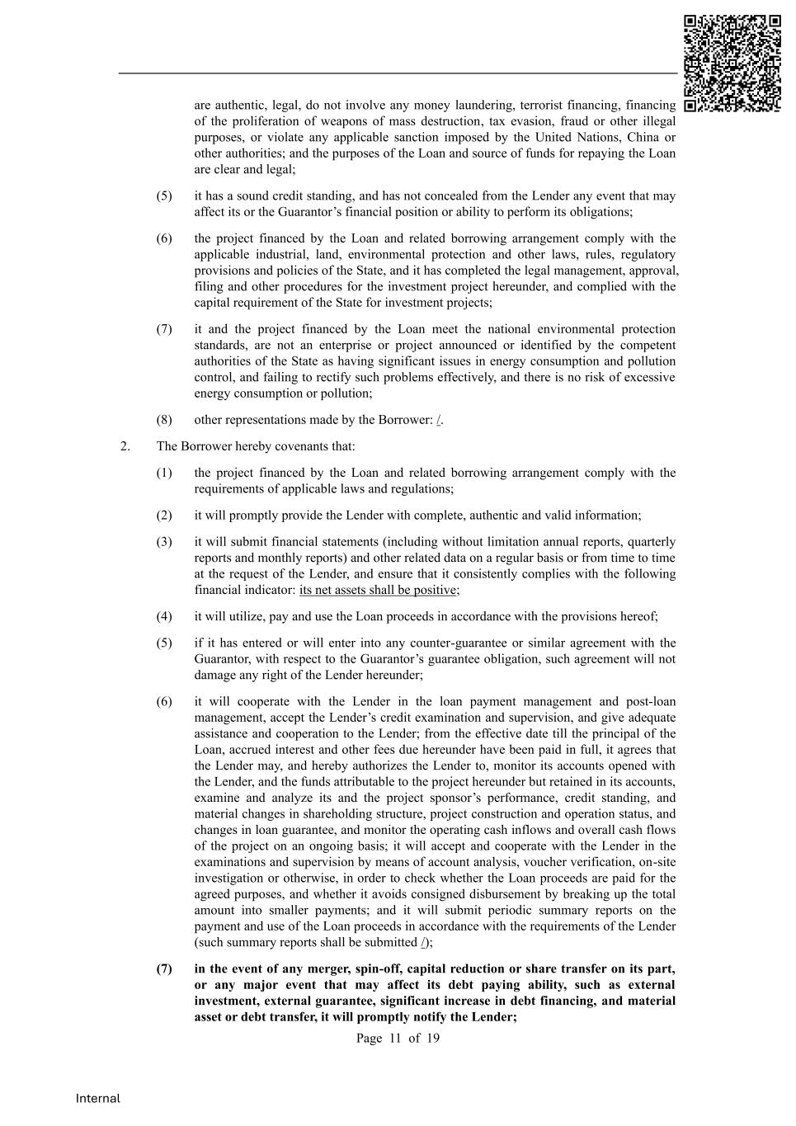
Page 11 of 19 Internal are authentic, legal, do not involve any money laundering, terrorist financing, financing of the proliferation of weapons of mass destruction, tax evasion, fraud or other illegal purposes, or violate any applicable sanction imposed by the United Nations, China or other authorities; and the purposes of the Loan and source of funds for repaying the Loan are clear and legal; (5) it has a sound credit standing, and has not concealed from the Lender any event that may affect its or the Guarantor’s financial position or ability to perform its obligations; (6) the project financed by the Loan and related borrowing arrangement comply with the applicable industrial, land, environmental protection and other laws, rules, regulatory provisions and policies of the State, and it has completed the legal management, approval, filing and other procedures for the investment project hereunder, and complied with the capital requirement of the State for investment projects; (7) it and the project financed by the Loan meet the national environmental protection standards, are not an enterprise or project announced or identified by the competent authorities of the State as having significant issues in energy consumption and pollution control, and failing to rectify such problems effectively, and there is no risk of excessive energy consumption or pollution; (8) other representations made by the Borrower: /. 2. The Borrower hereby covenants that: (1) the project financed by the Loan and related borrowing arrangement comply with the requirements of applicable laws and regulations; (2) it will promptly provide the Lender with complete, authentic and valid information; (3) it will submit financial statements (including without limitation annual reports, quarterly reports and monthly reports) and other related data on a regular basis or from time to time at the request of the Lender, and ensure that it consistently complies with the following financial indicator: its net assets shall be positive; (4) it will utilize, pay and use the Loan proceeds in accordance with the provisions hereof; (5) if it has entered or will enter into any counter-guarantee or similar agreement with the Guarantor, with respect to the Guarantor’s guarantee obligation, such agreement will not damage any right of the Lender hereunder; (6) it will cooperate with the Lender in the loan payment management and post-loan management, accept the Lender’s credit examination and supervision, and give adequate assistance and cooperation to the Lender; from the effective date till the principal of the Loan, accrued interest and other fees due hereunder have been paid in full, it agrees that the Lender may, and hereby authorizes the Lender to, monitor its accounts opened with the Lender, and the funds attributable to the project hereunder but retained in its accounts, examine and analyze its and the project sponsor’s performance, credit standing, and material changes in shareholding structure, project construction and operation status, and changes in loan guarantee, and monitor the operating cash inflows and overall cash flows of the project on an ongoing basis; it will accept and cooperate with the Lender in the examinations and supervision by means of account analysis, voucher verification, on-site investigation or otherwise, in order to check whether the Loan proceeds are paid for the agreed purposes, and whether it avoids consigned disbursement by breaking up the total amount into smaller payments; and it will submit periodic summary reports on the payment and use of the Loan proceeds in accordance with the requirements of the Lender (such summary reports shall be submitted /); (7) in the event of any merger, spin-off, capital reduction or share transfer on its part, or any major event that may affect its debt paying ability, such as external investment, external guarantee, significant increase in debt financing, and material asset or debt transfer, it will promptly notify the Lender;

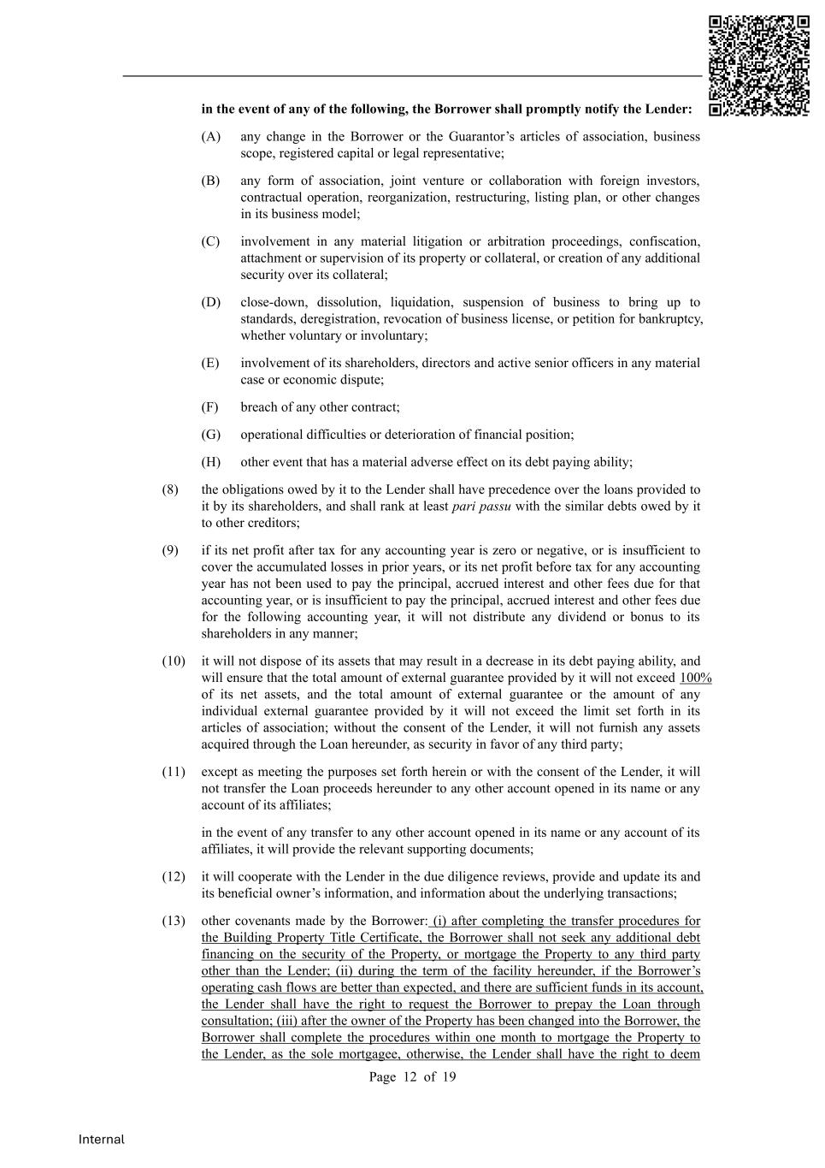
Page 12 of 19 Internal in the event of any of the following, the Borrower shall promptly notify the Lender: (A) any change in the Borrower or the Guarantor’s articles of association, business scope, registered capital or legal representative; (B) any form of association, joint venture or collaboration with foreign investors, contractual operation, reorganization, restructuring, listing plan, or other changes in its business model; (C) involvement in any material litigation or arbitration proceedings, confiscation, attachment or supervision of its property or collateral, or creation of any additional security over its collateral; (D) close-down, dissolution, liquidation, suspension of business to bring up to standards, deregistration, revocation of business license, or petition for bankruptcy, whether voluntary or involuntary; (E) involvement of its shareholders, directors and active senior officers in any material case or economic dispute; (F) breach of any other contract; (G) operational difficulties or deterioration of financial position; (H) other event that has a material adverse effect on its debt paying ability; (8) the obligations owed by it to the Lender shall have precedence over the loans provided to it by its shareholders, and shall rank at least pari passu with the similar debts owed by it to other creditors; (9) if its net profit after tax for any accounting year is zero or negative, or is insufficient to cover the accumulated losses in prior years, or its net profit before tax for any accounting year has not been used to pay the principal, accrued interest and other fees due for that accounting year, or is insufficient to pay the principal, accrued interest and other fees due for the following accounting year, it will not distribute any dividend or bonus to its shareholders in any manner; (10) it will not dispose of its assets that may result in a decrease in its debt paying ability, and will ensure that the total amount of external guarantee provided by it will not exceed 100% of its net assets, and the total amount of external guarantee or the amount of any individual external guarantee provided by it will not exceed the limit set forth in its articles of association; without the consent of the Lender, it will not furnish any assets acquired through the Loan hereunder, as security in favor of any third party; (11) except as meeting the purposes set forth herein or with the consent of the Lender, it will not transfer the Loan proceeds hereunder to any other account opened in its name or any account of its affiliates; in the event of any transfer to any other account opened in its name or any account of its affiliates, it will provide the relevant supporting documents; (12) it will cooperate with the Lender in the due diligence reviews, provide and update its and its beneficial owner’s information, and information about the underlying transactions; (13) other covenants made by the Borrower: (i) after completing the transfer procedures for the Building Property Title Certificate, the Borrower shall not seek any additional debt financing on the security of the Property, or mortgage the Property to any third party other than the Lender; (ii) during the term of the facility hereunder, if the Borrower’s operating cash flows are better than expected, and there are sufficient funds in its account, the Lender shall have the right to request the Borrower to prepay the Loan through consultation; (iii) after the owner of the Property has been changed into the Borrower, the Borrower shall complete the procedures within one month to mortgage the Property to the Lender, as the sole mortgagee, otherwise, the Lender shall have the right to deem

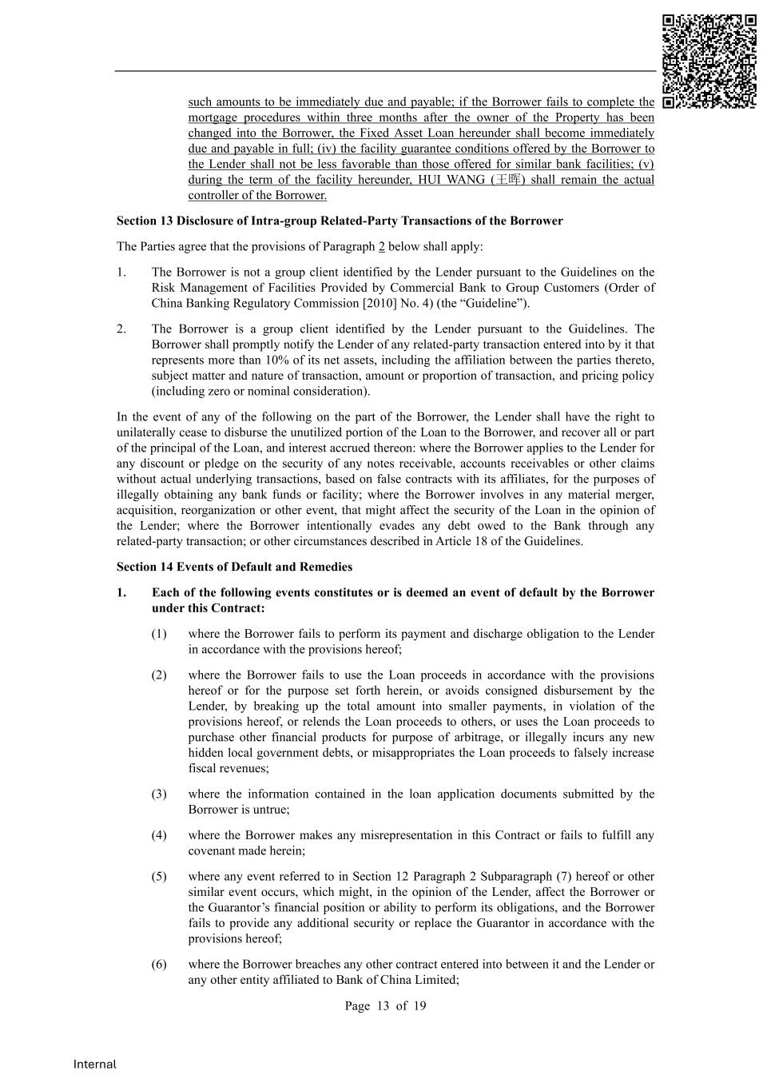
Page 13 of 19 Internal such amounts to be immediately due and payable; if the Borrower fails to complete the mortgage procedures within three months after the owner of the Property has been changed into the Borrower, the Fixed Asset Loan hereunder shall become immediately due and payable in full; (iv) the facility guarantee conditions offered by the Borrower to the Lender shall not be less favorable than those offered for similar bank facilities; (v) during the term of the facility hereunder, HUI WANG (王晖) shall remain the actual controller of the Borrower. Section 13 Disclosure of Intra-group Related-Party Transactions of the Borrower The Parties agree that the provisions of Paragraph 2 below shall apply: 1. The Borrower is not a group client identified by the Lender pursuant to the Guidelines on the Risk Management of Facilities Provided by Commercial Bank to Group Customers (Order of China Banking Regulatory Commission [2010] No. 4) (the “Guideline”). 2. The Borrower is a group client identified by the Lender pursuant to the Guidelines. The Borrower shall promptly notify the Lender of any related-party transaction entered into by it that represents more than 10% of its net assets, including the affiliation between the parties thereto, subject matter and nature of transaction, amount or proportion of transaction, and pricing policy (including zero or nominal consideration). In the event of any of the following on the part of the Borrower, the Lender shall have the right to unilaterally cease to disburse the unutilized portion of the Loan to the Borrower, and recover all or part of the principal of the Loan, and interest accrued thereon: where the Borrower applies to the Lender for any discount or pledge on the security of any notes receivable, accounts receivables or other claims without actual underlying transactions, based on false contracts with its affiliates, for the purposes of illegally obtaining any bank funds or facility; where the Borrower involves in any material merger, acquisition, reorganization or other event, that might affect the security of the Loan in the opinion of the Lender; where the Borrower intentionally evades any debt owed to the Bank through any related-party transaction; or other circumstances described in Article 18 of the Guidelines. Section 14 Events of Default and Remedies 1. Each of the following events constitutes or is deemed an event of default by the Borrower under this Contract: (1) where the Borrower fails to perform its payment and discharge obligation to the Lender in accordance with the provisions hereof; (2) where the Borrower fails to use the Loan proceeds in accordance with the provisions hereof or for the purpose set forth herein, or avoids consigned disbursement by the Lender, by breaking up the total amount into smaller payments, in violation of the provisions hereof, or relends the Loan proceeds to others, or uses the Loan proceeds to purchase other financial products for purpose of arbitrage, or illegally incurs any new hidden local government debts, or misappropriates the Loan proceeds to falsely increase fiscal revenues; (3) where the information contained in the loan application documents submitted by the Borrower is untrue; (4) where the Borrower makes any misrepresentation in this Contract or fails to fulfill any covenant made herein; (5) where any event referred to in Section 12 Paragraph 2 Subparagraph (7) hereof or other similar event occurs, which might, in the opinion of the Lender, affect the Borrower or the Guarantor’s financial position or ability to perform its obligations, and the Borrower fails to provide any additional security or replace the Guarantor in accordance with the provisions hereof; (6) where the Borrower breaches any other contract entered into between it and the Lender or any other entity affiliated to Bank of China Limited;

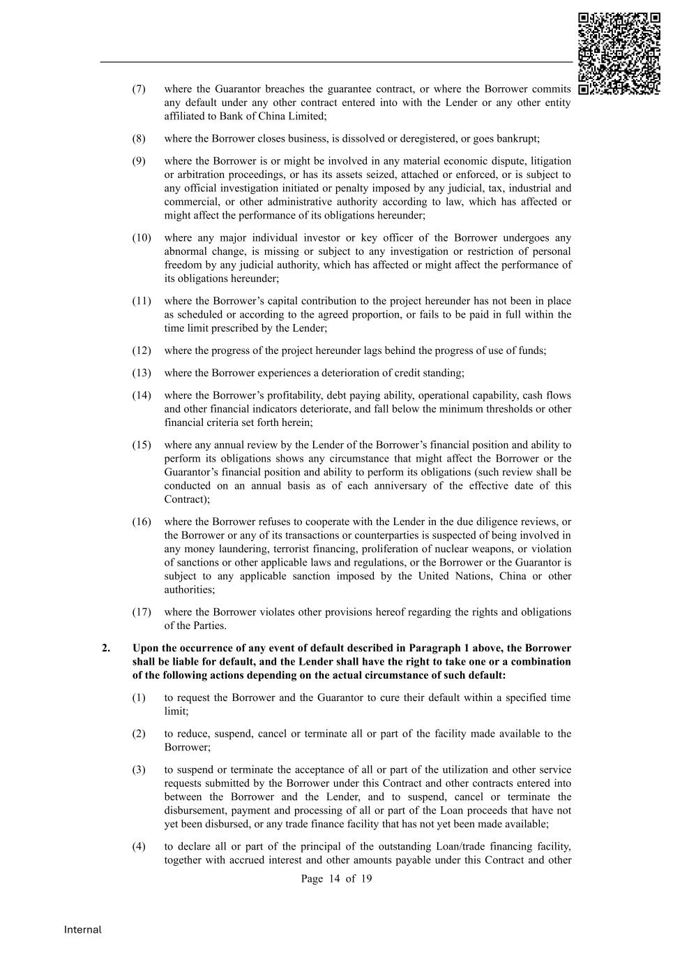
Page 14 of 19 Internal (7) where the Guarantor breaches the guarantee contract, or where the Borrower commits any default under any other contract entered into with the Lender or any other entity affiliated to Bank of China Limited; (8) where the Borrower closes business, is dissolved or deregistered, or goes bankrupt; (9) where the Borrower is or might be involved in any material economic dispute, litigation or arbitration proceedings, or has its assets seized, attached or enforced, or is subject to any official investigation initiated or penalty imposed by any judicial, tax, industrial and commercial, or other administrative authority according to law, which has affected or might affect the performance of its obligations hereunder; (10) where any major individual investor or key officer of the Borrower undergoes any abnormal change, is missing or subject to any investigation or restriction of personal freedom by any judicial authority, which has affected or might affect the performance of its obligations hereunder; (11) where the Borrower’s capital contribution to the project hereunder has not been in place as scheduled or according to the agreed proportion, or fails to be paid in full within the time limit prescribed by the Lender; (12) where the progress of the project hereunder lags behind the progress of use of funds; (13) where the Borrower experiences a deterioration of credit standing; (14) where the Borrower’s profitability, debt paying ability, operational capability, cash flows and other financial indicators deteriorate, and fall below the minimum thresholds or other financial criteria set forth herein; (15) where any annual review by the Lender of the Borrower’s financial position and ability to perform its obligations shows any circumstance that might affect the Borrower or the Guarantor’s financial position and ability to perform its obligations (such review shall be conducted on an annual basis as of each anniversary of the effective date of this Contract); (16) where the Borrower refuses to cooperate with the Lender in the due diligence reviews, or the Borrower or any of its transactions or counterparties is suspected of being involved in any money laundering, terrorist financing, proliferation of nuclear weapons, or violation of sanctions or other applicable laws and regulations, or the Borrower or the Guarantor is subject to any applicable sanction imposed by the United Nations, China or other authorities; (17) where the Borrower violates other provisions hereof regarding the rights and obligations of the Parties. 2. Upon the occurrence of any event of default described in Paragraph 1 above, the Borrower shall be liable for default, and the Lender shall have the right to take one or a combination of the following actions depending on the actual circumstance of such default: (1) to request the Borrower and the Guarantor to cure their default within a specified time limit; (2) to reduce, suspend, cancel or terminate all or part of the facility made available to the Borrower; (3) to suspend or terminate the acceptance of all or part of the utilization and other service requests submitted by the Borrower under this Contract and other contracts entered into between the Borrower and the Lender, and to suspend, cancel or terminate the disbursement, payment and processing of all or part of the Loan proceeds that have not yet been disbursed, or any trade finance facility that has not yet been made available; (4) to declare all or part of the principal of the outstanding Loan/trade financing facility, together with accrued interest and other amounts payable under this Contract and other

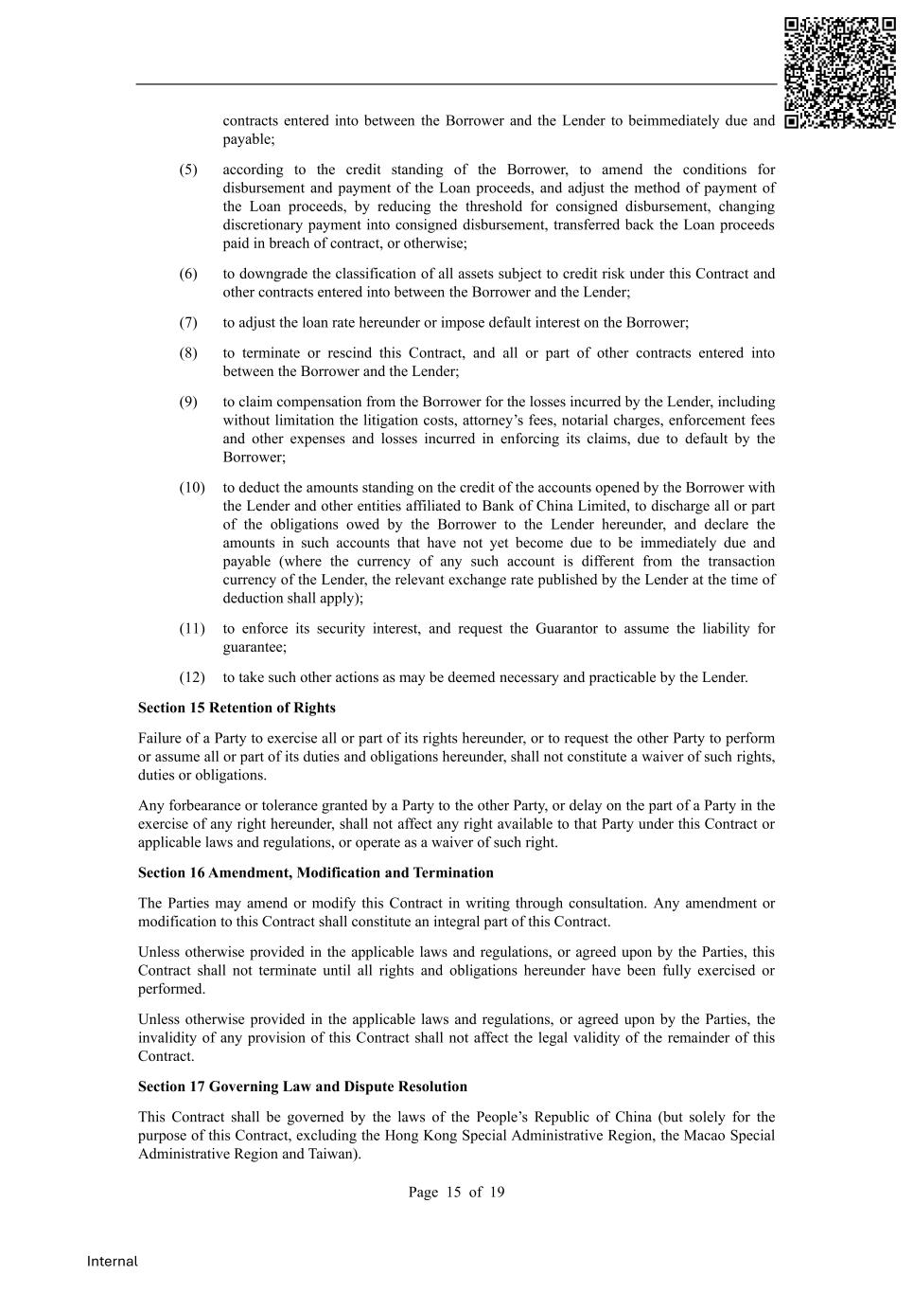
Page 15 of 19 Internal contracts entered into between the Borrower and the Lender to beimmediately due and payable; (5) according to the credit standing of the Borrower, to amend the conditions for disbursement and payment of the Loan proceeds, and adjust the method of payment of the Loan proceeds, by reducing the threshold for consigned disbursement, changing discretionary payment into consigned disbursement, transferred back the Loan proceeds paid in breach of contract, or otherwise; (6) to downgrade the classification of all assets subject to credit risk under this Contract and other contracts entered into between the Borrower and the Lender; (7) to adjust the loan rate hereunder or impose default interest on the Borrower; (8) to terminate or rescind this Contract, and all or part of other contracts entered into between the Borrower and the Lender; (9) to claim compensation from the Borrower for the losses incurred by the Lender, including without limitation the litigation costs, attorney’s fees, notarial charges, enforcement fees and other expenses and losses incurred in enforcing its claims, due to default by the Borrower; (10) to deduct the amounts standing on the credit of the accounts opened by the Borrower with the Lender and other entities affiliated to Bank of China Limited, to discharge all or part of the obligations owed by the Borrower to the Lender hereunder, and declare the amounts in such accounts that have not yet become due to be immediately due and payable (where the currency of any such account is different from the transaction currency of the Lender, the relevant exchange rate published by the Lender at the time of deduction shall apply); (11) to enforce its security interest, and request the Guarantor to assume the liability for guarantee; (12) to take such other actions as may be deemed necessary and practicable by the Lender. Section 15 Retention of Rights Failure of a Party to exercise all or part of its rights hereunder, or to request the other Party to perform or assume all or part of its duties and obligations hereunder, shall not constitute a waiver of such rights, duties or obligations. Any forbearance or tolerance granted by a Party to the other Party, or delay on the part of a Party in the exercise of any right hereunder, shall not affect any right available to that Party under this Contract or applicable laws and regulations, or operate as a waiver of such right. Section 16 Amendment, Modification and Termination The Parties may amend or modify this Contract in writing through consultation. Any amendment or modification to this Contract shall constitute an integral part of this Contract. Unless otherwise provided in the applicable laws and regulations, or agreed upon by the Parties, this Contract shall not terminate until all rights and obligations hereunder have been fully exercised or performed. Unless otherwise provided in the applicable laws and regulations, or agreed upon by the Parties, the invalidity of any provision of this Contract shall not affect the legal validity of the remainder of this Contract. Section 17 Governing Law and Dispute Resolution This Contract shall be governed by the laws of the People’s Republic of China (but solely for the purpose of this Contract, excluding the Hong Kong Special Administrative Region, the Macao Special Administrative Region and Taiwan).

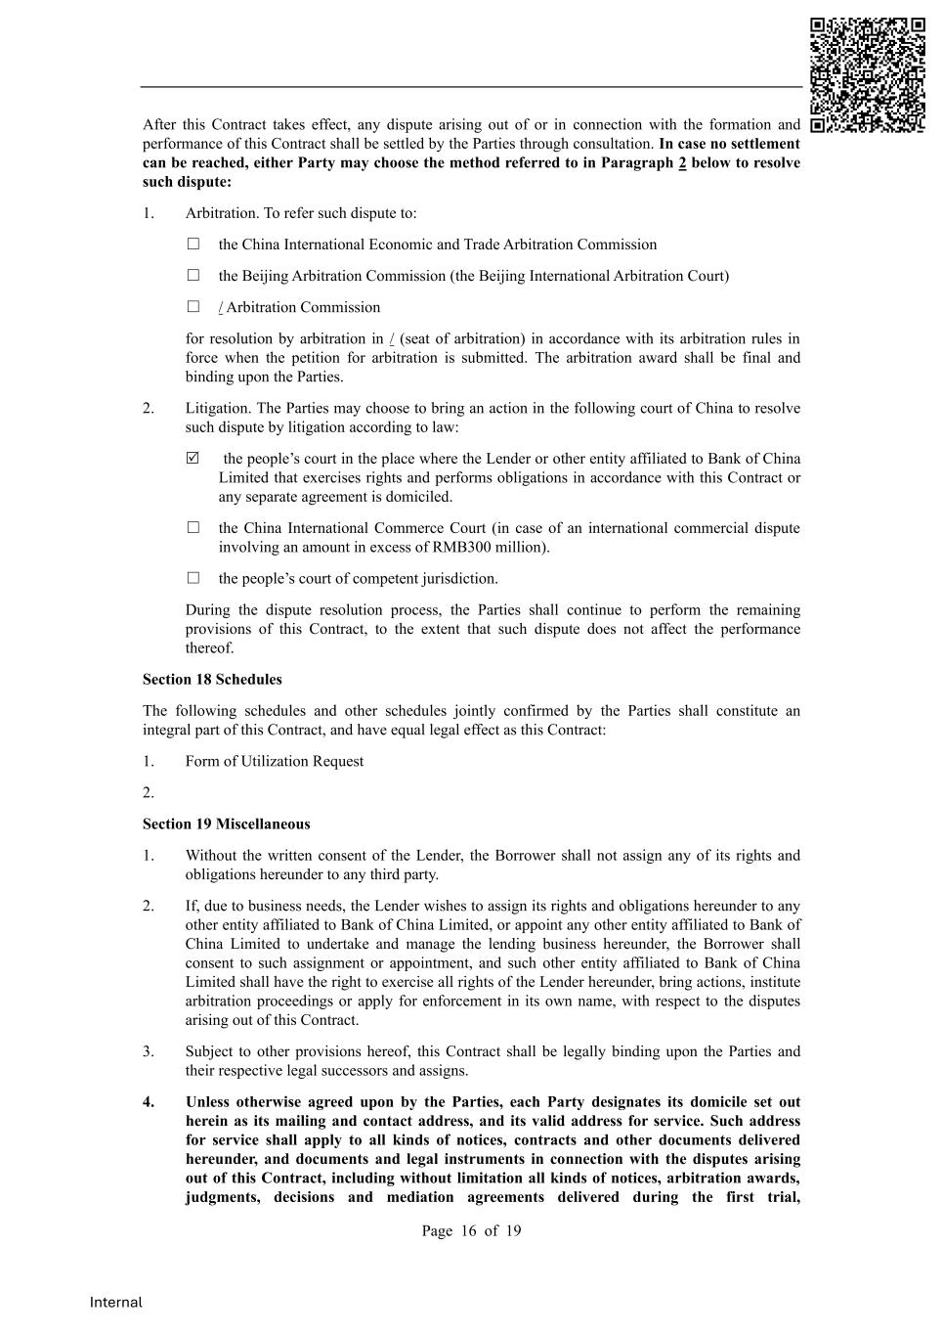
Page 16 of 19 Internal After this Contract takes effect, any dispute arising out of or in connection with the formation and performance of this Contract shall be settled by the Parties through consultation. In case no settlement can be reached, either Party may choose the method referred to in Paragraph 2 below to resolve such dispute: 1. Arbitration. To refer such dispute to: □ the China International Economic and Trade Arbitration Commission □ the Beijing Arbitration Commission (the Beijing International Arbitration Court) □ / Arbitration Commission for resolution by arbitration in / (seat of arbitration) in accordance with its arbitration rules in force when the petition for arbitration is submitted. The arbitration award shall be final and binding upon the Parties. 2. Litigation. The Parties may choose to bring an action in the following court of China to resolve such dispute by litigation according to law:  the people’s court in the place where the Lender or other entity affiliated to Bank of China Limited that exercises rights and performs obligations in accordance with this Contract or any separate agreement is domiciled. □ the China International Commerce Court (in case of an international commercial dispute involving an amount in excess of RMB300 million). □ the people’s court of competent jurisdiction. During the dispute resolution process, the Parties shall continue to perform the remaining provisions of this Contract, to the extent that such dispute does not affect the performance thereof. Section 18 Schedules The following schedules and other schedules jointly confirmed by the Parties shall constitute an integral part of this Contract, and have equal legal effect as this Contract: 1. Form of Utilization Request 2. Section 19 Miscellaneous 1. Without the written consent of the Lender, the Borrower shall not assign any of its rights and obligations hereunder to any third party. 2. If, due to business needs, the Lender wishes to assign its rights and obligations hereunder to any other entity affiliated to Bank of China Limited, or appoint any other entity affiliated to Bank of China Limited to undertake and manage the lending business hereunder, the Borrower shall consent to such assignment or appointment, and such other entity affiliated to Bank of China Limited shall have the right to exercise all rights of the Lender hereunder, bring actions, institute arbitration proceedings or apply for enforcement in its own name, with respect to the disputes arising out of this Contract. 3. Subject to other provisions hereof, this Contract shall be legally binding upon the Parties and their respective legal successors and assigns. 4. Unless otherwise agreed upon by the Parties, each Party designates its domicile set out herein as its mailing and contact address, and its valid address for service. Such address for service shall apply to all kinds of notices, contracts and other documents delivered hereunder, and documents and legal instruments in connection with the disputes arising out of this Contract, including without limitation all kinds of notices, arbitration awards, judgments, decisions and mediation agreements delivered during the first trial,

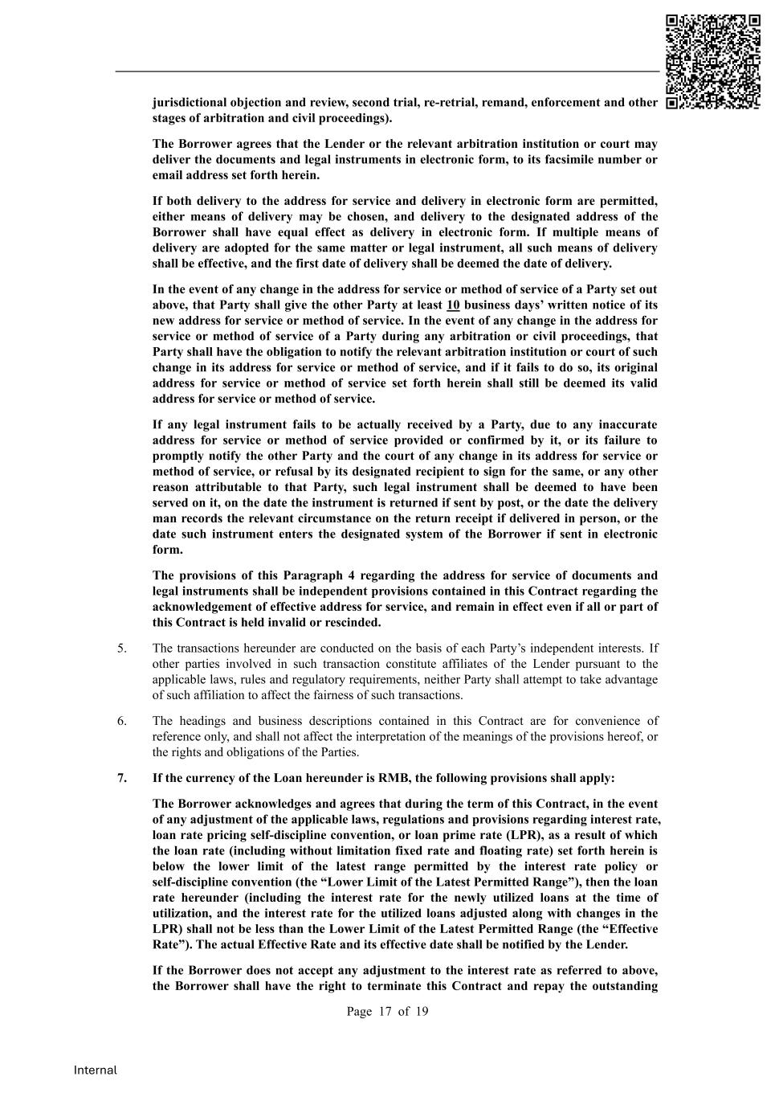
Page 17 of 19 Internal jurisdictional objection and review, second trial, re-retrial, remand, enforcement and other stages of arbitration and civil proceedings). The Borrower agrees that the Lender or the relevant arbitration institution or court may deliver the documents and legal instruments in electronic form, to its facsimile number or email address set forth herein. If both delivery to the address for service and delivery in electronic form are permitted, either means of delivery may be chosen, and delivery to the designated address of the Borrower shall have equal effect as delivery in electronic form. If multiple means of delivery are adopted for the same matter or legal instrument, all such means of delivery shall be effective, and the first date of delivery shall be deemed the date of delivery. In the event of any change in the address for service or method of service of a Party set out above, that Party shall give the other Party at least 10 business days’ written notice of its new address for service or method of service. In the event of any change in the address for service or method of service of a Party during any arbitration or civil proceedings, that Party shall have the obligation to notify the relevant arbitration institution or court of such change in its address for service or method of service, and if it fails to do so, its original address for service or method of service set forth herein shall still be deemed its valid address for service or method of service. If any legal instrument fails to be actually received by a Party, due to any inaccurate address for service or method of service provided or confirmed by it, or its failure to promptly notify the other Party and the court of any change in its address for service or method of service, or refusal by its designated recipient to sign for the same, or any other reason attributable to that Party, such legal instrument shall be deemed to have been served on it, on the date the instrument is returned if sent by post, or the date the delivery man records the relevant circumstance on the return receipt if delivered in person, or the date such instrument enters the designated system of the Borrower if sent in electronic form. The provisions of this Paragraph 4 regarding the address for service of documents and legal instruments shall be independent provisions contained in this Contract regarding the acknowledgement of effective address for service, and remain in effect even if all or part of this Contract is held invalid or rescinded. 5. The transactions hereunder are conducted on the basis of each Party’s independent interests. If other parties involved in such transaction constitute affiliates of the Lender pursuant to the applicable laws, rules and regulatory requirements, neither Party shall attempt to take advantage of such affiliation to affect the fairness of such transactions. 6. The headings and business descriptions contained in this Contract are for convenience of reference only, and shall not affect the interpretation of the meanings of the provisions hereof, or the rights and obligations of the Parties. 7. If the currency of the Loan hereunder is RMB, the following provisions shall apply: The Borrower acknowledges and agrees that during the term of this Contract, in the event of any adjustment of the applicable laws, regulations and provisions regarding interest rate, loan rate pricing self-discipline convention, or loan prime rate (LPR), as a result of which the loan rate (including without limitation fixed rate and floating rate) set forth herein is below the lower limit of the latest range permitted by the interest rate policy or self-discipline convention (the “Lower Limit of the Latest Permitted Range”), then the loan rate hereunder (including the interest rate for the newly utilized loans at the time of utilization, and the interest rate for the utilized loans adjusted along with changes in the LPR) shall not be less than the Lower Limit of the Latest Permitted Range (the “Effective Rate”). The actual Effective Rate and its effective date shall be notified by the Lender. If the Borrower does not accept any adjustment to the interest rate as referred to above, the Borrower shall have the right to terminate this Contract and repay the outstanding

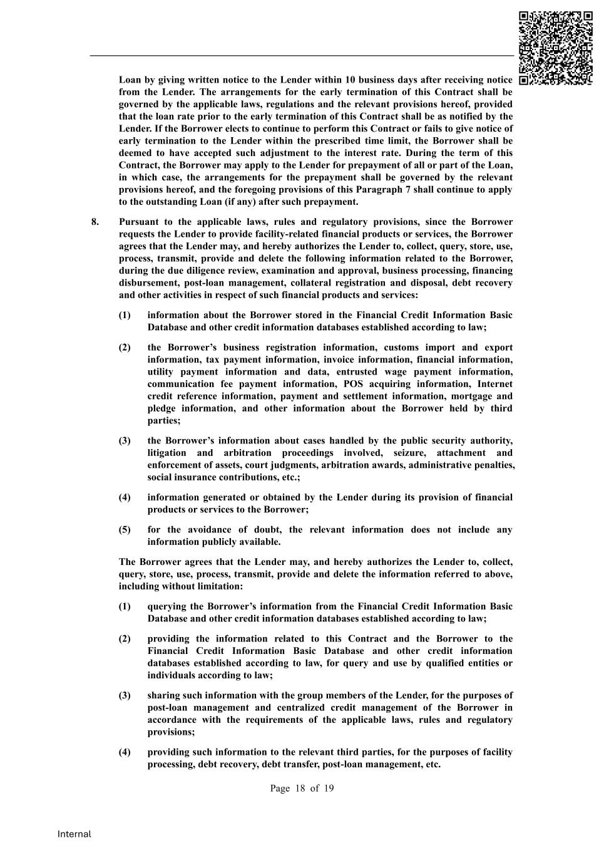
Page 18 of 19 Internal Loan by giving written notice to the Lender within 10 business days after receiving notice from the Lender. The arrangements for the early termination of this Contract shall be governed by the applicable laws, regulations and the relevant provisions hereof, provided that the loan rate prior to the early termination of this Contract shall be as notified by the Lender. If the Borrower elects to continue to perform this Contract or fails to give notice of early termination to the Lender within the prescribed time limit, the Borrower shall be deemed to have accepted such adjustment to the interest rate. During the term of this Contract, the Borrower may apply to the Lender for prepayment of all or part of the Loan, in which case, the arrangements for the prepayment shall be governed by the relevant provisions hereof, and the foregoing provisions of this Paragraph 7 shall continue to apply to the outstanding Loan (if any) after such prepayment. 8. Pursuant to the applicable laws, rules and regulatory provisions, since the Borrower requests the Lender to provide facility-related financial products or services, the Borrower agrees that the Lender may, and hereby authorizes the Lender to, collect, query, store, use, process, transmit, provide and delete the following information related to the Borrower, during the due diligence review, examination and approval, business processing, financing disbursement, post-loan management, collateral registration and disposal, debt recovery and other activities in respect of such financial products and services: (1) information about the Borrower stored in the Financial Credit Information Basic Database and other credit information databases established according to law; (2) the Borrower’s business registration information, customs import and export information, tax payment information, invoice information, financial information, utility payment information and data, entrusted wage payment information, communication fee payment information, POS acquiring information, Internet credit reference information, payment and settlement information, mortgage and pledge information, and other information about the Borrower held by third parties; (3) the Borrower’s information about cases handled by the public security authority, litigation and arbitration proceedings involved, seizure, attachment and enforcement of assets, court judgments, arbitration awards, administrative penalties, social insurance contributions, etc.; (4) information generated or obtained by the Lender during its provision of financial products or services to the Borrower; (5) for the avoidance of doubt, the relevant information does not include any information publicly available. The Borrower agrees that the Lender may, and hereby authorizes the Lender to, collect, query, store, use, process, transmit, provide and delete the information referred to above, including without limitation: (1) querying the Borrower’s information from the Financial Credit Information Basic Database and other credit information databases established according to law; (2) providing the information related to this Contract and the Borrower to the Financial Credit Information Basic Database and other credit information databases established according to law, for query and use by qualified entities or individuals according to law; (3) sharing such information with the group members of the Lender, for the purposes of post-loan management and centralized credit management of the Borrower in accordance with the requirements of the applicable laws, rules and regulatory provisions; (4) providing such information to the relevant third parties, for the purposes of facility processing, debt recovery, debt transfer, post-loan management, etc.

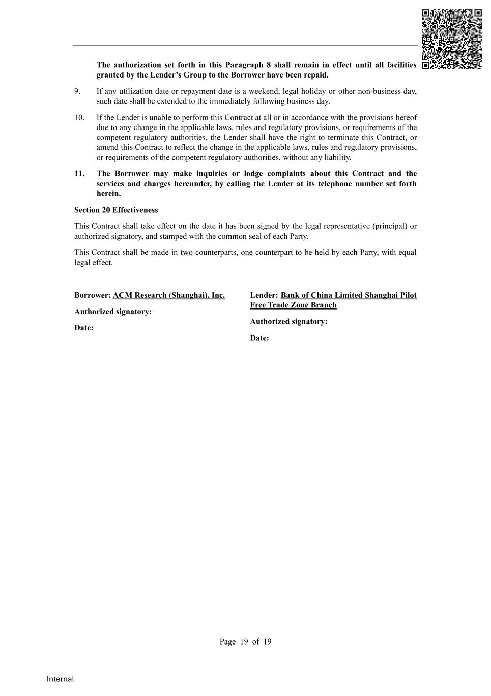
Page 19 of 19 Internal The authorization set forth in this Paragraph 8 shall remain in effect until all facilities granted by the Lender’s Group to the Borrower have been repaid. 9. If any utilization date or repayment date is a weekend, legal holiday or other non-business day, such date shall be extended to the immediately following business day. 10. If the Lender is unable to perform this Contract at all or in accordance with the provisions hereof due to any change in the applicable laws, rules and regulatory provisions, or requirements of the competent regulatory authorities, the Lender shall have the right to terminate this Contract, or amend this Contract to reflect the change in the applicable laws, rules and regulatory provisions, or requirements of the competent regulatory authorities, without any liability. 11. The Borrower may make inquiries or lodge complaints about this Contract and the services and charges hereunder, by calling the Lender at its telephone number set forth herein. Section 20 Effectiveness This Contract shall take effect on the date it has been signed by the legal representative (principal) or authorized signatory, and stamped with the common seal of each Party. This Contract shall be made in two counterparts, one counterpart to be held by each Party, with equal legal effect. Borrower: ACM Research (Shanghai), Inc. Authorized signatory: Date: Lender: Bank of China Limited Shanghai Pilot Free Trade Zone Branch Authorized signatory: Date:


Internal Contract No.: Asset Transaction Contract Subject Matter: Property located at 71/F, Shanghai World Financial Center, 100 Century Avenue, Pudong New Area, Shanghai Transferor: Honwa Financial Leasing Co., Ltd. Transferee: ACM Research (Shanghai), Inc.

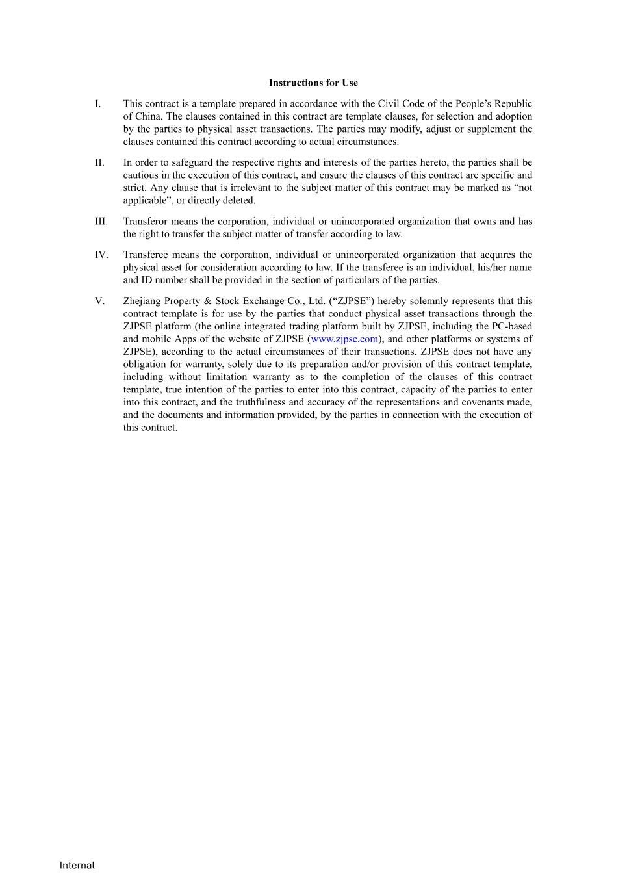
Internal Instructions for Use I. This contract is a template prepared in accordance with the Civil Code of the People’s Republic of China. The clauses contained in this contract are template clauses, for selection and adoption by the parties to physical asset transactions. The parties may modify, adjust or supplement the clauses contained this contract according to actual circumstances. II. In order to safeguard the respective rights and interests of the parties hereto, the parties shall be cautious in the execution of this contract, and ensure the clauses of this contract are specific and strict. Any clause that is irrelevant to the subject matter of this contract may be marked as “not applicable”, or directly deleted. III. Transferor means the corporation, individual or unincorporated organization that owns and has the right to transfer the subject matter of transfer according to law. IV. Transferee means the corporation, individual or unincorporated organization that acquires the physical asset for consideration according to law. If the transferee is an individual, his/her name and ID number shall be provided in the section of particulars of the parties. V. Zhejiang Property & Stock Exchange Co., Ltd. (“ZJPSE”) hereby solemnly represents that this contract template is for use by the parties that conduct physical asset transactions through the ZJPSE platform (the online integrated trading platform built by ZJPSE, including the PC-based and mobile Apps of the website of ZJPSE (www.zjpse.com), and other platforms or systems of ZJPSE), according to the actual circumstances of their transactions. ZJPSE does not have any obligation for warranty, solely due to its preparation and/or provision of this contract template, including without limitation warranty as to the completion of the clauses of this contract template, true intention of the parties to enter into this contract, capacity of the parties to enter into this contract, and the truthfulness and accuracy of the representations and covenants made, and the documents and information provided, by the parties in connection with the execution of this contract.

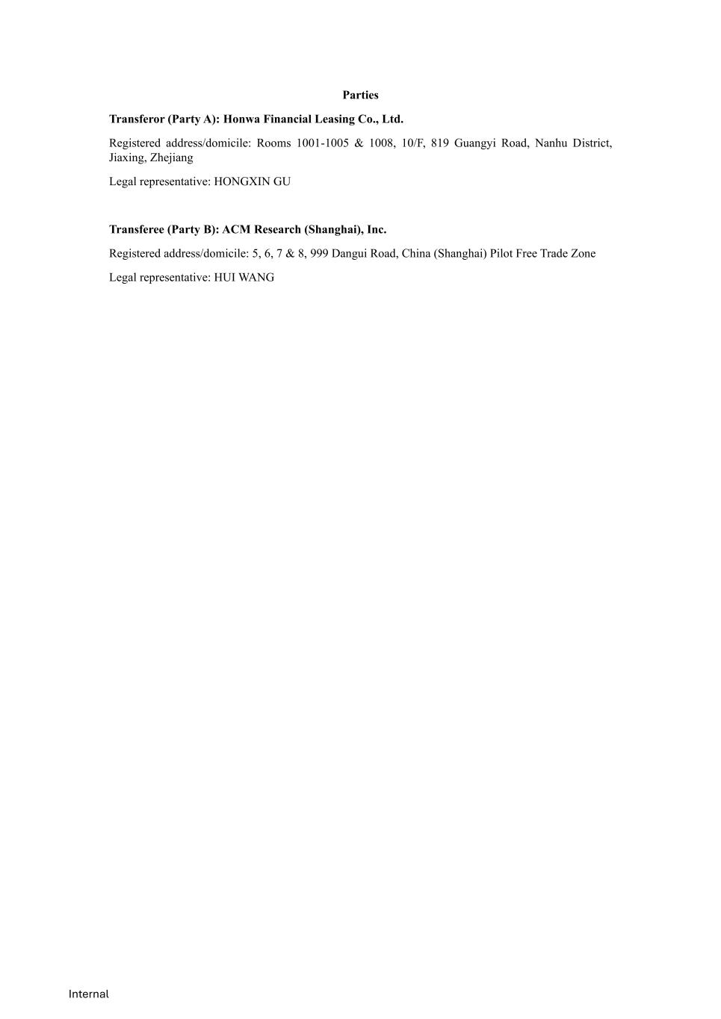
Internal Parties Transferor (Party A): Honwa Financial Leasing Co., Ltd. Registered address/domicile: Rooms 1001-1005 & 1008, 10/F, 819 Guangyi Road, Nanhu District, Jiaxing, Zhejiang Legal representative: HONGXIN GU Transferee (Party B): ACM Research (Shanghai), Inc. Registered address/domicile: 5, 6, 7 & 8, 999 Dangui Road, China (Shanghai) Pilot Free Trade Zone Legal representative: HUI WANG

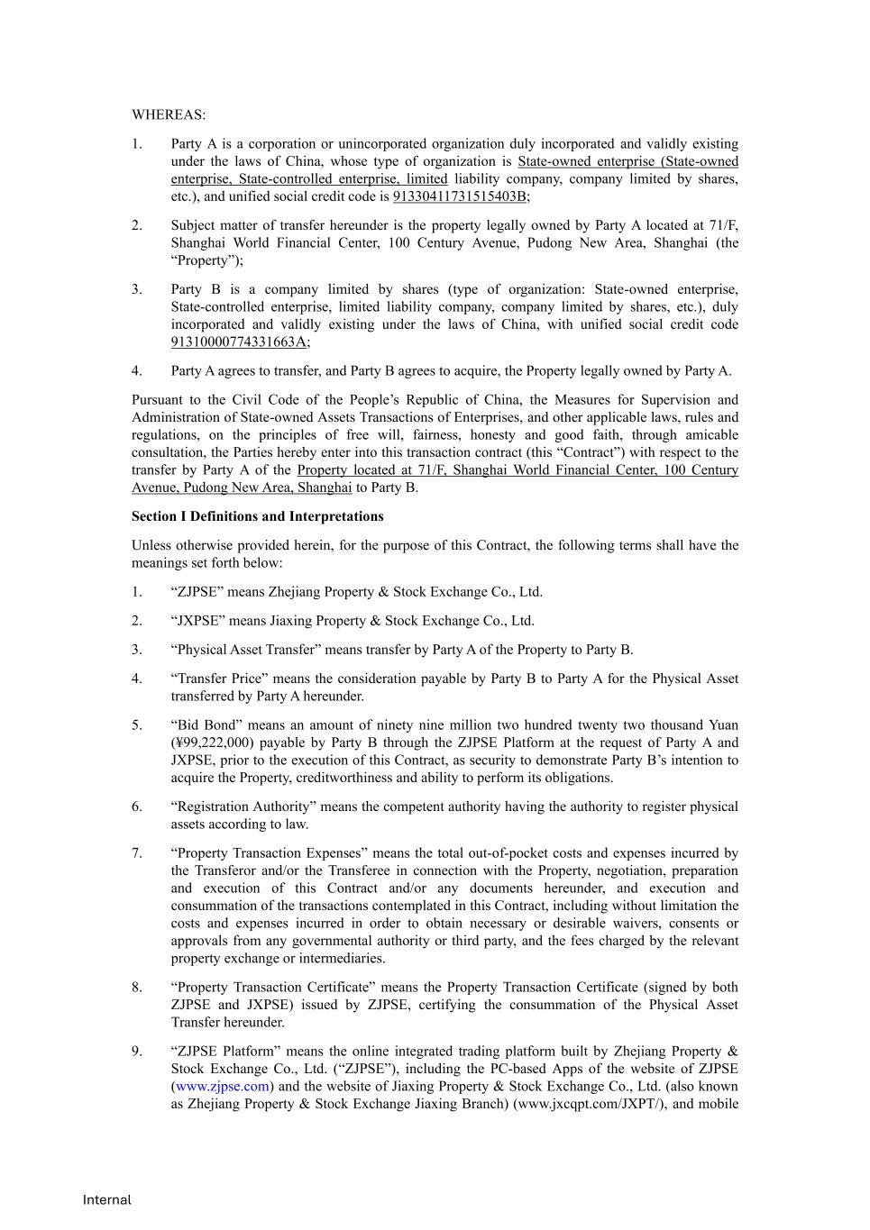
Internal WHEREAS: 1. Party A is a corporation or unincorporated organization duly incorporated and validly existing under the laws of China, whose type of organization is State-owned enterprise (State-owned enterprise, State-controlled enterprise, limited liability company, company limited by shares, etc.), and unified social credit code is 91330411731515403B; 2. Subject matter of transfer hereunder is the property legally owned by Party A located at 71/F, Shanghai World Financial Center, 100 Century Avenue, Pudong New Area, Shanghai (the “Property”); 3. Party B is a company limited by shares (type of organization: State-owned enterprise, State-controlled enterprise, limited liability company, company limited by shares, etc.), duly incorporated and validly existing under the laws of China, with unified social credit code 91310000774331663A; 4. Party A agrees to transfer, and Party B agrees to acquire, the Property legally owned by Party A. Pursuant to the Civil Code of the People’s Republic of China, the Measures for Supervision and Administration of State-owned Assets Transactions of Enterprises, and other applicable laws, rules and regulations, on the principles of free will, fairness, honesty and good faith, through amicable consultation, the Parties hereby enter into this transaction contract (this “Contract”) with respect to the transfer by Party A of the Property located at 71/F, Shanghai World Financial Center, 100 Century Avenue, Pudong New Area, Shanghai to Party B. Section I Definitions and Interpretations Unless otherwise provided herein, for the purpose of this Contract, the following terms shall have the meanings set forth below: 1. “ZJPSE” means Zhejiang Property & Stock Exchange Co., Ltd. 2. “JXPSE” means Jiaxing Property & Stock Exchange Co., Ltd. 3. “Physical Asset Transfer” means transfer by Party A of the Property to Party B. 4. “Transfer Price” means the consideration payable by Party B to Party A for the Physical Asset transferred by Party A hereunder. 5. “Bid Bond” means an amount of ninety nine million two hundred twenty two thousand Yuan (¥99,222,000) payable by Party B through the ZJPSE Platform at the request of Party A and JXPSE, prior to the execution of this Contract, as security to demonstrate Party B’s intention to acquire the Property, creditworthiness and ability to perform its obligations. 6. “Registration Authority” means the competent authority having the authority to register physical assets according to law. 7. “Property Transaction Expenses” means the total out-of-pocket costs and expenses incurred by the Transferor and/or the Transferee in connection with the Property, negotiation, preparation and execution of this Contract and/or any documents hereunder, and execution and consummation of the transactions contemplated in this Contract, including without limitation the costs and expenses incurred in order to obtain necessary or desirable waivers, consents or approvals from any governmental authority or third party, and the fees charged by the relevant property exchange or intermediaries. 8. “Property Transaction Certificate” means the Property Transaction Certificate (signed by both ZJPSE and JXPSE) issued by ZJPSE, certifying the consummation of the Physical Asset Transfer hereunder. 9. “ZJPSE Platform” means the online integrated trading platform built by Zhejiang Property & Stock Exchange Co., Ltd. (“ZJPSE”), including the PC-based Apps of the website of ZJPSE (www.zjpse.com) and the website of Jiaxing Property & Stock Exchange Co., Ltd. (also known as Zhejiang Property & Stock Exchange Jiaxing Branch) (www.jxcqpt.com/JXPT/), and mobile

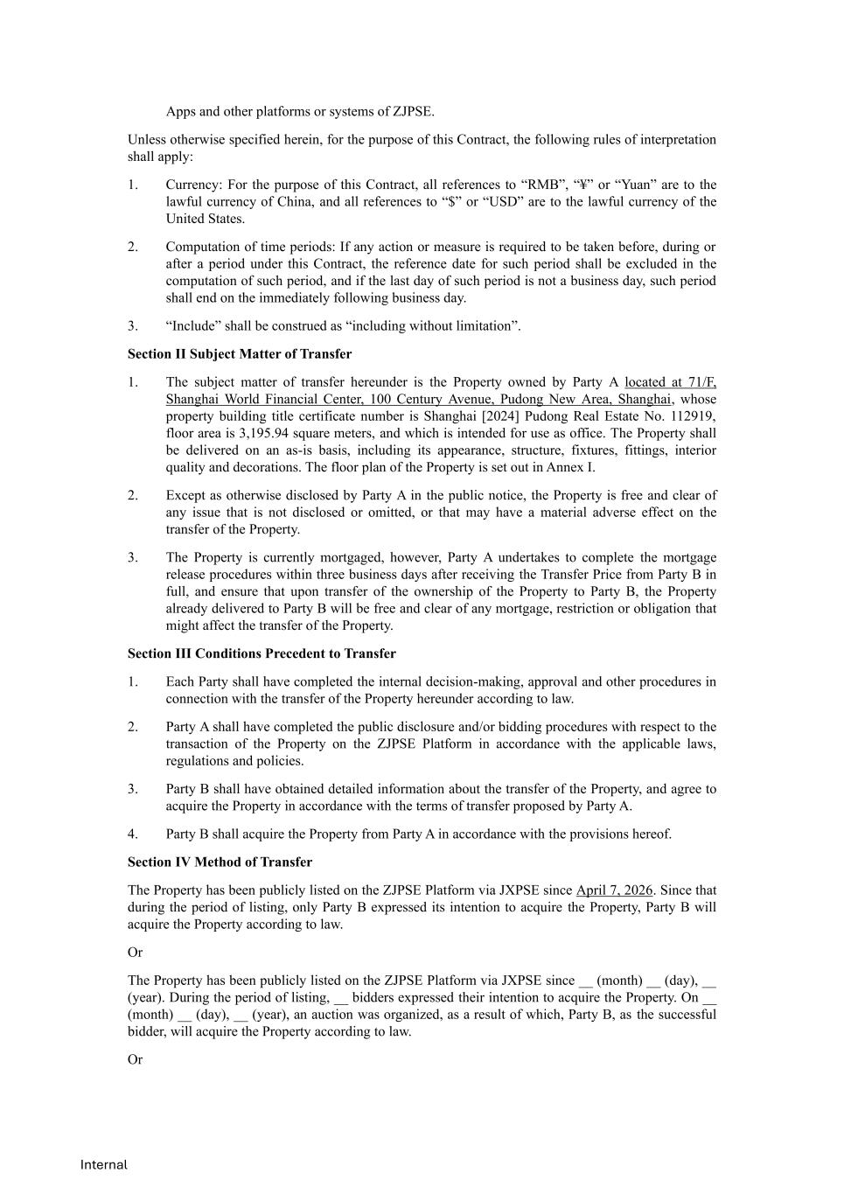
Internal Apps and other platforms or systems of ZJPSE. Unless otherwise specified herein, for the purpose of this Contract, the following rules of interpretation shall apply: 1. Currency: For the purpose of this Contract, all references to “RMB”, “¥” or “Yuan” are to the lawful currency of China, and all references to “$” or “USD” are to the lawful currency of the United States. 2. Computation of time periods: If any action or measure is required to be taken before, during or after a period under this Contract, the reference date for such period shall be excluded in the computation of such period, and if the last day of such period is not a business day, such period shall end on the immediately following business day. 3. “Include” shall be construed as “including without limitation”. Section II Subject Matter of Transfer 1. The subject matter of transfer hereunder is the Property owned by Party A located at 71/F, Shanghai World Financial Center, 100 Century Avenue, Pudong New Area, Shanghai, whose property building title certificate number is Shanghai [2024] Pudong Real Estate No. 112919, floor area is 3,195.94 square meters, and which is intended for use as office. The Property shall be delivered on an as-is basis, including its appearance, structure, fixtures, fittings, interior quality and decorations. The floor plan of the Property is set out in Annex I. 2. Except as otherwise disclosed by Party A in the public notice, the Property is free and clear of any issue that is not disclosed or omitted, or that may have a material adverse effect on the transfer of the Property. 3. The Property is currently mortgaged, however, Party A undertakes to complete the mortgage release procedures within three business days after receiving the Transfer Price from Party B in full, and ensure that upon transfer of the ownership of the Property to Party B, the Property already delivered to Party B will be free and clear of any mortgage, restriction or obligation that might affect the transfer of the Property. Section III Conditions Precedent to Transfer 1. Each Party shall have completed the internal decision-making, approval and other procedures in connection with the transfer of the Property hereunder according to law. 2. Party A shall have completed the public disclosure and/or bidding procedures with respect to the transaction of the Property on the ZJPSE Platform in accordance with the applicable laws, regulations and policies. 3. Party B shall have obtained detailed information about the transfer of the Property, and agree to acquire the Property in accordance with the terms of transfer proposed by Party A. 4. Party B shall acquire the Property from Party A in accordance with the provisions hereof. Section IV Method of Transfer The Property has been publicly listed on the ZJPSE Platform via JXPSE since April 7, 2026. Since that during the period of listing, only Party B expressed its intention to acquire the Property, Party B will acquire the Property according to law. Or The Property has been publicly listed on the ZJPSE Platform via JXPSE since __ (month) __ (day), __ (year). During the period of listing, __ bidders expressed their intention to acquire the Property. On __ (month) __ (day), __ (year), an auction was organized, as a result of which, Party B, as the successful bidder, will acquire the Property according to law. Or

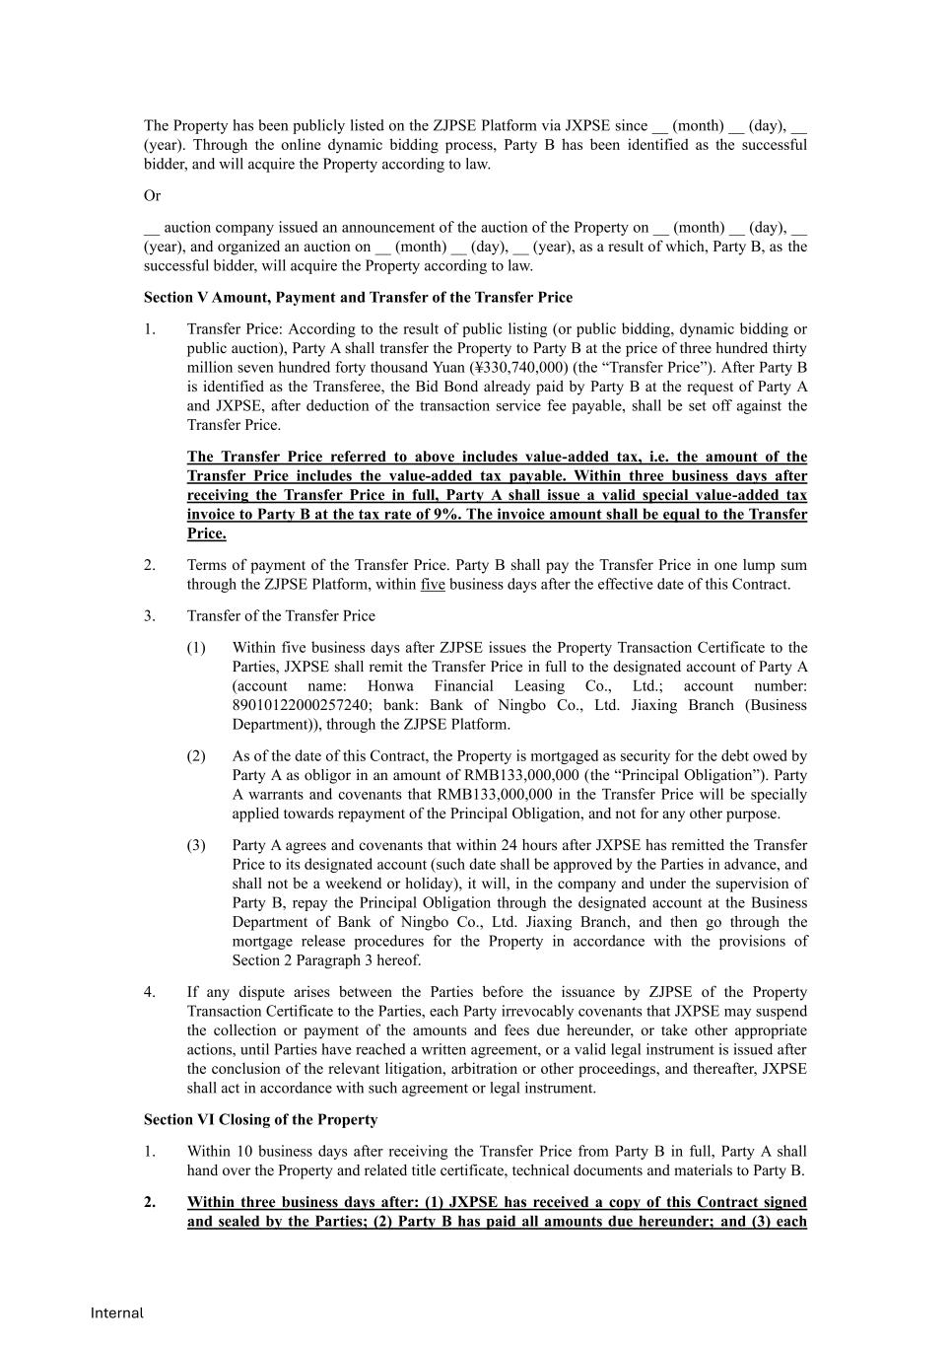
Internal The Property has been publicly listed on the ZJPSE Platform via JXPSE since __ (month) __ (day), __ (year). Through the online dynamic bidding process, Party B has been identified as the successful bidder, and will acquire the Property according to law. Or __ auction company issued an announcement of the auction of the Property on __ (month) __ (day), __ (year), and organized an auction on __ (month) __ (day), __ (year), as a result of which, Party B, as the successful bidder, will acquire the Property according to law. Section V Amount, Payment and Transfer of the Transfer Price 1. Transfer Price: According to the result of public listing (or public bidding, dynamic bidding or public auction), Party A shall transfer the Property to Party B at the price of three hundred thirty million seven hundred forty thousand Yuan (¥330,740,000) (the “Transfer Price”). After Party B is identified as the Transferee, the Bid Bond already paid by Party B at the request of Party A and JXPSE, after deduction of the transaction service fee payable, shall be set off against the Transfer Price. The Transfer Price referred to above includes value-added tax, i.e. the amount of the Transfer Price includes the value-added tax payable. Within three business days after receiving the Transfer Price in full, Party A shall issue a valid special value-added tax invoice to Party B at the tax rate of 9%. The invoice amount shall be equal to the Transfer Price. 2. Terms of payment of the Transfer Price. Party B shall pay the Transfer Price in one lump sum through the ZJPSE Platform, within five business days after the effective date of this Contract. 3. Transfer of the Transfer Price (1) Within five business days after ZJPSE issues the Property Transaction Certificate to the Parties, JXPSE shall remit the Transfer Price in full to the designated account of Party A (account name: Honwa Financial Leasing Co., Ltd.; account number: 89010122000257240; bank: Bank of Ningbo Co., Ltd. Jiaxing Branch (Business Department)), through the ZJPSE Platform. (2) As of the date of this Contract, the Property is mortgaged as security for the debt owed by Party A as obligor in an amount of RMB133,000,000 (the “Principal Obligation”). Party A warrants and covenants that RMB133,000,000 in the Transfer Price will be specially applied towards repayment of the Principal Obligation, and not for any other purpose. (3) Party A agrees and covenants that within 24 hours after JXPSE has remitted the Transfer Price to its designated account (such date shall be approved by the Parties in advance, and shall not be a weekend or holiday), it will, in the company and under the supervision of Party B, repay the Principal Obligation through the designated account at the Business Department of Bank of Ningbo Co., Ltd. Jiaxing Branch, and then go through the mortgage release procedures for the Property in accordance with the provisions of Section 2 Paragraph 3 hereof. 4. If any dispute arises between the Parties before the issuance by ZJPSE of the Property Transaction Certificate to the Parties, each Party irrevocably covenants that JXPSE may suspend the collection or payment of the amounts and fees due hereunder, or take other appropriate actions, until Parties have reached a written agreement, or a valid legal instrument is issued after the conclusion of the relevant litigation, arbitration or other proceedings, and thereafter, JXPSE shall act in accordance with such agreement or legal instrument. Section VI Closing of the Property 1. Within 10 business days after receiving the Transfer Price from Party B in full, Party A shall hand over the Property and related title certificate, technical documents and materials to Party B. 2. Within three business days after: (1) JXPSE has received a copy of this Contract signed and sealed by the Parties; (2) Party B has paid all amounts due hereunder; and (3) each

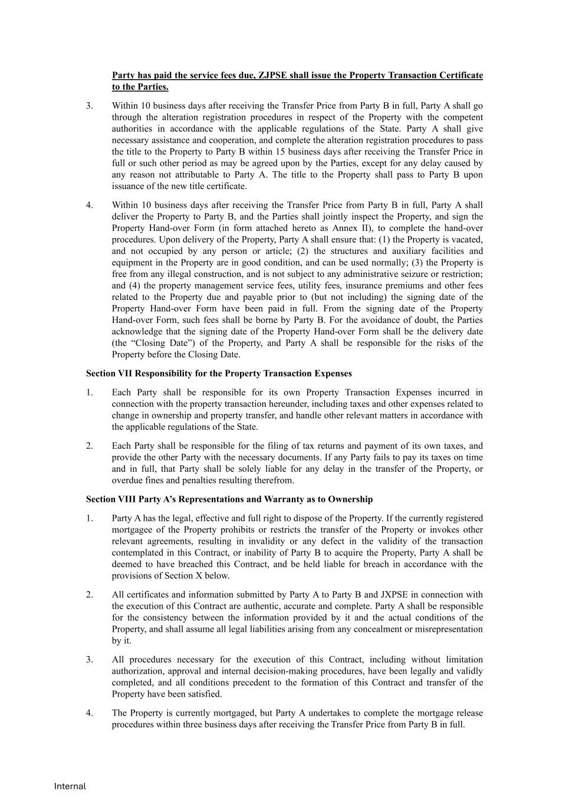
Internal Party has paid the service fees due, ZJPSE shall issue the Property Transaction Certificate to the Parties. 3. Within 10 business days after receiving the Transfer Price from Party B in full, Party A shall go through the alteration registration procedures in respect of the Property with the competent authorities in accordance with the applicable regulations of the State. Party A shall give necessary assistance and cooperation, and complete the alteration registration procedures to pass the title to the Property to Party B within 15 business days after receiving the Transfer Price in full or such other period as may be agreed upon by the Parties, except for any delay caused by any reason not attributable to Party A. The title to the Property shall pass to Party B upon issuance of the new title certificate. 4. Within 10 business days after receiving the Transfer Price from Party B in full, Party A shall deliver the Property to Party B, and the Parties shall jointly inspect the Property, and sign the Property Hand-over Form (in form attached hereto as Annex II), to complete the hand-over procedures. Upon delivery of the Property, Party A shall ensure that: (1) the Property is vacated, and not occupied by any person or article; (2) the structures and auxiliary facilities and equipment in the Property are in good condition, and can be used normally; (3) the Property is free from any illegal construction, and is not subject to any administrative seizure or restriction; and (4) the property management service fees, utility fees, insurance premiums and other fees related to the Property due and payable prior to (but not including) the signing date of the Property Hand-over Form have been paid in full. From the signing date of the Property Hand-over Form, such fees shall be borne by Party B. For the avoidance of doubt, the Parties acknowledge that the signing date of the Property Hand-over Form shall be the delivery date (the “Closing Date”) of the Property, and Party A shall be responsible for the risks of the Property before the Closing Date. Section VII Responsibility for the Property Transaction Expenses 1. Each Party shall be responsible for its own Property Transaction Expenses incurred in connection with the property transaction hereunder, including taxes and other expenses related to change in ownership and property transfer, and handle other relevant matters in accordance with the applicable regulations of the State. 2. Each Party shall be responsible for the filing of tax returns and payment of its own taxes, and provide the other Party with the necessary documents. If any Party fails to pay its taxes on time and in full, that Party shall be solely liable for any delay in the transfer of the Property, or overdue fines and penalties resulting therefrom. Section VIII Party A’s Representations and Warranty as to Ownership 1. Party A has the legal, effective and full right to dispose of the Property. If the currently registered mortgagee of the Property prohibits or restricts the transfer of the Property or invokes other relevant agreements, resulting in invalidity or any defect in the validity of the transaction contemplated in this Contract, or inability of Party B to acquire the Property, Party A shall be deemed to have breached this Contract, and be held liable for breach in accordance with the provisions of Section X below. 2. All certificates and information submitted by Party A to Party B and JXPSE in connection with the execution of this Contract are authentic, accurate and complete. Party A shall be responsible for the consistency between the information provided by it and the actual conditions of the Property, and shall assume all legal liabilities arising from any concealment or misrepresentation by it. 3. All procedures necessary for the execution of this Contract, including without limitation authorization, approval and internal decision-making procedures, have been legally and validly completed, and all conditions precedent to the formation of this Contract and transfer of the Property have been satisfied. 4. The Property is currently mortgaged, but Party A undertakes to complete the mortgage release procedures within three business days after receiving the Transfer Price from Party B in full.

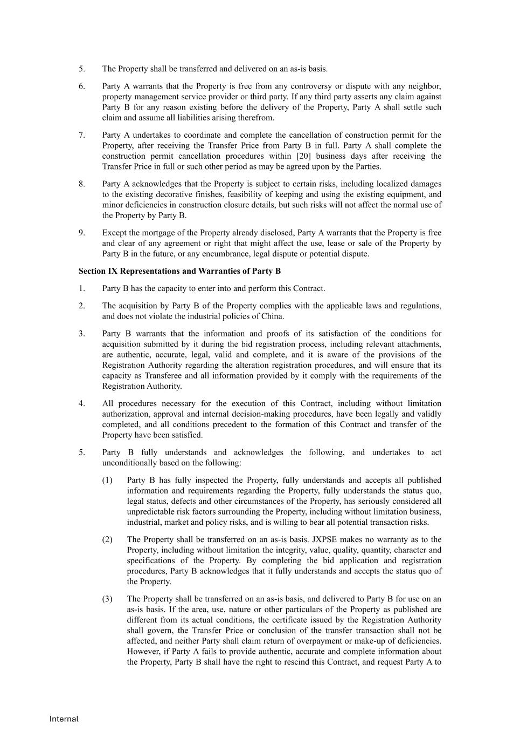
Internal 5. The Property shall be transferred and delivered on an as-is basis. 6. Party A warrants that the Property is free from any controversy or dispute with any neighbor, property management service provider or third party. If any third party asserts any claim against Party B for any reason existing before the delivery of the Property, Party A shall settle such claim and assume all liabilities arising therefrom. 7. Party A undertakes to coordinate and complete the cancellation of construction permit for the Property, after receiving the Transfer Price from Party B in full. Party A shall complete the construction permit cancellation procedures within [20] business days after receiving the Transfer Price in full or such other period as may be agreed upon by the Parties. 8. Party A acknowledges that the Property is subject to certain risks, including localized damages to the existing decorative finishes, feasibility of keeping and using the existing equipment, and minor deficiencies in construction closure details, but such risks will not affect the normal use of the Property by Party B. 9. Except the mortgage of the Property already disclosed, Party A warrants that the Property is free and clear of any agreement or right that might affect the use, lease or sale of the Property by Party B in the future, or any encumbrance, legal dispute or potential dispute. Section IX Representations and Warranties of Party B 1. Party B has the capacity to enter into and perform this Contract. 2. The acquisition by Party B of the Property complies with the applicable laws and regulations, and does not violate the industrial policies of China. 3. Party B warrants that the information and proofs of its satisfaction of the conditions for acquisition submitted by it during the bid registration process, including relevant attachments, are authentic, accurate, legal, valid and complete, and it is aware of the provisions of the Registration Authority regarding the alteration registration procedures, and will ensure that its capacity as Transferee and all information provided by it comply with the requirements of the Registration Authority. 4. All procedures necessary for the execution of this Contract, including without limitation authorization, approval and internal decision-making procedures, have been legally and validly completed, and all conditions precedent to the formation of this Contract and transfer of the Property have been satisfied. 5. Party B fully understands and acknowledges the following, and undertakes to act unconditionally based on the following: (1) Party B has fully inspected the Property, fully understands and accepts all published information and requirements regarding the Property, fully understands the status quo, legal status, defects and other circumstances of the Property, has seriously considered all unpredictable risk factors surrounding the Property, including without limitation business, industrial, market and policy risks, and is willing to bear all potential transaction risks. (2) The Property shall be transferred on an as-is basis. JXPSE makes no warranty as to the Property, including without limitation the integrity, value, quality, quantity, character and specifications of the Property. By completing the bid application and registration procedures, Party B acknowledges that it fully understands and accepts the status quo of the Property. (3) The Property shall be transferred on an as-is basis, and delivered to Party B for use on an as-is basis. If the area, use, nature or other particulars of the Property as published are different from its actual conditions, the certificate issued by the Registration Authority shall govern, the Transfer Price or conclusion of the transfer transaction shall not be affected, and neither Party shall claim return of overpayment or make-up of deficiencies. However, if Party A fails to provide authentic, accurate and complete information about the Property, Party B shall have the right to rescind this Contract, and request Party A to

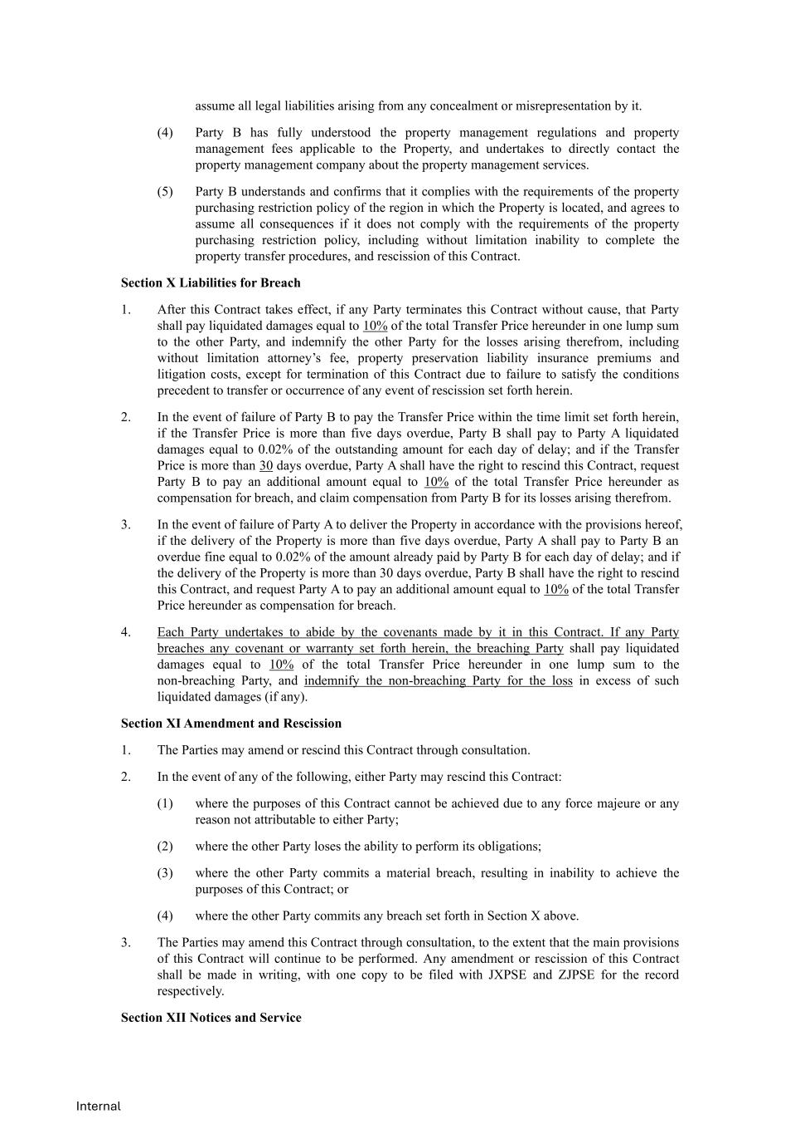
Internal assume all legal liabilities arising from any concealment or misrepresentation by it. (4) Party B has fully understood the property management regulations and property management fees applicable to the Property, and undertakes to directly contact the property management company about the property management services. (5) Party B understands and confirms that it complies with the requirements of the property purchasing restriction policy of the region in which the Property is located, and agrees to assume all consequences if it does not comply with the requirements of the property purchasing restriction policy, including without limitation inability to complete the property transfer procedures, and rescission of this Contract. Section X Liabilities for Breach 1. After this Contract takes effect, if any Party terminates this Contract without cause, that Party shall pay liquidated damages equal to 10% of the total Transfer Price hereunder in one lump sum to the other Party, and indemnify the other Party for the losses arising therefrom, including without limitation attorney’s fee, property preservation liability insurance premiums and litigation costs, except for termination of this Contract due to failure to satisfy the conditions precedent to transfer or occurrence of any event of rescission set forth herein. 2. In the event of failure of Party B to pay the Transfer Price within the time limit set forth herein, if the Transfer Price is more than five days overdue, Party B shall pay to Party A liquidated damages equal to 0.02% of the outstanding amount for each day of delay; and if the Transfer Price is more than 30 days overdue, Party A shall have the right to rescind this Contract, request Party B to pay an additional amount equal to 10% of the total Transfer Price hereunder as compensation for breach, and claim compensation from Party B for its losses arising therefrom. 3. In the event of failure of Party A to deliver the Property in accordance with the provisions hereof, if the delivery of the Property is more than five days overdue, Party A shall pay to Party B an overdue fine equal to 0.02% of the amount already paid by Party B for each day of delay; and if the delivery of the Property is more than 30 days overdue, Party B shall have the right to rescind this Contract, and request Party A to pay an additional amount equal to 10% of the total Transfer Price hereunder as compensation for breach. 4. Each Party undertakes to abide by the covenants made by it in this Contract. If any Party breaches any covenant or warranty set forth herein, the breaching Party shall pay liquidated damages equal to 10% of the total Transfer Price hereunder in one lump sum to the non-breaching Party, and indemnify the non-breaching Party for the loss in excess of such liquidated damages (if any). Section XI Amendment and Rescission 1. The Parties may amend or rescind this Contract through consultation. 2. In the event of any of the following, either Party may rescind this Contract: (1) where the purposes of this Contract cannot be achieved due to any force majeure or any reason not attributable to either Party; (2) where the other Party loses the ability to perform its obligations; (3) where the other Party commits a material breach, resulting in inability to achieve the purposes of this Contract; or (4) where the other Party commits any breach set forth in Section X above. 3. The Parties may amend this Contract through consultation, to the extent that the main provisions of this Contract will continue to be performed. Any amendment or rescission of this Contract shall be made in writing, with one copy to be filed with JXPSE and ZJPSE for the record respectively. Section XII Notices and Service

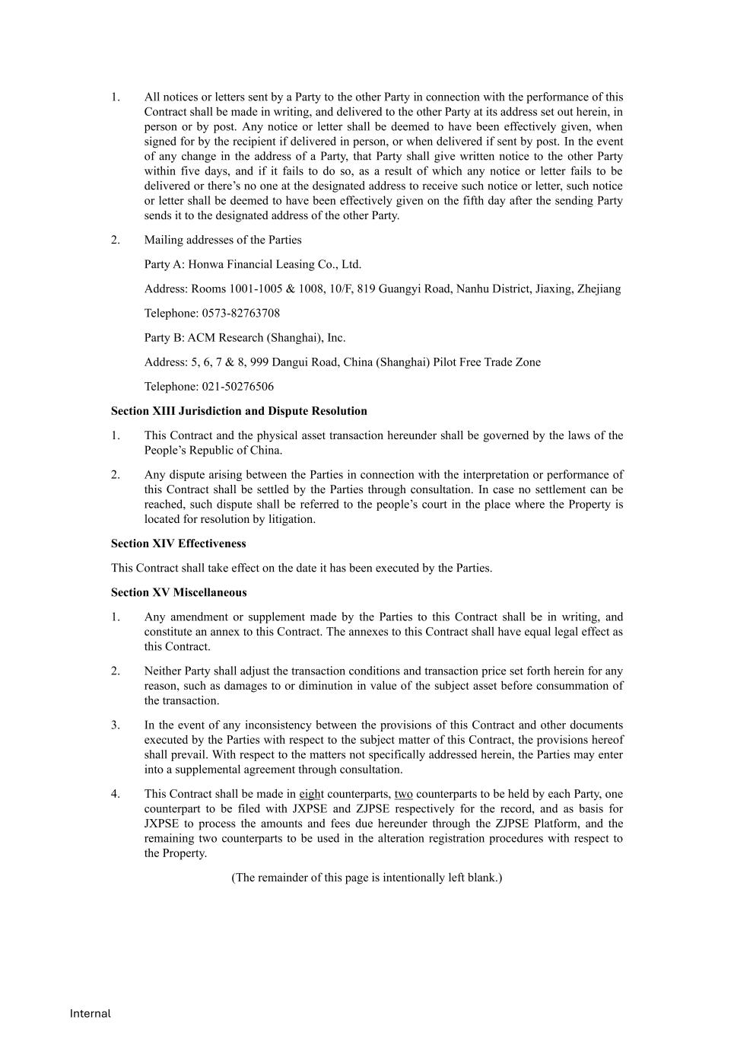
Internal 1. All notices or letters sent by a Party to the other Party in connection with the performance of this Contract shall be made in writing, and delivered to the other Party at its address set out herein, in person or by post. Any notice or letter shall be deemed to have been effectively given, when signed for by the recipient if delivered in person, or when delivered if sent by post. In the event of any change in the address of a Party, that Party shall give written notice to the other Party within five days, and if it fails to do so, as a result of which any notice or letter fails to be delivered or there’s no one at the designated address to receive such notice or letter, such notice or letter shall be deemed to have been effectively given on the fifth day after the sending Party sends it to the designated address of the other Party. 2. Mailing addresses of the Parties Party A: Honwa Financial Leasing Co., Ltd. Address: Rooms 1001-1005 & 1008, 10/F, 819 Guangyi Road, Nanhu District, Jiaxing, Zhejiang Telephone: 0573-82763708 Party B: ACM Research (Shanghai), Inc. Address: 5, 6, 7 & 8, 999 Dangui Road, China (Shanghai) Pilot Free Trade Zone Telephone: 021-50276506 Section XIII Jurisdiction and Dispute Resolution 1. This Contract and the physical asset transaction hereunder shall be governed by the laws of the People’s Republic of China. 2. Any dispute arising between the Parties in connection with the interpretation or performance of this Contract shall be settled by the Parties through consultation. In case no settlement can be reached, such dispute shall be referred to the people’s court in the place where the Property is located for resolution by litigation. Section XIV Effectiveness This Contract shall take effect on the date it has been executed by the Parties. Section XV Miscellaneous 1. Any amendment or supplement made by the Parties to this Contract shall be in writing, and constitute an annex to this Contract. The annexes to this Contract shall have equal legal effect as this Contract. 2. Neither Party shall adjust the transaction conditions and transaction price set forth herein for any reason, such as damages to or diminution in value of the subject asset before consummation of the transaction. 3. In the event of any inconsistency between the provisions of this Contract and other documents executed by the Parties with respect to the subject matter of this Contract, the provisions hereof shall prevail. With respect to the matters not specifically addressed herein, the Parties may enter into a supplemental agreement through consultation. 4. This Contract shall be made in eight counterparts, two counterparts to be held by each Party, one counterpart to be filed with JXPSE and ZJPSE respectively for the record, and as basis for JXPSE to process the amounts and fees due hereunder through the ZJPSE Platform, and the remaining two counterparts to be used in the alteration registration procedures with respect to the Property. (The remainder of this page is intentionally left blank.)

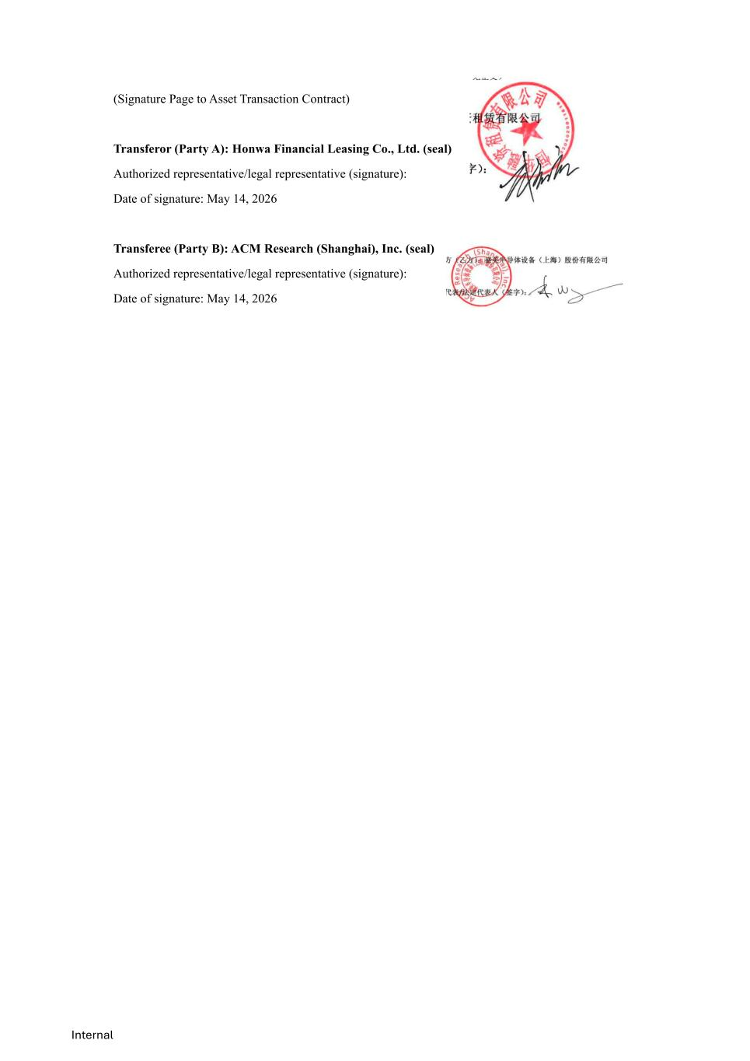
Internal (Signature Page to Asset Transaction Contract) Transferor (Party A): Honwa Financial Leasing Co., Ltd. (seal) Authorized representative/legal representative (signature): Date of signature: May 14, 2026 Transferee (Party B): ACM Research (Shanghai), Inc. (seal) Authorized representative/legal representative (signature): Date of signature: May 14, 2026

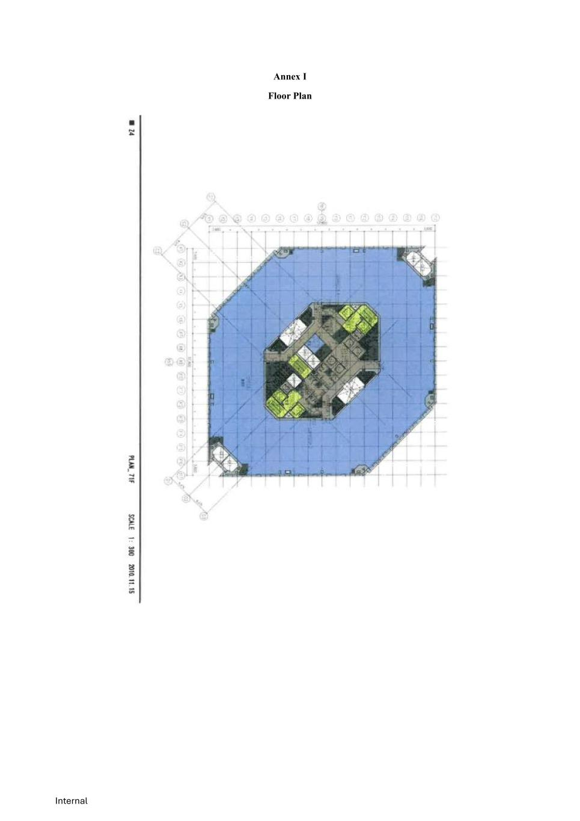
Internal Annex I Floor Plan

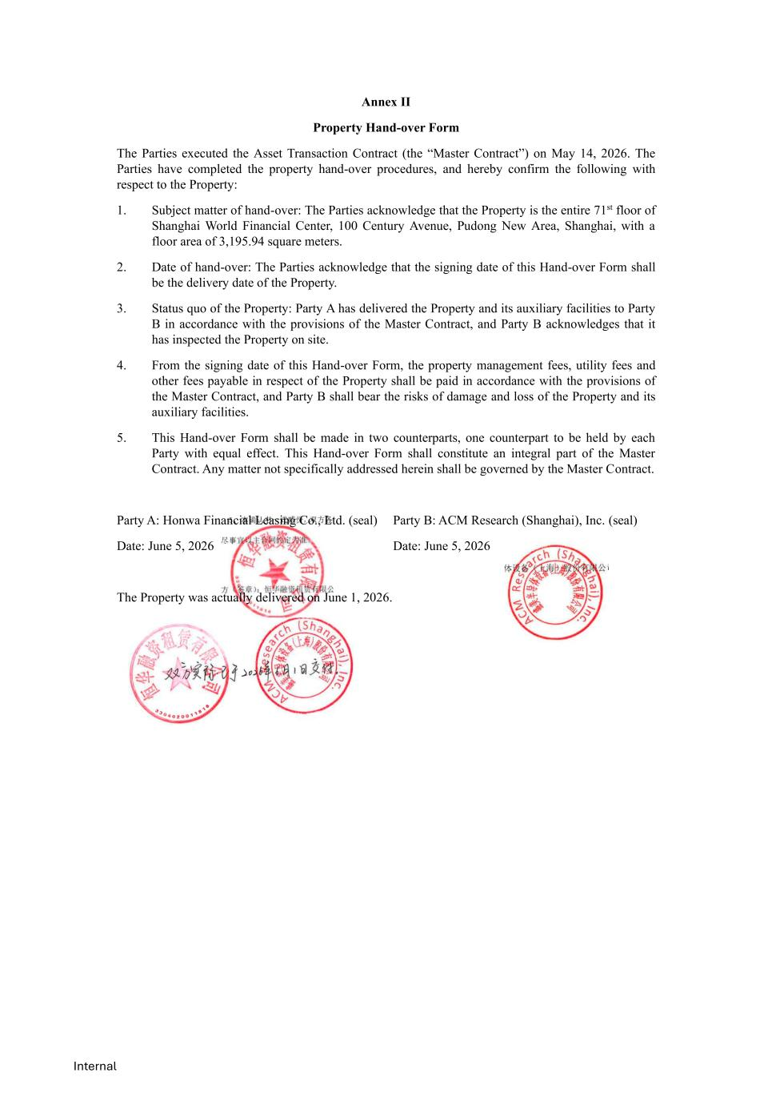
Internal Annex II Property Hand-over Form The Parties executed the Asset Transaction Contract (the “Master Contract”) on May 14, 2026. The Parties have completed the property hand-over procedures, and hereby confirm the following with respect to the Property: 1. Subject matter of hand-over: The Parties acknowledge that the Property is the entire 71st floor of Shanghai World Financial Center, 100 Century Avenue, Pudong New Area, Shanghai, with a floor area of 3,195.94 square meters. 2. Date of hand-over: The Parties acknowledge that the signing date of this Hand-over Form shall be the delivery date of the Property. 3. Status quo of the Property: Party A has delivered the Property and its auxiliary facilities to Party B in accordance with the provisions of the Master Contract, and Party B acknowledges that it has inspected the Property on site. 4. From the signing date of this Hand-over Form, the property management fees, utility fees and other fees payable in respect of the Property shall be paid in accordance with the provisions of the Master Contract, and Party B shall bear the risks of damage and loss of the Property and its auxiliary facilities. 5. This Hand-over Form shall be made in two counterparts, one counterpart to be held by each Party with equal effect. This Hand-over Form shall constitute an integral part of the Master Contract. Any matter not specifically addressed herein shall be governed by the Master Contract. Party A: Honwa Financial Leasing Co., Ltd. (seal) Date: June 5, 2026 Party B: ACM Research (Shanghai), Inc. (seal) Date: June 5, 2026 The Property was actually delivered on June 1, 2026.

Exhibit 31.01
CERTIFICATION OF PRINCIPAL EXECUTIVE OFFICER
PURSUANT TO SECTION 302 OF THE SARBANES-OXLEY ACT OF 2002
I, David H. Wang, certify that:
1.I have reviewed this Quarterly Report on Form 10-Q of ACM Research, Inc.
2.Based on my knowledge, this report does not contain any untrue statement of a material fact or omit to state a material fact necessary to make the statements made, in light of the circumstances under which such statements were made, not misleading with respect to the period covered by this quarterly report.
3.Based on my knowledge, the financial statements, and other financial information included in this report, fairly present in all material respects the financial condition, results of operations and cash flows of the registrant as of, and for, the periods presented in this report.
4.The registrant’s other certifying officer and I are responsible for establishing and maintaining disclosure controls and procedures (as defined in Exchange Act Rules 13a-15(e) and 15d-15(e)) and internal control over financial reporting (as defined in Exchange Act Rules 13a-15(f) and 15d-15(f)), for the registrant and have:
(a)designed such disclosure controls and procedures, or caused such disclosure controls and procedures to be designed under our supervision, to ensure that material information relating to the registrant, including its consolidated subsidiaries, is made known to us by others within those entities, particularly during the period in which this report is being prepared;
(b)designed such internal control over financial reporting, or caused such internal control over financial reporting to be designed under our supervision, to provide reasonable assurance regarding the reliability of financial reporting and the preparation of financial statements for external purposes in accordance with generally accepted accounting principles;
(c)evaluated the effectiveness of the registrant’s disclosure controls and procedures and presented in this report our conclusions about the effectiveness of the disclosure controls and procedures, as of the end of the period covered by this report based on such evaluation; and
(d)disclosed in this report any change in the registrant’s internal control over financial reporting that occurred during the registrant’s most recent fiscal quarter (the registrant’s fourth fiscal quarter in the case of an annual report) that has materially affected, or is reasonably likely to materially affect, the registrant’s internal control over financial reporting.
5.The registrant’s other certifying officer and I have disclosed, based on our most recent evaluation of internal control over financial reporting, to the registrant’s auditors and the audit committee of the registrant’s board of directors (or persons performing the equivalent functions):
(a)all significant deficiencies and material weaknesses in the design or operation of internal control over financial reporting which are reasonably likely to adversely affect the registrant’s ability to record, process, summarize and report financial information; and

(b)any fraud, whether or not material, that involves management or other employees who have a significant role in the registrant’s internal control over financial reporting.
Date: August 7, 2026
David H. Wang
Chief Executive Officer and President
(Principal Executive Officer)

Exhibit 31.02
CERTIFICATION OF PRINCIPAL FINANCIAL OFFICER
PURSUANT TO SECTION 302 OF THE SARBANES-OXLEY ACT OF 2002
I, Mark McKechnie, certify that:
1.I have reviewed this Quarterly Report on Form 10-Q of ACM Research, Inc.
2.Based on my knowledge, this report does not contain any untrue statement of a material fact or omit to state a material fact necessary to make the statements made, in light of the circumstances under which such statements were made, not misleading with respect to the period covered by this quarterly report.
3.Based on my knowledge, the financial statements, and other financial information included in this report, fairly present in all material respects the financial condition, results of operations and cash flows of the registrant as of, and for, the periods presented in this report.
4.The registrant’s other certifying officer and I are responsible for establishing and maintaining disclosure controls and procedures (as defined in Exchange Act Rules 13a-15(e) and 15d-15(e)) and internal control over financial reporting (as defined in Exchange Act Rules 13a-15(f) and 15d-15(f)), for the registrant and have:
(a)designed such disclosure controls and procedures, or caused such disclosure controls and procedures to be designed under our supervision, to ensure that material information relating to the registrant, including its consolidated subsidiaries, is made known to us by others within those entities, particularly during the period in which this report is being prepared;
(b)designed such internal control over financial reporting, or caused such internal control over financial reporting to be designed under our supervision, to provide reasonable assurance regarding the reliability of financial reporting and the preparation of financial statements for external purposes in accordance with generally accepted accounting principles;
(c)evaluated the effectiveness of the registrant’s disclosure controls and procedures and presented in this report our conclusions about the effectiveness of the disclosure controls and procedures, as of the end of the period covered by this report based on such evaluation; and
(d)disclosed in this report any change in the registrant’s internal control over financial reporting that occurred during the registrant’s most recent fiscal quarter (the registrant’s fourth fiscal quarter in the case of an annual report) that has materially affected, or is reasonably likely to materially affect, the registrant’s internal control over financial reporting.
5.The registrant’s other certifying officer and I have disclosed, based on our most recent evaluation of internal control over financial reporting, to the registrant’s auditors and the audit committee of registrant’s board of directors (or persons performing the equivalent functions):
(a)all significant deficiencies and material weaknesses in the design or operation of internal control over financial reporting which are reasonably likely to adversely affect the registrant’s ability to record, process, summarize and report financial information; and

(b)any fraud, whether or not material, that involves management or other employees who have a significant role in the registrant’s internal control over financial reporting.
Date: August 7, 2026
Mark McKechnie
Chief Financial Officer, Executive Vice President and Treasurer
(Principal Financial Officer)

Exhibit 32.01
CERTIFICATION PURSUANT TO 18 U.S.C. 1350,
AS ADOPTED PURSUANT TO SECTION 906 OF THE SARBANES-OXLEY ACT OF 2002
In connection with the Quarterly Report on Form 10-Q of ACM Research, Inc. for the quarterly period ended June 30, 2026, as filed with the Securities and Exchange Commission on the date hereof (the “Report”), each of the undersigned certifies, pursuant to 18 U.S.C. Section 1350, as adopted pursuant to Section 906 of the Sarbanes-Oxley Act of 2002, that, to his or her knowledge on the date hereof:
1.The Report fully complies with the requirements of Section 13(a) or 15(d) of the Securities Exchange Act of 1934; and
2.The information contained in the Report fairly presents, in all material respects, the financial condition and results of operations of ACM Research, Inc. for the period presented therein.
Date: August 7, 2026
David H. Wang
Chief Executive Officer and President
(Principal Executive Officer)
Date: August 7, 2026
Mark McKechnie
Chief Financial Officer, Executive Vice President and Treasurer
(Principal Financial Officer)
The foregoing certification is being furnished solely pursuant to 18 U.S.C. § 1350 and is not being filed as part of the Report or as a separate disclosure document.

