UNITED STATES SECURITIES AND EXCHANGE COMMISSION
Washington, D.C. 20549
FORM 8-K
CURRENT REPORT
Pursuant to Section 13 or 15(d) of the Securities Exchange Act of 1934
Date of Report (Date of earliest event reported): March 13, 2026
ACM Research, Inc.
(Exact Name of Registrant as Specified in its Charter)
Delaware |  |  | 001-38273 |  |  | 94-3290283
(State or Other Jurisdiction of Incorporation) |  |  | (Commission File Number) |  |  | (IRS Employer Identification No.)
42307 Osgood Road, Suite I  Fremont, California |  |  | 94539
(Address of Principal Executive Offices) |  |  | (Zip Code)
Registrant’s telephone number, including area code: (510) 445-3700
Check the appropriate box below if the Form 8-K filing is intended to simultaneously satisfy the filing obligation of the registrant under any of the following provisions:
o |  |  | Written communications pursuant to Rule 425 under the Securities Act (17 CFR 230.425)
o |  |  | Soliciting material pursuant to Rule 14a-12 under the Exchange Act (17 CFR 240.14a-12)
o |  |  | Pre-commencement communications pursuant to Rule 14d-2(b) under the Exchange Act (17 CFR 240.14d-2(b))
o |  |  | Pre-commencement communications pursuant to Rule 13e-4(c) under the Exchange Act (17 CFR 240.13e-4(c))
Securities registered pursuant to Section 12(b) of the Act:
Title of each class |  |  |  |  |  | Trading symbol |  |  |  |  |  | Name of each exchange on which registered
Class A Common Stock, par value $0.0001 per share |  |  |  |  |  | ACMR |  |  |  |  |  | The Nasdaq Stock Market LLC
Indicate by check mark whether the registrant is an emerging growth company as defined in Rule 405 of the Securities Act of 1933 or Rule 12b-2 of the Securities Exchange Act of 1934:Emerging growth company o
If an emerging growth company, indicate by check mark if the registrant has elected not to use the extended transition period for complying with any new or revised financial accounting standards provided pursuant to Section 13(a) of the Exchange Act. o

Item 8.01 Other Events.

The shares of our operating subsidiary ACM Research (Shanghai), Inc. (“ACM Shanghai”) are listed on the Sci-Tech innovation board (the “STAR Market”) of the Shanghai Stock Exchange (the “SSE”). In accordance with the SSE’s rules governing the STAR Market, ACM Shanghai filed with the SSE a Record of March 2026 Investor Relations Activity (the “Record”). The SSE posted the Record to the SSE’s website on March 13, 2026. A copy of the Record is attached as Exhibit 99.1 hereto.

The information in this Current Report on Form 8-K, including Exhibit 99.1, is intended to be furnished and shall not be deemed “filed” for purposes of Section 18 of the Securities Exchange Act of 1934, as amended, or otherwise subject to the liabilities of that Section, nor shall it be deemed to be incorporated by reference into any filing of ACM Research, Inc. under the Securities Act of 1933, as amended.

Item 9.01 Financial Statements and Exhibits.
(d) Exhibits.
Exhibit |  |  |  |  |  | Description
99.1*  104 |  |  |  |  |  | Record of March 2026 Investor Relations Activity filed by ACM Research (Shanghai), Inc. with the Shanghai Stock Exchange on March 13, 2026  Cover Page Interactive Data File (embedded within the XBRL document)
* Unofficial English translation of original document prepared in Mandarin Chinese.
2

SIGNATURE
Pursuant to the requirements of the Securities Exchange Act of 1934, the Registrant has duly caused this report to be signed on its behalf by the undersigned, hereunto duly authorized.
ACM RESEARCH, INC.
By: /s/ Mark McKechnie________________________
Mark McKechnie
Chief Financial Officer and Treasurer
Dated: March 19, 2026
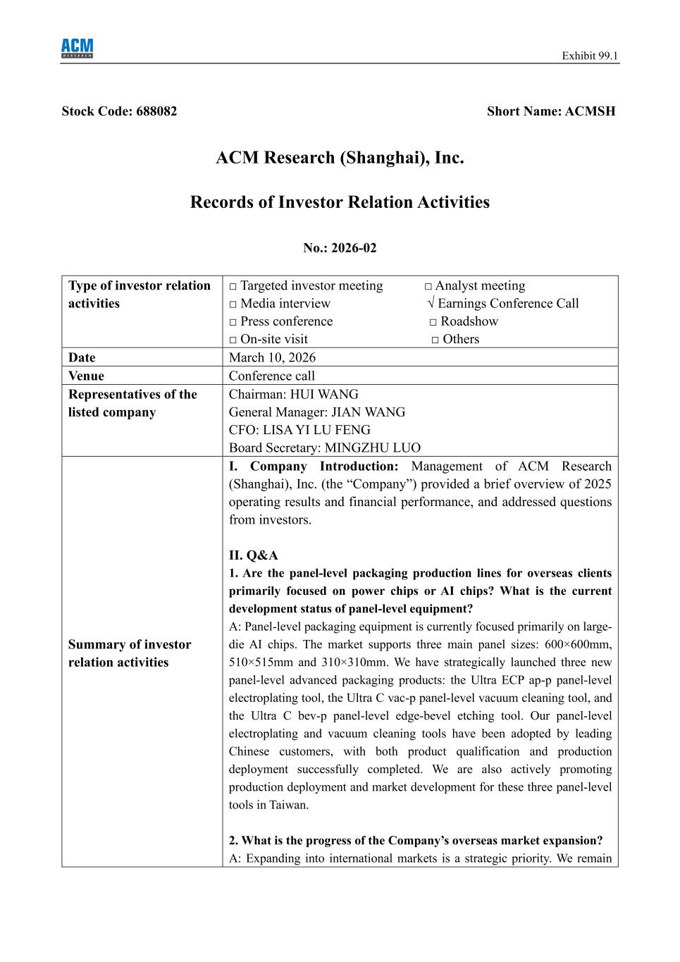
3
Exhibit 99.1 Stock Code: 688082 Short Name: ACMSH ACM Research (Shanghai), Inc. Records of Investor Relation Activities No.: 2026-02 Type of investor relation activities □ Targeted investor meeting □ Analyst meeting □ Media interview √ Earnings Conference Call □ Press conference □ Roadshow □ On-site visit □ Others Date March 10, 2026 Venue Conference call Representatives of the listed company Chairman: HUI WANG General Manager: JIAN WANG CFO: LISA YI LU FENG Board Secretary: MINGZHU LUO Summary of investor relation activities I. Company Introduction: Management of ACM Research (Shanghai), Inc. (the “Company”) provided a brief overview of 2025 operating results and financial performance, and addressed questions from investors. II. Q&A 1. Are the panel-level packaging production lines for overseas clients primarily focused on power chips or AI chips? What is the current development status of panel-level equipment? A: Panel-level packaging equipment is currently focused primarily on large- die AI chips. The market supports three main panel sizes: 600×600mm, 510×515mm and 310×310mm. We have strategically launched three new panel-level advanced packaging products: the Ultra ECP ap-p panel-level electroplating tool, the Ultra C vac-p panel-level vacuum cleaning tool, and the Ultra C bev-p panel-level edge-bevel etching tool. Our panel-level electroplating and vacuum cleaning tools have been adopted by leading Chinese customers, with both product qualification and production deployment successfully completed. We are also actively promoting production deployment and market development for these three panel-level tools in Taiwan. 2. What is the progress of the Company’s overseas market expansion? A: Expanding into international markets is a strategic priority. We remain

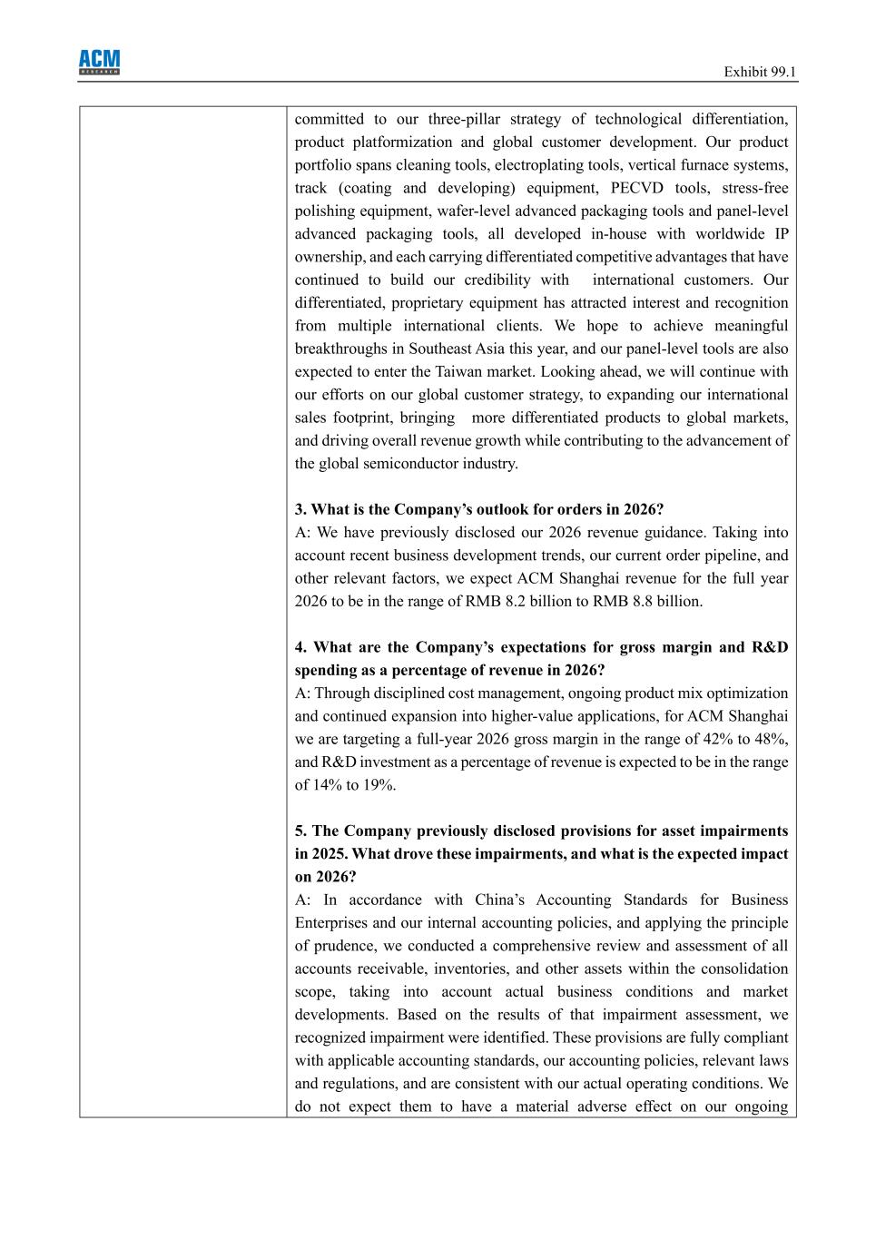
Exhibit 99.1 committed to our three-pillar strategy of technological differentiation, product platformization and global customer development. Our product portfolio spans cleaning tools, electroplating tools, vertical furnace systems, track (coating and developing) equipment, PECVD tools, stress-free polishing equipment, wafer-level advanced packaging tools and panel-level advanced packaging tools, all developed in-house with worldwide IP ownership, and each carrying differentiated competitive advantages that have continued to build our credibility with international customers. Our differentiated, proprietary equipment has attracted interest and recognition from multiple international clients. We hope to achieve meaningful breakthroughs in Southeast Asia this year, and our panel-level tools are also expected to enter the Taiwan market. Looking ahead, we will continue with our efforts on our global customer strategy, to expanding our international sales footprint, bringing more differentiated products to global markets, and driving overall revenue growth while contributing to the advancement of the global semiconductor industry. 3. What is the Company’s outlook for orders in 2026? A: We have previously disclosed our 2026 revenue guidance. Taking into account recent business development trends, our current order pipeline, and other relevant factors, we expect ACM Shanghai revenue for the full year 2026 to be in the range of RMB 8.2 billion to RMB 8.8 billion. 4. What are the Company’s expectations for gross margin and R&D spending as a percentage of revenue in 2026? A: Through disciplined cost management, ongoing product mix optimization and continued expansion into higher-value applications, for ACM Shanghai we are targeting a full-year 2026 gross margin in the range of 42% to 48%, and R&D investment as a percentage of revenue is expected to be in the range of 14% to 19%. 5. The Company previously disclosed provisions for asset impairments in 2025. What drove these impairments, and what is the expected impact on 2026? A: In accordance with China’s Accounting Standards for Business Enterprises and our internal accounting policies, and applying the principle of prudence, we conducted a comprehensive review and assessment of all accounts receivable, inventories, and other assets within the consolidation scope, taking into account actual business conditions and market developments. Based on the results of that impairment assessment, we recognized impairment were identified. These provisions are fully compliant with applicable accounting standards, our accounting policies, relevant laws and regulations, and are consistent with our actual operating conditions. We do not expect them to have a material adverse effect on our ongoing

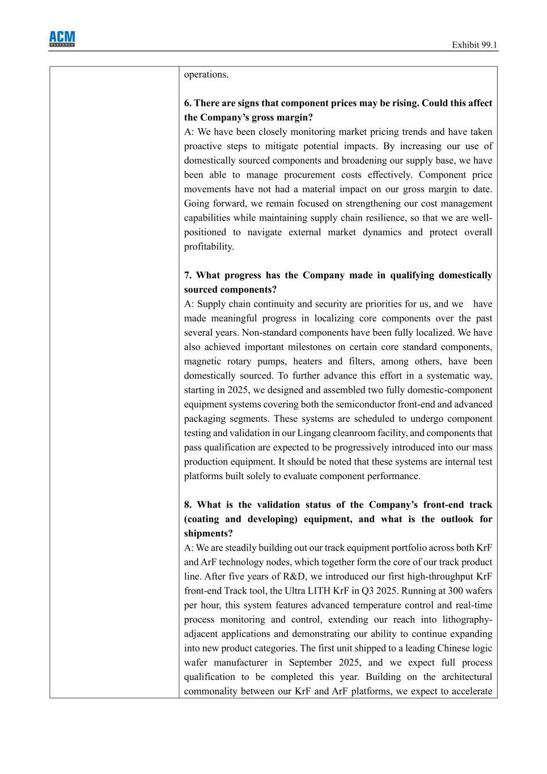
Exhibit 99.1 operations. 6. There are signs that component prices may be rising. Could this affect the Company’s gross margin? A: We have been closely monitoring market pricing trends and have taken proactive steps to mitigate potential impacts. By increasing our use of domestically sourced components and broadening our supply base, we have been able to manage procurement costs effectively. Component price movements have not had a material impact on our gross margin to date. Going forward, we remain focused on strengthening our cost management capabilities while maintaining supply chain resilience, so that we are well- positioned to navigate external market dynamics and protect overall profitability. 7. What progress has the Company made in qualifying domestically sourced components? A: Supply chain continuity and security are priorities for us, and we have made meaningful progress in localizing core components over the past several years. Non-standard components have been fully localized. We have also achieved important milestones on certain core standard components, magnetic rotary pumps, heaters and filters, among others, have been domestically sourced. To further advance this effort in a systematic way, starting in 2025, we designed and assembled two fully domestic-component equipment systems covering both the semiconductor front-end and advanced packaging segments. These systems are scheduled to undergo component testing and validation in our Lingang cleanroom facility, and components that pass qualification are expected to be progressively introduced into our mass production equipment. It should be noted that these systems are internal test platforms built solely to evaluate component performance. 8. What is the validation status of the Company’s front-end track (coating and developing) equipment, and what is the outlook for shipments? A: We are steadily building out our track equipment portfolio across both KrF and ArF technology nodes, which together form the core of our track product line. After five years of R&D, we introduced our first high-throughput KrF front-end Track tool, the Ultra LITH KrF in Q3 2025. Running at 300 wafers per hour, this system features advanced temperature control and real-time process monitoring and control, extending our reach into lithography- adjacent applications and demonstrating our ability to continue expanding into new product categories. The first unit shipped to a leading Chinese logic wafer manufacturer in September 2025, and we expect full process qualification to be completed this year. Building on the architectural commonality between our KrF and ArF platforms, we expect to accelerate

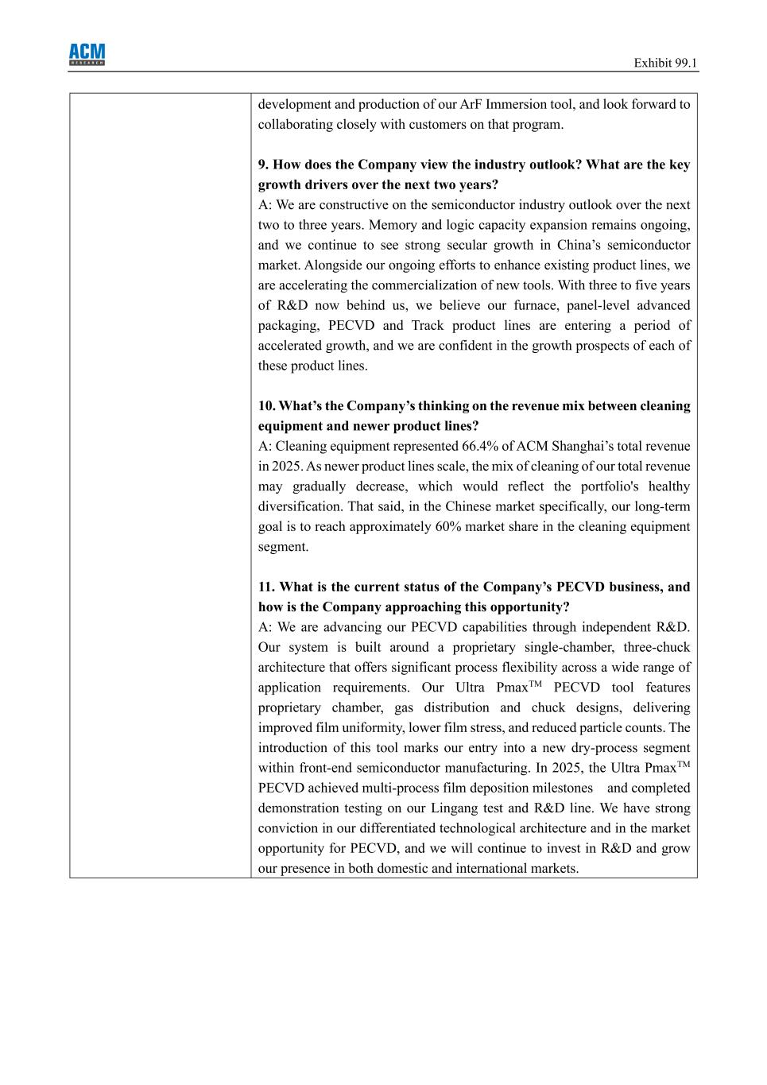
Exhibit 99.1 development and production of our ArF Immersion tool, and look forward to collaborating closely with customers on that program. 9. How does the Company view the industry outlook? What are the key growth drivers over the next two years? A: We are constructive on the semiconductor industry outlook over the next two to three years. Memory and logic capacity expansion remains ongoing, and we continue to see strong secular growth in China’s semiconductor market. Alongside our ongoing efforts to enhance existing product lines, we are accelerating the commercialization of new tools. With three to five years of R&D now behind us, we believe our furnace, panel-level advanced packaging, PECVD and Track product lines are entering a period of accelerated growth, and we are confident in the growth prospects of each of these product lines. 10. What’s the Company’s thinking on the revenue mix between cleaning equipment and newer product lines? A: Cleaning equipment represented 66.4% of ACM Shanghai’s total revenue in 2025. As newer product lines scale, the mix of cleaning of our total revenue may gradually decrease, which would reflect the portfolio's healthy diversification. That said, in the Chinese market specifically, our long-term goal is to reach approximately 60% market share in the cleaning equipment segment. 11. What is the current status of the Company’s PECVD business, and how is the Company approaching this opportunity? A: We are advancing our PECVD capabilities through independent R&D. Our system is built around a proprietary single-chamber, three-chuck architecture that offers significant process flexibility across a wide range of application requirements. Our Ultra PmaxTM PECVD tool features proprietary chamber, gas distribution and chuck designs, delivering improved film uniformity, lower film stress, and reduced particle counts. The introduction of this tool marks our entry into a new dry-process segment within front-end semiconductor manufacturing. In 2025, the Ultra PmaxTM PECVD achieved multi-process film deposition milestones and completed demonstration testing on our Lingang test and R&D line. We have strong conviction in our differentiated technological architecture and in the market opportunity for PECVD, and we will continue to invest in R&D and grow our presence in both domestic and international markets.

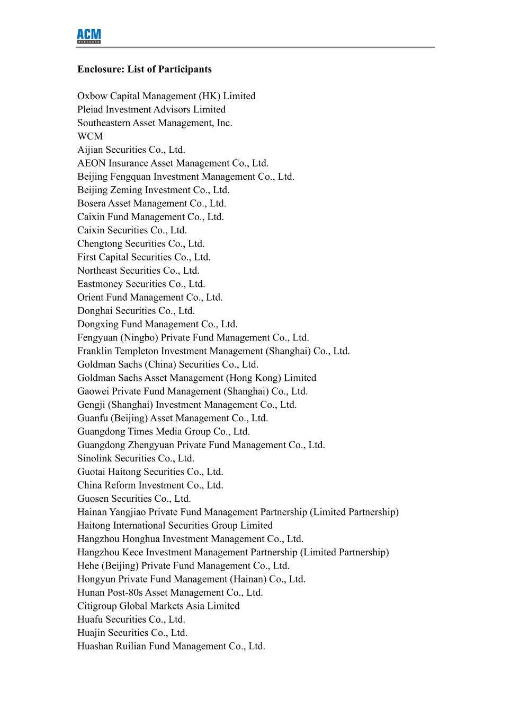
Enclosure: List of Participants Oxbow Capital Management (HK) Limited Pleiad Investment Advisors Limited Southeastern Asset Management, Inc. WCM Aijian Securities Co., Ltd. AEON Insurance Asset Management Co., Ltd. Beijing Fengquan Investment Management Co., Ltd. Beijing Zeming Investment Co., Ltd. Bosera Asset Management Co., Ltd. Caixin Fund Management Co., Ltd. Caixin Securities Co., Ltd. Chengtong Securities Co., Ltd. First Capital Securities Co., Ltd. Northeast Securities Co., Ltd. Eastmoney Securities Co., Ltd. Orient Fund Management Co., Ltd. Donghai Securities Co., Ltd. Dongxing Fund Management Co., Ltd. Fengyuan (Ningbo) Private Fund Management Co., Ltd. Franklin Templeton Investment Management (Shanghai) Co., Ltd. Goldman Sachs (China) Securities Co., Ltd. Goldman Sachs Asset Management (Hong Kong) Limited Gaowei Private Fund Management (Shanghai) Co., Ltd. Gengji (Shanghai) Investment Management Co., Ltd. Guanfu (Beijing) Asset Management Co., Ltd. Guangdong Times Media Group Co., Ltd. Guangdong Zhengyuan Private Fund Management Co., Ltd. Sinolink Securities Co., Ltd. Guotai Haitong Securities Co., Ltd. China Reform Investment Co., Ltd. Guosen Securities Co., Ltd. Hainan Yangjiao Private Fund Management Partnership (Limited Partnership) Haitong International Securities Group Limited Hangzhou Honghua Investment Management Co., Ltd. Hangzhou Kece Investment Management Partnership (Limited Partnership) Hehe (Beijing) Private Fund Management Co., Ltd. Hongyun Private Fund Management (Hainan) Co., Ltd. Hunan Post-80s Asset Management Co., Ltd. Citigroup Global Markets Asia Limited Huafu Securities Co., Ltd. Huajin Securities Co., Ltd. Huashan Ruilian Fund Management Co., Ltd.

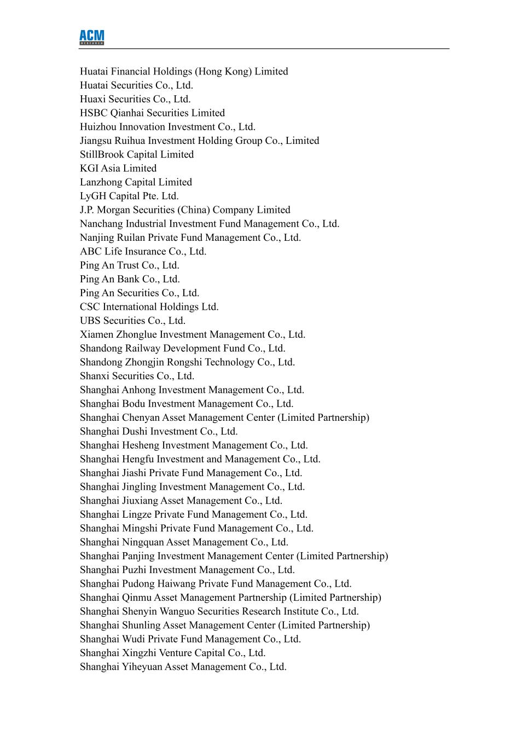
Huatai Financial Holdings (Hong Kong) Limited Huatai Securities Co., Ltd. Huaxi Securities Co., Ltd. HSBC Qianhai Securities Limited Huizhou Innovation Investment Co., Ltd. Jiangsu Ruihua Investment Holding Group Co., Limited StillBrook Capital Limited KGI Asia Limited Lanzhong Capital Limited LyGH Capital Pte. Ltd. J.P. Morgan Securities (China) Company Limited Nanchang Industrial Investment Fund Management Co., Ltd. Nanjing Ruilan Private Fund Management Co., Ltd. ABC Life Insurance Co., Ltd. Ping An Trust Co., Ltd. Ping An Bank Co., Ltd. Ping An Securities Co., Ltd. CSC International Holdings Ltd. UBS Securities Co., Ltd. Xiamen Zhonglue Investment Management Co., Ltd. Shandong Railway Development Fund Co., Ltd. Shandong Zhongjin Rongshi Technology Co., Ltd. Shanxi Securities Co., Ltd. Shanghai Anhong Investment Management Co., Ltd. Shanghai Bodu Investment Management Co., Ltd. Shanghai Chenyan Asset Management Center (Limited Partnership) Shanghai Dushi Investment Co., Ltd. Shanghai Hesheng Investment Management Co., Ltd. Shanghai Hengfu Investment and Management Co., Ltd. Shanghai Jiashi Private Fund Management Co., Ltd. Shanghai Jingling Investment Management Co., Ltd. Shanghai Jiuxiang Asset Management Co., Ltd. Shanghai Lingze Private Fund Management Co., Ltd. Shanghai Mingshi Private Fund Management Co., Ltd. Shanghai Ningquan Asset Management Co., Ltd. Shanghai Panjing Investment Management Center (Limited Partnership) Shanghai Puzhi Investment Management Co., Ltd. Shanghai Pudong Haiwang Private Fund Management Co., Ltd. Shanghai Qinmu Asset Management Partnership (Limited Partnership) Shanghai Shenyin Wanguo Securities Research Institute Co., Ltd. Shanghai Shunling Asset Management Center (Limited Partnership) Shanghai Wudi Private Fund Management Co., Ltd. Shanghai Xingzhi Venture Capital Co., Ltd. Shanghai Yiheyuan Asset Management Co., Ltd.

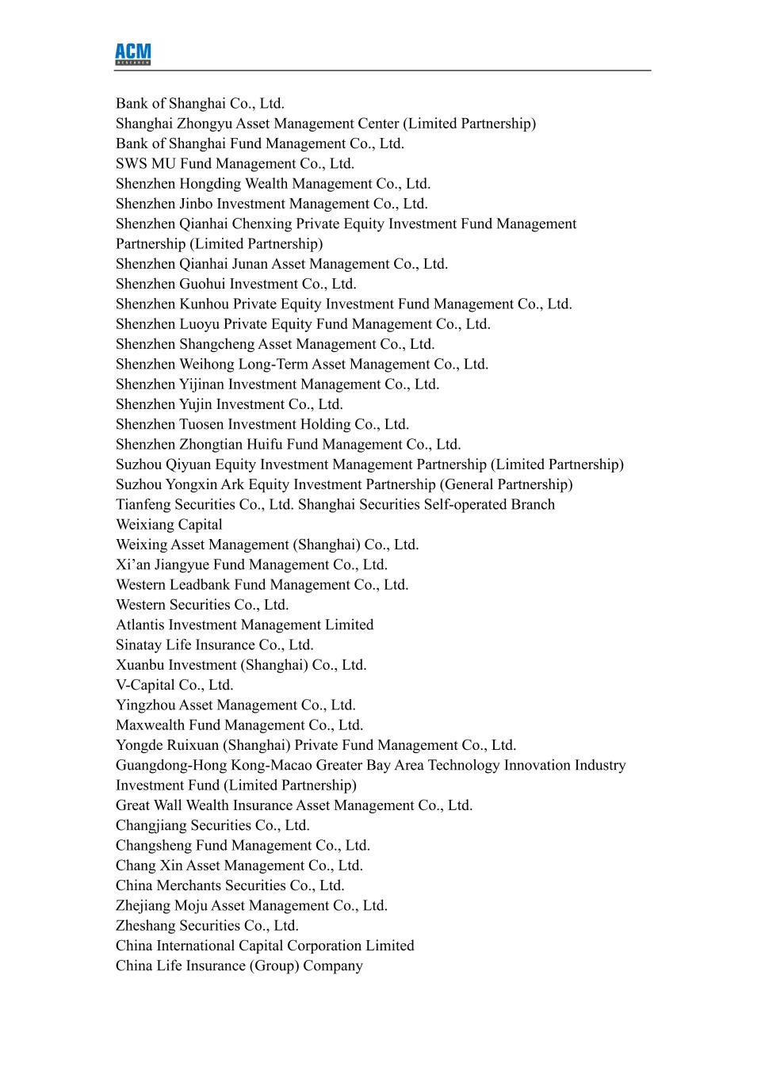
Bank of Shanghai Co., Ltd. Shanghai Zhongyu Asset Management Center (Limited Partnership) Bank of Shanghai Fund Management Co., Ltd. SWS MU Fund Management Co., Ltd. Shenzhen Hongding Wealth Management Co., Ltd. Shenzhen Jinbo Investment Management Co., Ltd. Shenzhen Qianhai Chenxing Private Equity Investment Fund Management Partnership (Limited Partnership) Shenzhen Qianhai Junan Asset Management Co., Ltd. Shenzhen Guohui Investment Co., Ltd. Shenzhen Kunhou Private Equity Investment Fund Management Co., Ltd. Shenzhen Luoyu Private Equity Fund Management Co., Ltd. Shenzhen Shangcheng Asset Management Co., Ltd. Shenzhen Weihong Long-Term Asset Management Co., Ltd. Shenzhen Yijinan Investment Management Co., Ltd. Shenzhen Yujin Investment Co., Ltd. Shenzhen Tuosen Investment Holding Co., Ltd. Shenzhen Zhongtian Huifu Fund Management Co., Ltd. Suzhou Qiyuan Equity Investment Management Partnership (Limited Partnership) Suzhou Yongxin Ark Equity Investment Partnership (General Partnership) Tianfeng Securities Co., Ltd. Shanghai Securities Self-operated Branch Weixiang Capital Weixing Asset Management (Shanghai) Co., Ltd. Xi’an Jiangyue Fund Management Co., Ltd. Western Leadbank Fund Management Co., Ltd. Western Securities Co., Ltd. Atlantis Investment Management Limited Sinatay Life Insurance Co., Ltd. Xuanbu Investment (Shanghai) Co., Ltd. V-Capital Co., Ltd. Yingzhou Asset Management Co., Ltd. Maxwealth Fund Management Co., Ltd. Yongde Ruixuan (Shanghai) Private Fund Management Co., Ltd. Guangdong-Hong Kong-Macao Greater Bay Area Technology Innovation Industry Investment Fund (Limited Partnership) Great Wall Wealth Insurance Asset Management Co., Ltd. Changjiang Securities Co., Ltd. Changsheng Fund Management Co., Ltd. Chang Xin Asset Management Co., Ltd. China Merchants Securities Co., Ltd. Zhejiang Moju Asset Management Co., Ltd. Zheshang Securities Co., Ltd. China International Capital Corporation Limited China Life Insurance (Group) Company

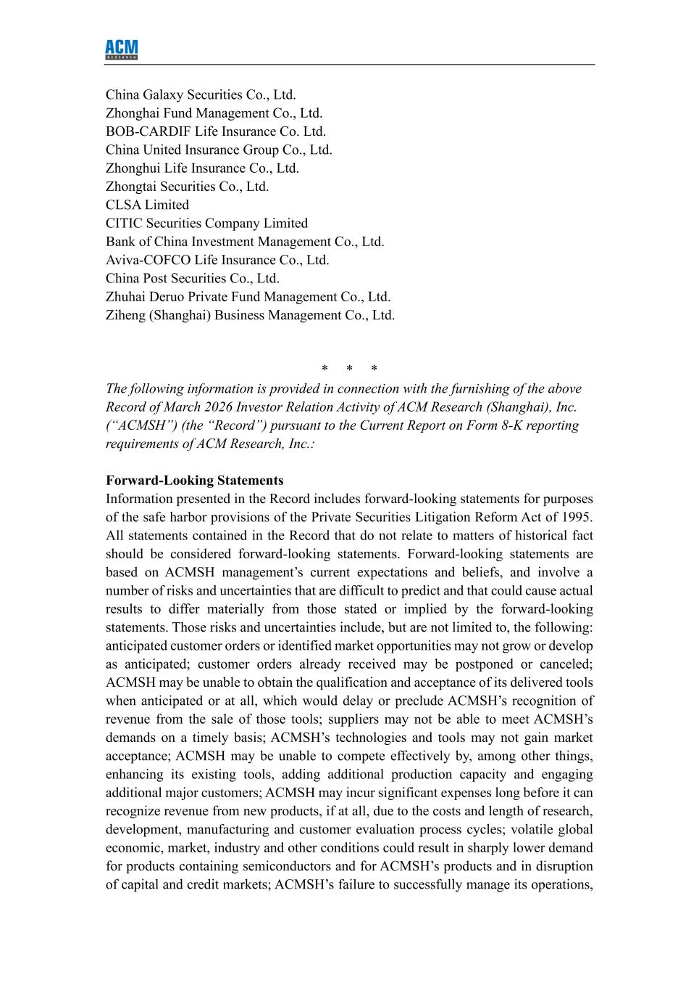
China Galaxy Securities Co., Ltd. Zhonghai Fund Management Co., Ltd. BOB-CARDIF Life Insurance Co. Ltd. China United Insurance Group Co., Ltd. Zhonghui Life Insurance Co., Ltd. Zhongtai Securities Co., Ltd. CLSA Limited CITIC Securities Company Limited Bank of China Investment Management Co., Ltd. Aviva-COFCO Life Insurance Co., Ltd. China Post Securities Co., Ltd. Zhuhai Deruo Private Fund Management Co., Ltd. Ziheng (Shanghai) Business Management Co., Ltd. * * * The following information is provided in connection with the furnishing of the above Record of March 2026 Investor Relation Activity of ACM Research (Shanghai), Inc. (“ACMSH”) (the “Record”) pursuant to the Current Report on Form 8-K reporting requirements of ACM Research, Inc.: Forward-Looking Statements Information presented in the Record includes forward-looking statements for purposes of the safe harbor provisions of the Private Securities Litigation Reform Act of 1995. All statements contained in the Record that do not relate to matters of historical fact should be considered forward-looking statements. Forward-looking statements are based on ACMSH management’s current expectations and beliefs, and involve a number of risks and uncertainties that are difficult to predict and that could cause actual results to differ materially from those stated or implied by the forward-looking statements. Those risks and uncertainties include, but are not limited to, the following: anticipated customer orders or identified market opportunities may not grow or develop as anticipated; customer orders already received may be postponed or canceled; ACMSH may be unable to obtain the qualification and acceptance of its delivered tools when anticipated or at all, which would delay or preclude ACMSH’s recognition of revenue from the sale of those tools; suppliers may not be able to meet ACMSH’s demands on a timely basis; ACMSH’s technologies and tools may not gain market acceptance; ACMSH may be unable to compete effectively by, among other things, enhancing its existing tools, adding additional production capacity and engaging additional major customers; ACMSH may incur significant expenses long before it can recognize revenue from new products, if at all, due to the costs and length of research, development, manufacturing and customer evaluation process cycles; volatile global economic, market, industry and other conditions could result in sharply lower demand for products containing semiconductors and for ACMSH’s products and in disruption of capital and credit markets; ACMSH’s failure to successfully manage its operations,

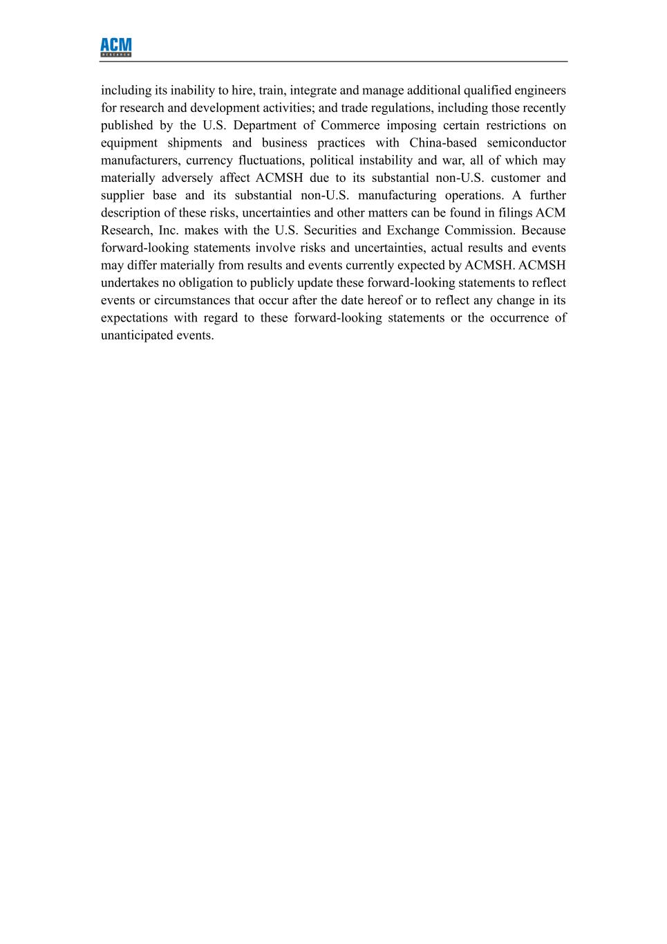
including its inability to hire, train, integrate and manage additional qualified engineers for research and development activities; and trade regulations, including those recently published by the U.S. Department of Commerce imposing certain restrictions on equipment shipments and business practices with China-based semiconductor manufacturers, currency fluctuations, political instability and war, all of which may materially adversely affect ACMSH due to its substantial non-U.S. customer and supplier base and its substantial non-U.S. manufacturing operations. A further description of these risks, uncertainties and other matters can be found in filings ACM Research, Inc. makes with the U.S. Securities and Exchange Commission. Because forward-looking statements involve risks and uncertainties, actual results and events may differ materially from results and events currently expected by ACMSH. ACMSH undertakes no obligation to publicly update these forward-looking statements to reflect events or circumstances that occur after the date hereof or to reflect any change in its expectations with regard to these forward-looking statements or the occurrence of unanticipated events.

